Notes From Lost Book Of Enki

1st Tablet
Enki makes a distinction between the "Times" or historical accounts. The "Beginning" was before the "Prior Times" and the "Prior Times" was before the "Olden Times". In the 1st Tablet Enki expresses himself in lamentation. In the "Beginning" he tells of what is to happen in the "Olden Times". (Is this the first account of what we know as prophecy?)

Excerpt: Enki tells of the "Prior Times"
In the Olden Times the gods came to Earth and created the Earthlings.
In the Prior Times, none of the gods was on the Earth, nor were the Earthlings yet fashioned.
In the Prior Times, the abode of the gods was on their own planet; Nibiru is its name.
A great planet, reddish in radiance; around the Sun an elongated circuit Nibiru makes.
For a time in the cold is Nibiru engulfed; for part of its circuit by the Sun strongly is it heated.
A thick atmosphere Nibiru envelops, by volcanic eruptions constantly fed.
(Is this what is actually coming off that planet rather than what the scientists say is iron oxide?)
All manner of life this atmosphere sustains; without it there will be only perishing!
In the cold period the inner heat of Nibiru it keeps about the planet, like a warm coat that is
constantly renewed.
In the hot period it shields Nibiru from the Sun's scorching rays.
In its midst rains it holds and releases, to lakes and streams giving rise.
Lush vegetation our atmosphere feeds and protects; all manner of life in the waters and on the
land to sprout it caused.
After aeons of time our own species sprouted, by our own essence an eternal seed to
procreate.

The population on Nibiru had grown to a point to where the inhabitants were living and flourishing all over the planet. Clans turned into tribes, then the tribes turned into 2 nations, the North and the South. Before long the 2 Nations were at war for many circuits until all life had been diminished. At that point a truce was declared.

The emissaries of the 2 Nations agreed that there should be only one throne on Nibiru, therefore one king to reign over the planet. Also, to foster unity, the king, whether from either the North or South, would have a spouse as equal queen from the other Nation and their firstborn son would be the successor. The expected outcome was to establish a unified dynasty forever.

Note: 1st King on Nibiru -- An
Lots were cast to choose the first king. His title was An, meaning the Celestial One, and he was from the North. His abode/dwelling place was a city built for him called Agade, meaning Unity. Everybody was in agreement with the decrees of laws and regulations he put forth. He appointed governors whose foremost task was restoration and reclamation. It was recorded in the royal annals that An unified the lands and restored peace on Nibiru. His spouse was An.Tu, meaning Leader Who Is An's Spouse. She was noted in the South for both love and warring. An and An.Tu had 3 sons and no daughters, and the firstborn was named An.Ki, meaning By An a Solid Foundation.

Note: 2nd King on Nibiru -- An.Ki
An's successor was his firstborn son An.Ki, who did not take a spouse. He chose concubines to bring forth his successor, but did not produce a son. He died without producing a successor.

Note: 3rd King on Nibiru -- Ib/An.Ib
After An.Ki died the middle son, Ib was Legal Heir. His name meant One in the Middle. In the royal annals he was called the One Who Is An's Son. He was the 3rd King on Nibiru. His spouse was the daughter of his younger brother. She was called Nin.Ib, meaning the Lady of Ib.

Note: 4th King on Nibiru -- An.Shar.Gal
An.Ib and Nin.Ib had a son named An.Shar.Gal, meaning An's Prince Who Is Greatest of Princes. His spouse was his half sister, Ki.Shar.Gal. She studied the ways of the heavens as her main ambition was knowledge and understanding.
An.Shar.Gal studied the circuit/orbit of Nibiru. He fixed the length of the orbit to a Shar, which by it would measure on year of Nibiru and the royal reigns would be numbered and recorded. He divided the Shar into 10 portions and 2 festivals/seasons, Spring/Summer (when the planet was closest to the Sun) and Fall/Winter (when the planet was farthest from the Sun), celebrated as the festival of warmth and the festival of coolness respectively. This replaced all the olden festivals that the tribes and nations had established in an effort to unify the people. He also established by decree:
1) laws of husband and wife, of sons and daughters
2) proclamation of customs from the first tribes for the whole land
3) a male could have more than one female for knowing (as a result of the wars females outnumbered males)
4) by law, a male could choose one wife as his official spouse, called First Wife (Is this the origin of First Lady?)
5) by law, a father's successor would be his firstborn son
Special Note: Consort is also a relative term in relationships.

Soon thereafter, these laws caused confusion. If the Firstborn son was not by the First Wife and afterwards a son was born by the First Wife, by law that son would become the Legal Heir. As it was in the reign of An.Ki, during the reign of An.Shar.Gal concubines were brought into the palace. He had sons and daughters with concubines. Then he had a son by his spouse and First Wife. Although he was not the Firstborn son, by law he was the Legal Heir. Ki.Shar.Gal "raises hell" in the palace saying:
"If by rules my son, by a First Wife born, from succession shall be barred,
Let the double seed not be neglected!
Though of different mothers, of one father the king and I are offspring.
I am the king's half sister; of me the king is half brother.
By that my son the double seed of our father An.Ib possesses!
Let henceforth the Law of the Seed, the Law of Espousal overpower!
Let henceforth a son by a half sister, whenever born, above all other sons rise to succession!"
Special Note: Who is the son by the concubine? Who is the son by the First Wife?

An.Shar.Gal thought about it and embraced the Law of the Seed. It would solve or avoid the confusion of spouse and concubines and of marriage and divorce. He takes the idea to the royal counselors and they adopted the Law of the Seed for succession. (Is this the origin of a bill becoming law?) The scribes recorded the decree by order of the king, An.Shar.Gal.

Note: 5th King on Nibiru -- An.Shar
The next king proclaimed the Law of the Seed for succession. His royal name was An.Shar, he was the 5th King on Nibiru. An.Shar was the Firstborn son of An.Shar.Gal and Ki.Shar.Gal.
When the law was changed there were words but no rebellion from the other princes. An.Shar took a half sister and made her First Wife. Her name was Ki.Shar. Ki.Shar was a daughter of An.Shar.Gal by one of the concubines he had children with. Now, by law, the dynasty continued.

Now, Nibiru was experiencing climate change and An.Shar assembled learned savants to find out what was going on. Crops were not yielding abundance and the temperature at the time of the 2 festivals were becoming extreme, respectively. Some of the savants told him it had happened before and others said it was destiny. Others observing the circuit/orbit did not consider it as destiny. They found a breach in the atmosphere. Volcanoes were not erupting making the air thinner and their "ozone layer" thinner. Pestilences start appearing in the fields and they could not overcome their toil. (Does this sound similar to the theory of Global Warming on Earth?)

Note: 6th King on Nibiru -- En.Shar
En.Shar, the son of An.Shar and Ki.Shar, takes the throne. His name meant Lordly Master of the Shar. He had mastered much knowledge and made himself available to find the solution to their planet's dilemma. He studied the atmosphere of other planets in the solar system. En.Shar gave the planets names honoring ancestral forefathers. The first two planets, the twin like planets, he called An and Antu. The two largest, the second twin like pair, the called Anshar and Kishar. The fifth one he called Gaga. These were the 5 planets that Nibiru passed by in its circuit/orbit with Gaga sometimes being the first in line. Beyond these 5 the Hammered Bracelet encircled the Sun protecting it as it shielded 4 other planets (children of the Sun) from intrusion. En.Shar chose to study the "5 greeters'" atmospheres for a solution. Eventually they came up with the idea of causing the volcanoes to erupt but didn't know how to accomplish it. The breach got worst and things on the planet and amongst the people grew worse.

Note: 7th King on Nibiru -- Du-Uru
En.Shar espoused his half sister Nin.Shar. She did not bear him a son. En.Shar has a son by a concubine, his Firstborn son, and by Law of Succession takes the throne. (Law of Succession was the old law; Law of the Seed was the new law) His royal name was Du-Uru, meaning Dwelling Place Fashioned, because he was conceived in the house of Concubines and not in the palace. His spouse's royal name was Da.Uru, meaning She Who Is by My Side. She was not half sister of Du-Uru but a female Du-Uru had loved since his youth. This caused confusion in the royal court because sons were not heirs and wives were not half sisters.

At that time, desolation was on the rise. The fields were scarce and in the palace children were not being born. There were 7 rulers from An's seed. That was the end of that line.

Note: 8th King on Nibiru -- Lahma
Da.Uru finds a child at the palace gateway and adopts him, then decrees him Legal Heir. She calls him Lahma, meaning Dryness. There was grumbling among the princes and complaints in the Council of Counselors. Nevertheless, Lahma took the throne even though he was not of the seed/line of An. His spouse was Lahama.

Meanwhile, the councils had 2 suggestions to heal the breach in the atmosphere:
1) use gold that was abundant in the Hammered Bracelet, but rare on Nibiru. It was the only substance ground to powder that would float in their atmosphere once applied. With replenishments it would heal the breach a fortify it better.
2) use Weapons of Terror (nuclear weapons) to cause the volcanoes to erupt. Erupting volcanoes is what had previously been the protection for their atmosphere.

For 4 Shars things were getting unbearable as Lahma was too feeble to make a decision and would only take council from Lahama, his spouse. Her advise to him was to "beseech the Great Creator of All, that's the only hope".

The princes in the royal court were astir as they directed accusations at Lahma, the king. Rebellion was brewing as weapons were taken from the olden storehouses. One of the princes was the first to take up arms as he agitated the other princes. His name was Alalu. Alalu led the others in a rebellion to unnerve Lahma and cause him to abandon the throne. As they stormed the throne room, Lahma escaped to the palace tower with Alalu in hot pursuit. Alalu catches up to Lahma in the palace tower, there is a struggle, and Lahma falls to his death. Alalu rushes to the throne room, takes a seat on the throne, and pronounced himself king.

Note: 9th King on Nibiru -- Alalu
Some of the people rejoiced by Lahma's death and others were saddened by what Alalu did. Unity was lost in the land. Princes in the palace were agitated and counselors were upset. Even though Lahma was proclaimed a son of An by way of Adoption, succession from An on the throne continued. But, who was Alalu?

Alalu was summoned before the Seven Who Judge. He lays out his case that he is of royal seed. He tells them that he is a descendant of An.Shar.Gal. An.Shar.Gal had fathered his Firstborn son with a concubine. His name was Alam. At that time, the throne belonged to him. (Remember Ki.Shar.Gal "raised hell" about her son being deprived of succession because, even though he was the Firstborn son of First Wife, he was not the Firstborn son. Then, the Law of the Seed was adopted.) The Law of the Seed had deprived Alam of kingship. By descent, Alalu continued Alam's generations, and he was the seed of An.Shar.Gal. The Seven Who Judge had to listen to his words. They brought forth the royal annals from the House of Records to determine if what they had been told was either true or false. (Is this the origin of what we know today as Probate Court or the Department of Vital Statistics?)
When the Seven Who Judge review the royal annals, they find that there was no record of the Firstborn son of An.Shar.Gal, because his mother was a concubine and not of the royal seed. Alalu had proven that he was the son of Alam, who had been deprived of kingship because of a legal technicality. He had also proven that he was entitled to kingship. The counselors demanded him swear an oath of life or death on what he told them. He did so, and they considered him king. They pronounced the decision to the elders and the princes. Then, a young prince stepped forward and said that succession must be reconsidered.
The counselors, in amazement, asked the young prince to step forward and identify himself. He replied, "I am Anu, named after my forefather An". They ask about his generations and he runs it down to them starting with the fact that An had 3 sons and no daughters. He tells them:
1) An.Ki was Firstborn, and died with no son or daughter
2) Ib/An.Ib, the middle son took the throne
3) Ib/An.Ib married the daughter of the youngest of the 3 sons
4) the youngest of An's 3 sons was Enuru
5) Enuru's spouse was his half sister Ninuru
6) her son, Enama, was firstborn
7) Enama espoused his half sister and she bore him a son
8) they named their son Anu, after An
Then he states that "we were removed from throneship but not from An's pure seed".
Special Note: Alalu and Anu are 4th cousins

Here's where we need to start following the name chart: Name Chart #1
Line of An (1st King on Nibiru) and his Spouse An.Tu - 3 sons: An.Ki, An.Ib, & Enuru
An.Ki  Brother to An.Ib & Enuru | An.Ib  Brother to An.Ki & Enuru  Father of An.Shar.Gal with spouse Nin.Ib  Uncle to Enama  Great Uncle to Anu | Enuru  Brother to An.Ki & An.Ib  Father of Enama with spouse Ninuru  Uncle to An.Shar.Gal  Great Uncle to Alam  Great, Great Uncle to Alalu
(NO SONS) | An.Shar.Gal  Grandson to An & An.Tu  Son of An.Ib  Father of Alam with concubine  Nephew to Enuru  1st Cousin to Enama  2nd Cousin to Anu | Enama  Grandson to An & An.Tu  Son of Enuru  Father of Anu with half-sister  Nephew to An.Ib  1st Cousin to An.Shar.Gal  2nd Cousin to Alam  3rd Cousin to Alalu
 | Alam  Great Grandson to An & An.Tu  Grandson of An.Ib  Son of An.Shar.Gal  Father of Alalu  2nd Cousin to Enama  3rd Cousin to Anu | Anu  Great Grandson to An & An.Tu  Grandson to Enuru  Son of Enama  Father of Enlil & Enki with spouse Antu  Great Nephew to An.Ib  2nd Cousin to An.Shar.Gal  3rd Cousin to Alam  4th Cousin to Alalu
 | Alalu  Great, Great Grandson to An & An.Tu  Great Grandson to An.Ib  Grandson to An.Shar.Gal  Son of Alam  4th Cousin to Anu  5th Cousin to Enlil & Enki  (NO SONS) | Enlil - Son of Anu & Antu; Legal Heir  Enki - Son of Anu & Ninlul; Firstborn son with a concubine  Great, Great Grandsons to An & An.Tu  Great Grandsons to Enuru  Grandsons to Enama
Many counselors erupted with excitement saying "let Anu be king, let Alalu be removed". The counselors together decided that in order to maintain unity they must bring Alalu in and tell him what has been discovered. Alalu greets Anu and acknowledges that they both are descended from An. He offers a solution: "Let us live in peace, together Nibiru to abundance return!
Let me keep the throne, let you keep the succession!"
Then he tells the council:
"Let Anu Crown Prince be, let him be my successor!
Let his son my daughter espouse, let succession be united!"
Anu accepts and tells the council that he will be cupbearer to Alalu and that a son of his would espouse a daughter of Alalu. It was final, and the council's decision was recorded in the royal annals.

Right away Alalu calls the sages, savants and commanders for consultation. He decided to build celestial boats to seek gold in the Hammered Bracelet/Asteroid Belt. All of them were destroyed and none of them returned. Then he commands the unleashing of the nuclear weapons on the volcanoes to cause them to erupt. With great expectation, the people in the land rejoiced. Meanwhile, Anu served quietly as cupbearer to Alalu. He would bow at his feet, and place the drinking cup in Alalu's hand.
Volcanic eruptions did not increase, the atmosphere did not heal, winds blew harder, rains stopped, and the rejoicing of the people stopped, the heat and the cold grew more unbearable, and the people ceased to revere the king because he had caused more misery rather than relief.

Note: 10th King on Nibiru -- Anu
Alalu was king on Nibiru for 9 Shars (3,600 x 9 = 32,400 years). In the 9th Shar Anu challenges Alalu to a wrestling match and defeats him. By acclaim Anu was hailed as king. Anu was escorted to the palace and Alalu did not return to the palace.

Alalu escapes the crowds in fear that what he did to Lahma would happen to him. He hurries to the spaceport, gets into a spacecraft armed with nuclear weapons and departs for Earth. From the Beginning he had secretly planned his destination.

2nd Tablet
Alalu identified the 5 outer planets by Celestial Names as he made his way to Earth. The first planet he saw was called Gaga, the Celestial Greeter. This is the planet Pluto. He next sees the twin planets Neptune and Uranus. Neptune was called Antu and Uranus was called An. Next were Saturn, called Anshar, then Jupiter, called Kishar. Then Alalu used nuclear weapons to "open the door" of the Asteroid Belt, called the Hammered Bracelet, to make his way toward Earth. Next he sees Mars, and describes it as red brown, and it was called Lahmu. And finally, at that time, he describes Earth, called Ki, as a ball with an atmosphere thinner than that of Nibiru, with clouds swirling within it, and having 3 regions: snow-white on the top and bottom and blue and brown in between.

Alalu could distinguish between dry land and the oceans. He directed the Beam That Penetrates at the dark-hued land (Africa) and could see that gold was beneath the surface and in the waters too. (Alalu had some type of x-ray equipment to locate the gold deposits)

After Alalu arrives on Ki/Earth, he reminisces on his knowledge of how Ki/Earth came about. It is described in the manner of a battle amongst the celestial gods/planets, in the "Beginning":
The gods in the Above (3rd Heaven?) had not been called into being and in the Below (2nd Heaven?) Ki/Earth had not been named. There was only the Sun/Apsu in existence. "As Above So Below", the gods had not been formed because destinies were not yet decreed.
Apsu then made Tiamat/Mother of All his spouse and brought forth Mummu/Mercury as his messenger to present a gift to Tiamat. The gift was gold for her sole possession.
Then, Apsu and Tiamat mingle their waters and bring forth a male, Lahmu/Mars, and a female, Lahamu/Venus. Their abode/dwelling place was in the 2nd Heaven?, made by Apsu and Tiamat.
Anshar/Saturn and Kishar/Jupiter were formed in the 3rd Heaven? before Lahmu/Mars and Lahamu/Venus grew in age and stature, and as celestial twins were larger than their brothers Mummu/Mercury and Lahmu/Mars.
Anshar/Saturn and Kishar/Jupiter had a son and heir in the distant heavens. His name is An/Uranus. His spouse, Antu/Neptune was brought forth.
Now there were 3 heavenly couples made:
1) Lahmu/Mars and Lahamu/Venus
2) Anshar/Saturn and Kishar/Jupiter
3) An/Uranus and Antu/Neptune

At the time of the 3 heavenly couples the Earth had not been called into being and Nibiru had not been seen. The destinies of the gods were not decreed and their circuits/orbits were not in place. Neither were the heavenly waters separated by the Hammered Bracelet/Asteroid Belt. The celestial family (the planets) was erratic and loathsome toward Apsu, as Tiamat formed a crowd to accompany her in opposition to the sons of Apsu. Tiamat was tired and angry. She brought forth 11 and made the firstborn chief among them. His name was Kingu. Tiamat gave Kingu the same rank as An. She attached a Tablet of Destiny to his chest, thereby acquiring his own circuit/orbit, and instructed him to battle against the gods (other planets). (Is this the origin of the breastplate that Aaron wore as high priest in the bible?) Exodus 28:15-30
The gods (other planets) were concerned, and ask each other "Who shall stand up to Tiamat?".
None of the gods would step forward in their circuits and bear a weapon for battle.
The description of how Nibiru is brought forth:
In the heart of the "Deep" a god is born in a "Chamber of Fates"/place of destinies. (Is this another solar system, or another galaxy, or another universe? Is the Chamber of Fates a place where the past meets the future?) This celestial god/planet/Nibiru was created by an artful "Creator" and acknowledged as the son of his own Sun. (Is this referring to An/the celestial god/planet creating celestial god/planet /Nibiru from the Sun of another solar system?)
This new celestial god/planet /Nibiru left his family, carrying a gift of his "Creator", the Seed of Life (DNA) with his course set on the void (our solar system), seeking a new destiny.
The first to see this new celestial god/planet/Nibiru was the spouse of An, Antu. She cast her net (gravitational pull) and pulls him to her as she asks him to be her son. She nurses him and, haughty, he sprouted 4 members at his side. (Is this the creation of 4 other unnamed planets?) As he accepts Antu's invitation to be his mother, he turns toward Antu and soon shows his face to An. An sees him and shouts "My son! My son! You shall be consigned/assigned to leadership with a host by your side as your servants. Let your name be Nibiru, forever known as Crossing (Is this the origin of the epithet "Planet of the Crossing"?)
As the celestial god/planet/Nibiru passes the celestial god/planet/An, An bows to him, spread his net, and brought forth the 4 servants:
1) the South Wind
2) the North Wind
3) the East Wind
4) the West Wind
Then, An announces the arrival of Nibiru to Anshar/Saturn.

Upon hearing the announcement of Nibiru's arrival, Anshar/Saturn sends Gaga/Pluto, as an emissary, to deliver a message to An to assign a task to Nibiru. Gaga/Pluto tells An that Tiamat is angry and has set up a warring host of 11 warriors with Kingu/Moon in command who unrightfully has a tablet of destiny attached to his chest. Gaga/Pluto asks An to let Nibiru be their avenger because none of the celestial gods/planets can stand up to Tiamat for fear of the host of 11. (Is this the origin of the epithet "The Avenger"?)

Hearing that Tiamat would destroy her children, Nibiru was already prompted for action. He tells An and Gaga that if he is to be their avenger, to the gods/planets to assemble in council and make him the leader, therefore bow to his command. This was a strange demand heard by Lahmu/Mars and Lahamu/Venus. The gods/planets who decree the fates agree to make Nibiru their Avenger and vowed that "From this day on your commandments shall be unchallengeable and no one among us shall transgress your bounds".
Then the gods/planets who decree the fates set for him a circuit/orbit to proceed toward Tiamat.
They gave him their blessing as well as awesome weapons.
Anshar/Saturn gave Nibiru 3 more winds:
1) the Evil Wind
2) the Whirlwind
3) the Matchless Wind
Kishar/Jupiter filled his body with a blazing flame to enfold/envelop Tiamat with.
Ready for battle, Nibiru set his course directly toward Tiamat.

Now Nibiru, referred to as the "lord" because of the vow of the gods/planets who decree the fates, follows his course toward Tiamat. He put on the Pulser and Emitter as a cloak of protection. The Pulser and Emitter are instruments used together to revive the dead or in reverse to extinguish the living. He then sends forth the 7 winds. The gods/planets crowded around him then moved from his path as he looked at Tiamat and her helpers to recognize the scheme of Kingu/Moon. The sight of Kingu/Moon blurred his vision as the sight of the 11 distracted his direction. His course and doings were confused. As Tiamat's host of 11 gathered around her in terror, she roars, casting a spell on Nibiru.
Then Nibiru, referred to as "Lord", spread his net (gravitational pull) to surround her as she cried out. As she cried out Nibiru let loose the Evil Wind in her face and she swallowed it but could not close her lips. Then Nibiru shot an arrow of lightning into her open mouth, and it tore her belly apart as it pierced her innards, tearing into her womb and severing her heart. Tiamat had been extinguished.
Tiamat's 11 helpers trembled with terror as they stayed by her side. Nibiru caught them all in his inescapable net, including Kingu/Moon. Then, Nibiru took the Tablets of Destinies from Kingu/Moon, stamped it with his own seal, and fastened it to his own chest. He also bound Tiamat and Kingu/Moon together. He bound the rest of Tiamat's helpers and ensnared them in his circuit as he trampled them and cut them into pieces. He made them to go on a backward course. (Is this how Nibiru acquired the planets that are now in its solar system? Is this why the planets in Nibiru's solar system orbit opposite/counterclockwise of the orbit of Nibiru?)

Next, Nibiru makes his way to Anshar/Saturn and Kishar/Jupiter making an orbit around Apsu/Sun journeying to make the announcement of victory to the gods/planets that appointed him. Gaga/Pluto greets him and then journeys to the others as a herald (messenger). Nibiru proceeds to the Abode in the Deep beyond An and Antu, and considered the fate of Tiamat and Kingu/Moon. He then returns to Tiamat and splits her in two parts, separating her chest from her lower parts. He then cuts her inner channels apart exposing her golden veins. Nibiru completely severs her upper part as he trodded on her hind parts. Now, he summons the North Wind to thrust away the severed head of Tiamat and to place it in the void (2nd Heaven?) and Nibiru hovered his own Wind upon Tiamat, sweeping gushing waters upon her. Then, Tiamat's upper part was carried to an unknown region, exiled, with Kingu/Moon bound with the severed part as its companion. (Is this why the Moon is in close proximity of Earth?)
Nibiru then smashes the hind part of Tiamat to bits and pieces, strings them together to form the Hammered Bracelet/Asteroid Belt, a Firmament, dividing the Upper Waters from the Waters Below. This would serve as an everlasting battle trophy to enshrine the Place of the Battle.

Next, Nibiru, referred as "Lord" surveys the regions measuring from the quarters of Apsu/Sun to the abode of Gaga/Pluto. He then returns slowly to the Place of the Battle. As he again passes Apsu's/Sun's region he thought of Apsu's missing spouse. He gives attention to her Upper Part as the waters of life were still pouring from it and the rays of Apsu/Sun reflected her golden veins.
Nibiru then remembers his Creator's legacy, the Seed Of Life, surely he had imparted it to her when he split her in two. Following that revelation he tells Apsu/Sun to heal the wounds letting life be given to broken part, and the waters be gathered to one place, letting firm land appear. (Is this the separation of the oceans from dry land?) Nibiru tells Apsu/Sun that henceforth, the new daughter of the family, would be called Ki, meaning Firm Land.
Apsu/Sun welcomes Ki to the family and names her Earth and says "let there be day and night by her turning (rotation) and in the days I will provide my healing rays to her." He then appoints Kingu/Moon to shine at night and be Earth's companion forever.

Excerpt: The record is set straight and Nibiru assumes position
He crossed the heavens and surveyed the regions,
To the gods who had him elevated he granted permanent stations,
Their circuits he destined that none shall transgress nor fall short of each other.
He strengthened the heavenly locks, gates on both sides he established. (Is this the entry and exit points on the Zodiac as Nibiru makes its orbit?)
An outermost abode he chose for himself, beyond Gaga were its dimensions.
The great circuit to be his destiny he beseeched Apsu for him to decree.
All the gods spoke up from their stations: Let Nibiru's sovereignty be surpassing!
Most radiant of the gods he is, let him truly the Son of the Sun be!
From his quarter Apsu gave his blessing:
Nibiru shall hold the crossing of Heaven and Earth; Crossing shall be his name!
The gods shall cross over neither above nor below;
He shall hold the central position, the shepherd of the gods he shall be.
A Shar shall be his circuit; that his Destiny will forever be!

Alalu had much knowledge of the heavens and the circuits/orbits of the planets that he learned from An.Shar.Gal and En.Shar, who increased that knowledge. He was so advanced he discussed it with sages and consulted savants and commanders. The gold in the Hammered Bracelet/Asteroid Belt confirmed his knowledge and that in Tiamat's Upper Half was the indication.

1. Link to Map(s) of Celestial Battle
2. Link to Additional Map(s)

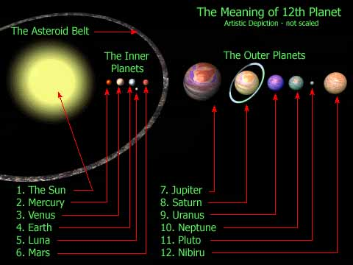 | 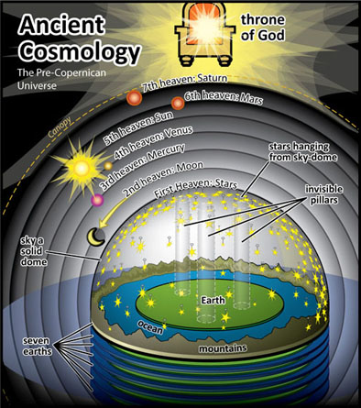

1. Link to Diagram(s)

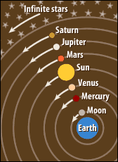 | 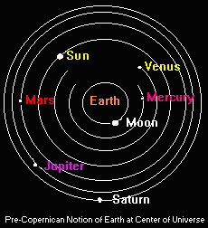

Link to Map(s) and Epic of Creation Link to page on Nibiru Orbit and Other Info

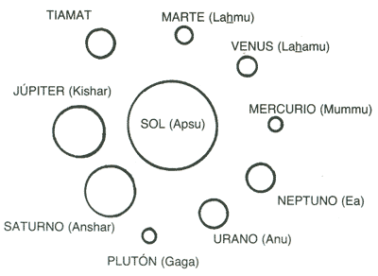 | 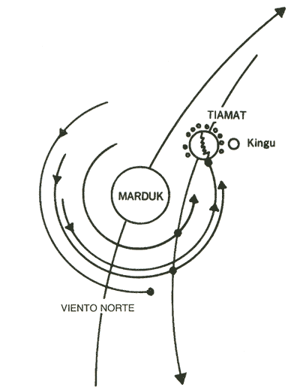
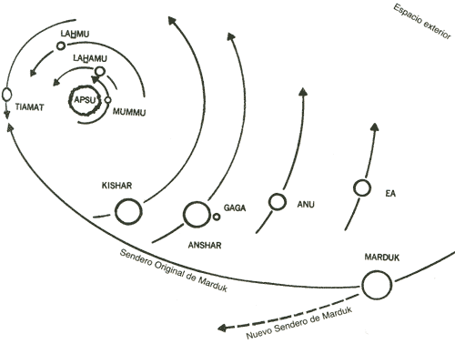 | 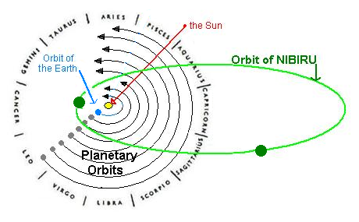  Possible Orbit of the hypothetical Nibiru (Planet X) as it made its 3,600 year elliptical orbit through our solar system disrupting the orbit of Tiamat (now earth) and the path it will once again take upon its possible return.
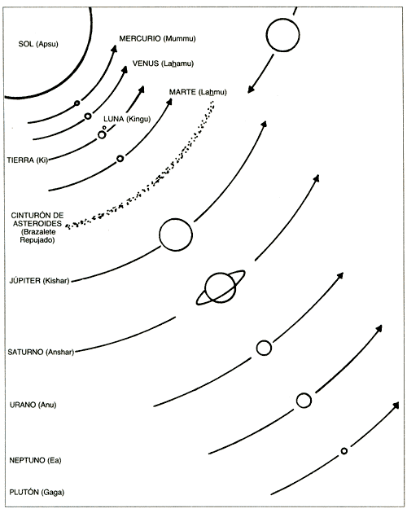 | 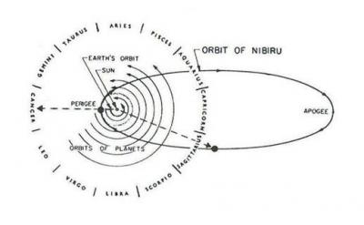

Alalu crash lands at the edge of marshes. He puts on an Eagle's helmet and a Fish's Suit. (Is this a pilot's helmet and some type of diving suit?) The ground was dark-colored and the skies were blue-white. There was no sound. Alalu was on Earth alone, and perhaps exiled from Nibiru forever. He leaves his spacecraft to take a look around then goes back to get a bite to eat and goes to sleep.

When Alalu wakes up there was a brightness (sunshine) outside unseen on Nibiru. He extends a device from the hatch of the spacecraft that analyzed the planet's air. It was compatible to the air on Nibiru. Alalu gets out of the spacecraft and the sunshine is so bright he goes back into the spacecraft and puts on "a mask for the eyes". (Is this the first account of some type of electronic equipment on Earth?) Is this the first account of sunglasses on Earth?)

Alalu picks up a Sampler and heads for the marshes. He discovers fish in the dark greenish waters and, using the Sampler, discovers that the water is not fit to drink (saltwater). (Is this the second account of some type of electronic equipment on Earth?) He then goes toward the hills and discovers a place like an orchard laden with fruit trees of which he ate and enjoyed. He notices a wetness under his feet and follows it. There is a pool in the middle of the forest. He tests the water and it is drinkable (freshwater), and had a different taste from the water on Nibiru. As he drinks from the pool he hears a hissing sound and a slithering body by the poolside. He pulls out some type of ray gun and kills what he describes as being a snake. Here's the sequence:
A hissing sound he could hear; a slithering body by the poolside was moving!
His carried weapon he seized, a blast of its ray toward the hissing he directed.
The moving stopped, the hissing was ended.
To examine the danger Alalu stepped forward.
The slithered body lay still; dead was the creature, a sight most strange:
Like a rope its long body was, without hands or feet was the body;
Fierce eyes were in its small head, out of its mouth a long tongue was sticking.
A sight on Nibiru never beheld it was, a creature of another world!
(Is this sequence of events an encounter by Alalu in the "Garden Of Eden"?)

Excerpt: Alalu witnesses the knowledge he had learned from An.Shar.Gal and En.Shar
In his carried flask he some water collected; with alertness to the chariot he made his way.
The sweet fruits he also picked; to the chariot he set his course.
The brightness of the Sun's rays was greatly diminished; darkness it was as the chariot he reached.
The shortness of the day Alalu pondered, its shortness him amazed.
From the direction of the marshes a cool lightness on the horizon was rising.
A white-hued ball in the heavens was quickly rising:
Kingu, the Earth's companion, he now beheld.
What in the accounts of the Beginning, his eyes the truth could now see:
The planets and their circuits, the Hammered Bracelet,
Ki the Earth, Kingu its moon, all created were, all by names were called!
In his heart Alalu knew one more truth a beholding needed:
The gold, the means of salvation, to be found was needed.
If truth be in the Beginning tales, if by the waters the golden veins of Tiamat were washed,
In the waters of Ki, its cut-off half, gold must be found!
With hands unsteady Alalu the Tester from the chariot's pole dismantled.
With trembling hands the Fish's suit he donned, the fast arriving daylight eagerly awaiting.
At daybreak the chariot he exited, to the marshes he quickly stepped.
Into deeper waters he waded, the Tester into the waters he inserted.
Its illuminated face he eagerly watched, in his chest his heart was pounding.
The water's contents was the Tester indicating, by symbols and numbers its findings disclosing.
Then Alalu's heartbeat stopped: There is gold in the waters, the Tester was telling!
Unsteady on his legs Alalu stepped forward, deeper into the marshes he made his way.
Again he the Tester into the waters inserted; again the Tester gold announced!
A cry, a cry of triumph, from Alalu's throat emanated: Nibiru's fate in his hands now was!

Excerpt: Alalu executes his scheme
Back to the chariot he made his way, the Fish's suit off he took, the commander's seat he
occupied.
The Tablets of Destinies that knows all circuits he enlivened, to Nibiru's circuit to find the
direction.
The Speaker-of-Words he stirred up, toward Nibiru the words to carry.
(Is this the third account of some type of electronic equipment and the first account of some type of telecommunication equipment on Earth?)
Then to Nibiru words he uttered, thus he was saying:
The words of the great Alalu to Anu on Nibiru are directed.
On another world I am, the gold of salvation I have found;
The fate of Nibiru is in my hands; to my conditions you must give heed!

3rd Tablet
When Anu heard the words of Alalu he was in disbelief and wondered if he had hidden himself somewhere on Nibiru.He calls the commanders of chariots and savants to investigate. They determine that the words were coming from beyond the Hammered Bracelet/Asteroid Belt. An tells them to send words of acknowledgement back to Alalu. These were his words:
"Anu the king, to you his greetings sends; of your well-being to learn he is pleased;
For your departing from Nibiru there was no reason, enmity is not in Anu's heart;
If gold for salvation you have indeed discovered, let Nibiru be saved!"

Alalu responds by telling the counselors to pronounce him king in place of Anu. So, they wondered if he was really being truthful about where he was and his findings. They call in the sages for their consultation. The oldest one of the sages, En.Shar tells them that he was Alalu's master (teacher) and that Alalu has knowledge of what he has told them.
He tells them that if Alalu has journeyed beyond the Hammered Bracelet/Asteroid Belt then Earth, the 7th planet, is indeed where he is.

A son of Anu and Antu, Enlil (meaning Lord of the Command), speaks up and says that Alalu cannot speak of conditions because he had forfeited the throne to his father Anu when he was defeated in a wrestling match. He adds
that if Alalu had really found the gold of Tiamat they needed proof and also they needed to know if it was sufficient to protect the atmosphere of Nibiru and how was it going to be transported through the Hammered Bracelet/Asteroid Belt and brought to Nibiru. This caused others to ask questions as well.

Alalu agrees to send the proof. He takes the crystals out of the Tester and the Sampler and inserts them into the Speaker to transmit his findings. When he does this, he demands kingship. (Is the telecommunication equipment also a scanner or computer of some sort?)
The sages think about the damage Alalu caused on Nibiru with the Weapons of Terror (nuclear weapons), the use of them to get past the Hammered Bracelet/Asteroid Belt, and the fact that when Nibiru is in its circuit it passes by that region. Kingship was a serious matter at this point because their is a "sore loser" attempting to extort the throne of Nibiru.

Then E.A./Enki, Firstborn son of Anu (his mother was a concubine; his name means He Whose Home Is Water) and son-in-law of Alalu ( E.A./Enki married Alalu's daughter, Damkina) speaks up. He proposes letting him resolve the conflict. His espousal of Damkina was for the purpose of bringing about unity between the clans. He suggests letting himself be Anu's emissary to Alalu. He would go to Earth and verify what Alalu has presented to them. He tells them he will use water to cut a path through the Hammered Bracelet/Asteroid Belt and not fire. He also tells them he will obtain the gold and make sure it is sent to Nibiru. He further proposes that while the sages are waiting to make a decision about kingship on Nibiru, let Alalu be king on Earth. Also if it will save Nibiru, let a second wrestling match occur for the kingship on Nibiru.

The princes, counselors, sages, and commanders all agree to the proposals laid out by E.A./Enki. Anu also agrees with the wise solution to the conflict.
The words of E.A./Enki were sent to Alalu and Alalu agrees. Anu decrees it in the assembly. Enlil speaks up in objection to the proposal, but once the king decrees a thing, it is unalterable.
(Is this the first account of a Treaty between Earth and another planet?)

E.A./Ea/Enki goes to the place of the chariots (spaceport on Nibiru) and consults the commanders and sages. Also, at that time he made a Tablet of Destinies for the mission. He spends one Shar planning and one Shar making preparations for the mission. ( 2 Shars had passed since Alalu "splashed down" on Earth; 2 x 3,600 = 7,200 years)

The Nibirians fitted the largest celestial chariot (interplanetary spacecraft) with the necessary equipment for the journey and E.A./Ea/Enki created a Tablet of Destiny for it. (Is the Tablet of Destiny being used, at this point, as a map or GPS-like device or a built-in MapQuest?) The right time for departure was selected by stargazers (astronomers on Nibiru). Fifty (50) heroes was the required size of the crew for the mission.

Multitudes of Nibirians gather at the spaceport as the heroes boarded the craft, each carrying an Eagle's helmet (pilot's helmet?) and a Fish's suit (diving suit). E.A./Ea/Enki was the last to board the craft. He acknowledged his family first:
1) he receives the blessing of Anu, his father
2) hugs his mother, Ninlul, a concubine, as she wishes him a safe trip
3) hugs and kisses his spouse, Damkina
4) locks arms with Enlil, his half brother, as Enlil wishes him success
Upon his command the "mother ship" departs Nibiru for Earth.

Anzu, meaning He Who Knows the Heavens, was specially selected as the commander/pilot of the celestial chariot. They traveled 1,000 leagues ( 1 league = 3 miles; 3,000 miles) before Gaga/Pluto came out to greet them and show the way to the blue-hued Antu/Neptune. Anzu admired the Antu/Neptune and wanted to examine her waters. E.A./Ea/Enki tells him to "keep it moving" and that it is a planet of no return. The next in line was An/Uranus. The Tester's beam indicated that they could stop for water if need be, but they continue on the journey. As they approach Anshar/Saturn, they fearfully admire his colored rings as they felt his ensnaring pull (gravitational pull). Anzu avoids any dangers and continues on. Next they approach Kishar/Jupiter, described as "giant". As Anzu divert the chariot's course to avoid her overpowering net pull (gravitational pull), she thrusted lightnings at the chariot. After Kishar/Jupiter was the Hammered Bracelet/Asteroid Belt.

Excerpt: Return to the Place of the Battle
Beyond the fifth planet the Hammered Bracelet was lurking!
Ea his handiwork to set a-whirring commanded, the Water Thruster to prepare.
Toward the host of turning boulders the chariot was rushing,
Each one like a slingshot's stone ferociously at the chariot aimed.
The word by Ea was given, with the force of a thousand heroes the stream
of water was thrust.
One by one the boulders turned face; a path for the chariot they were making!
But as one boulder fled, another in its stead was attacking;
A multitude beyond count was their number, a host for the splitting of
Tiamat revenge seeking!
Again and again Ea the commands gave, the Water Thruster to keep a-whirring;
Again and again toward the host of boulders streams of water were directed;
Again and again the boulders their faces turned, a path for the chariot making.
And then at last the path was clear; unharmed the chariot could continue!
A cry of joy the heroes sounded; double was the joy as the sight of the Sun was now unveiled.
Amidst the elation Anzu the alarm sounded: For the path to have fashioned, excessive waters
were Consumed,
Waters to feed the chariot's Fiery Stones for the remaining journey were not sufficient, (Is this evidence that this spacecraft was fueled by water?)
In the dark deepness the sixth planet they could see, the Sun's rays it was reflecting.

E.A./Ea/Enki tells Anzu there is water on Lahmu/Mars and asked him if he could land on the planet. Anzu orbits the planet to test its gravitational pull and determines it will be an easy landing. Here's how the planet is described:
A sight to behold was Lahmu, many hued it was; snow white was its cap, snow white were its
sandals. Reddish hued was its middle, in its midst lakes and rivers were aglitter!
Anzu set the spacecraft down beside a lake to refill. While refilling they check the surroundings and test the water and air. The water was drinkable but the air was insufficient. (Is this proof that there was water on Mars?) Their findings were recorded in the chariots annals, describing the need for the detour. (Is this the origin of a pilot's or a driver's log?)
The next encounter is the destination and as they depart Lahmu/Mars they can see Ki/Earth and her companion Kingu/Moon as she was making her circuit/orbit. Anzu tells E.A./Ea/Enki that they must slow down because of the thickness of Earth's atmosphere and he responds by suggesting Anzu make slow orbits around the Moon.
As they circle the Moon they see the scars it suffered at the hands of Nibiru in the Celestial Battle. As they circle it twice, they drew ever closer to Earth.

Excerpt: E.A./Ea/Enki and the heroes "splash down" on Earth
Snow hued was two thirds of the planet, dark hued was its middle.
They could see the oceans, they could see the Firm Lands; for the signal beacon from Alalu they
were searching.
Where an ocean touched dry land, where four rivers were swallowed by marshes, Alalu's signal
was beaconed.
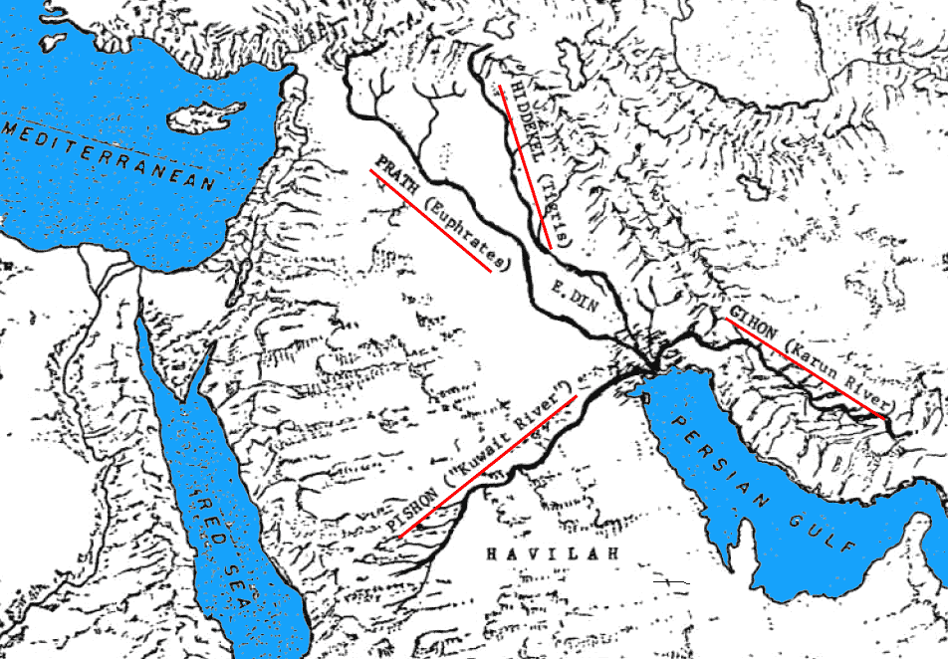

Too heavy and large the chariot is for the marshes! Anzu was declaring
The Earth's pulling net, too powerful for on dry land to descend it is! Anzu to Ea announced.
Splash down! Splash down in the ocean's waters! Ea to Anzu shouted.
Around the planet Anzu made one more circuit, the chariot with much care toward the ocean's
edge he lowered.
The chariot's lungs he filled with air; into the waters down it splashed, into the depth, it was not
sinking.
From the Speaker a voice was heard: To Earth be welcomed! Alalu was saying.
By his beamed words the direction of his whereabouts was determined.
Toward the place Anzu the chariot directed, floating as a boat it was upon the waters moving.
Soon the wide-ranging ocean narrowed, dry land on both sides as guardian appeared.
On the left side brown-hued hills were rising, on the right mountains to heaven their heads
raised.
Toward the place of Alalu was the chariot moving, floating like a boat upon the waters it was.
Ahead the dry land was covered with flooding, marshes the ocean were replacing.
Anzu to heroes commands uttered, their Fishes' suits to put on he ordered.
A hatch of the chariot was then opened, into the marshes the heroes descended.
Strong ropes to the chariot they attached, with the ropes the chariot they were pulling.
Alalu's beamed words more powerful were becoming. Hurry! Hurry! he was saying.
At the edge of the marshes, a sight there was to behold:
Gleaming in the sunrays was a chariot from Nibiru; Alalu's celestial boat it was!
The heroes their paces quickened, toward Alalu's chariot they hurried.
Impatient, Ea donned his Fish's suit; within his chest his heart was like a drum beating.
Into the marsh he jumped, toward its edge hurried steps he directed.
High were the marshes flooding, deeper was the bottom than he expected.
He changed his gait to swimming, with bold strokes forward he advanced.
As dry land he was approaching, green meadows he could see.
Then his feet touched firm ground; he stood up and by walking he continued.
Ahead he could see Alalu standing, with his hands with vigor waving.
Coming out of the waters, ashore Ea stepped: On dark-hued Earth he was standing!
Alalu toward him came running; his son by marriage he powerfully embraced.
Welcome to a different planet! Alalu to Ea said.

Alalu and E.A./Ea/Enki hug and he bows to his father-in-law in respect as the crew of 50 was making their way to dry land from the marshes. As they were making their way to dry land they also were bowing to Alalu. Anzu was the last to leave the spacecraft. (Is this the origin of the captain being the last to leave his ship?) Anzu also bowed to Alalu and locked arms with him. Alalu welcomed to all who had arrived. Enki sees that everyone is bowing to Alalu and lets everyone know that he is in control by saying:
"Here on Earth I am the commander!" (Is this the first account of a "power trip" or "ego" on Earth?)

Excerpt: Enki continues his "power trip"
On a life or death mission we have come; in our hands is Nibiru's fate!
He looked about, for a place for encampment he was searching.
Heap up soil, mounds fashion there! Ea gave command, an encampment to set up.
To a place not afar he was pointing, a reed-hut abode by Alalu erected.
To Anzu then words he directed: To Nibiru words by beaming deliver,
To the king my father, Anu, successful arrival announce!

Soon after E.A./Ea/Enki finishes his "power trip" moment the color of the skies was changing from brightness to reddish. The Nibirians were frightened because they had never seen a sunset. They thought a Great Calamity was about to happen. Alalu laughs and reassures them by educating them that it was only the marking of the ending of one day. (Is this the origin of what the Bible says in Genesis that "the evening and the morning was a new day"?) He lets them know that they should lie down and get a quick rest because the night goes by quickly. (Is this evidence that they "splashed down" during the summertime when the days are longer and the nights are shorter?) Darkness came quickly and that night there was a thunderstorm. The crew of heroes huddled in the chariot all night, and agitated by not getting rest. They were happy when Sunrise came. Genesis 1:5

Now the heroes were experiencing their first day on Earth. Enki begins setting things in order by giving heed to separate the waters from the waters. Here's how he proceeded:
1) Engur was placed in charge of providing drinking water as master of the sweet waters.
2) Enbilulu was placed in charge of the marshlands to mark out the reeds
3) Enkimdu was placed in charge of making a boundary of the marshes by digging ditches and building dikes to separate rainwater from the marshwaters
And it was evening and it was morning, the second day on Earth it was. Genesis 1:6-8
The third day Alalu, E.A./Ea/Enki, & Isimud (Enki's advisor) went to the place of grass and trees (Is this referring to the Garden of Eden?) to examine all that was growing in the orchards. Isimud could distinguish one fruit from the other.
4) Guru was placed in charge of food that grows
And it was evening and it was morning, the third day on Earth it was. Genesis 1:9-13
The fourth day was calm. No winds were blowing and the water was still. Enki commands the heroes to bring the tools from the chariot and built a camp.
5) Kulla was placed in charge of making clay bricks
6) Mushdammu was placed in charge of laying foundations to build dwelling places
It was sunny all day and that night was a full moon. Kingu cast a pale light on Earth. Genesis 1:14-19
And it was evening and it was morning, the fifth day on Earth it was.
7) Ningirsig was commanded to build a reed boat to measure the marshes so that they would have an idea of the stretch of swamplands
8) Ulmash had great knowledge of fish and fowl, knowing the good from the bad. Enbilulu was brought in to make a barrier separating fish from fish. He also built a net to trap the birds that were good for food. Genesis 1:20-23
And it was evening and it was morning, the sixth day on Earth it was.
On the sixth day E.A./Ea/Enki took account of the creatures in the orchards.
9) Enursag was placed in charge of take account of that which creeps and that which walk on feet and the ferocity of their wildness
10) E.A./Ea/Enki calls Kulla and Mushdammu and commands them to have the dwelling places complete by evetime and a fence for protection surrounding the orchards. Anzu brings a Beam That-Kills from the chariot and set up a Speaker-That-Words-Beams.
By evetime the camp was complete and the heroes gathered therein for the night. Genesis 1:24-25
Ea and Alalu and Anzu the doings considered; all that was done indeed was good!
And it was evening and it was morning, the seventh day.

Excerpt: Establishment of the Sabbath
On the seventh day, the heroes in the encampment were assembled,
To them Ea spoke these words:
A hazardous journey we have undertaken, from Nibiru to the seventh planet a dangerous way
we traversed.
At Earth we with success arrived, much good we attained, an encampment we established.
Let this day be a day of rest; the seventh day hereafter a day of resting always to be! Genesis 2:1-4
Let this place henceforth by the name Eridu be called, Home in the Faraway the meaning
thereof will be!
Let a promise be kept, let Alalu of Eridu the commander be declared!
The heroes thus assembled, in unison agreements shouted.
Words of consent Alalu uttered, then homage to Ea he greatly paid:
Let Ea a second name be given, Nudimmud, the Artful Fashioner, let him be called!
In unison the heroes agreement announced.
And it was evening and it was morning, the seventh day.

After the camp of Eridu was established, E.A./Ea/Enki/Nudimmud starts working on getting the gold out of the water. He set up a system, using the power of the chariot's engines, the That Which Water Sucks, and That Which Spits Out, and a vessel of crystals to extract all the metals from the water. In the vessel there was iron, copper, other metals, and very little gold. This goes on 6 days for 2 Earth weeks. Then, E.A./Ea/Enki/Nudimmud decides how to gauge their progress.

Excerpt: Establishment of the Earth Month and the Earth Year
In the nighttimes the Moon waxed and waned; by the name Month did Ea its circuit call.
At Month's very start, its luminous horns six days signified,
By its half crown the seventh day it announced; a day to rest it was.
At midway by a fullness was the Moon distinguished; then it paused to become diminished.
With the Sun's course was the Moon's circuit appearing, with Earth's circuit it was its face revealing.
Fascinated by the Moon's motions was Ea, its attachment as Kingu to Ki he contemplated:
What purpose did the attachment serve, what heavenly sign was it giving:
A Month did Ea the Moon's circuit call, Month to its circuit he gave the name.
For one Month, for two Months, in the chariot were the waters separated;
The Sun, every six Months, to Earth another season gave; Winter and Summer did Ea by names
them call. There was Winter and there was Summer; by Year of Earth did Ea the full circuit call.

E.A./Ea/Enki/Nudimmud, by the end of an Earth year, accounts for the gold accumulated and there was not much to send to Nibiru. Seeing that the current position of the chariot was in more shallow water he moves it back to deeper water. It works, and was getting more gold. (When the chariot was untied from its original position, it was described as being "untied from its moorings". Is this the true origin of the term Moor, meaning tied to the land?) Anu was pleased to hear the news when E.A./Ea/Enki/Nudimmud beams word from the chariot to Nibiru of the happenings.

At this time, Nibiru was getting close to Earth in its circuit/orbit and Anu asked E.A./Ea/Enki/Nudimmud if there was enough gold to send. He tells him there is not enough and to let another Shar pass and the quantity will be doubled. (This was a ploy to buy time to look elsewhere for gold. This also reveals that they had been on Earth for 1 Shar since E.A./Ea/Enki/Nudimmud's arrival; 3,600 years. If you count the 2 Shars that Alalu was on Earth before E.A./Ea/Enki/Nudimmud arrived, the total would be 3 Shars; 3 x 3,600 = 10,800 years) Next, chariot parts were hauled out to build a sky chamber. E.A./Ea/Enki/Nudimmud appoints Abgal to take him up daily to look for a better source of gold. He has an enclosure built for it and placed it by Alalu's chariot. (Is this the first account of a aircraft hangar on Earth?) He studied the crystals in Alalu's crystal to understand what was discovered by their beams. As E.A./Ea/Enki/Nudimmud stayed diligent at finding more abundant sources of gold patience had worn thin on Nibiru. Anu commanded him to deliver gold on Nibiru's nearing. Anu also tells him to repair Alalu's chariot and have it ready to return to Nibiru at the same time.

E.A./Ea/Enki/Nudimmud heeds his father's words, and after thinking about the repair of Alalu's chariot, he and Abgal sneaks into the chariot one evening and remove the Weapons of Terror (nuclear weapons) from the chariot. By sunrise, they take the 7 of them to another land and hide them in a cave. Then E.A./Ea/Enki/Nudimmud commands Anzu to repair the chariot and have it ready by the Shar's completion. Anzu was a skilled mechanic. He gets it up and running again. When he checks its tablets he notices that the 7 nuclear weapons are missing. Anzu goes nuts because he knows Alalu used the weapons to pass through the Hammered Bracelet/Asteroid Belt and without them it is impossible. E.A./Ea/Enki/Nudimmud tells him that those weapons were never supposed to be used neither in the heavens nor on Firm Lands. They go to Alalu, who now is the commander of Eridu, and verify that E.A./Ea/Enki/Nudimmud's words are recorded by the Council of Nibiru and Nibiru will be doomed without the return of the chariot.

After this exchange Abgal, he who knows piloting, volunteered to face the danger of taking the first shipment of gold to Nibiru without the use of the Weapons of Terror (nuclear weapons) and Anzu would stay on Earth. They load basketfuls of gold into Alalu's chariot and E.A./Ea/Enki/Nudimmud gives Abgal a Tablet of Destiny from his chariot to place in Alalu's chariot. It would show him the open pathway in the Hammered Bracelet/Asteroid Belt. They beam word to Nibiru that the first shipment of gold is on the way as they waited with much expectation.

4th Tablet
Abgal makes a circuit/orbit around Kingu/Moon, using its netpowers (gravitational pull) to gain speed as he headed 10,000 leagues toward Lahmu/Mars. (Abgal was using the Moon's gravitational pull like a "sling shot"; 1 league = 3 U.S. miles; 3 x 10,000 = 30,000 miles; Is Mars 30,000 miles from Earth?) Using the Moon's gravitational pull in this manner would give the chariot the speed to approach Mars, which by its gravitational pull, would give Abgal a direction toward Nibiru. Remember, Nibiru is on an elliptical orbit. Abgal uses E.A./Ea/Enki/Nudimmud's crystals to located the openings in the Hammered Bracelet/Asteroid Belt. Once beyond the Hammered Bracelet/Asteroid Belt the chariot started receiving signals from Nibiru, and once Abgal could see Nibiru the signals directed the chariot. (Does this sound familiar? Remember the movie Independence Day? Is the chariot being used as a drone once it gets within a certain range from Nibiru?) The chariot orbits Nibiru 3 times to slow it down. Abgal spread the chariot's wings to slow its descent as he approaches the spaceport to a place selected by the signals. (Does the chariot have retractable wings, like a bird OR is this some type of parachute being described in that manner?)

Link to Image
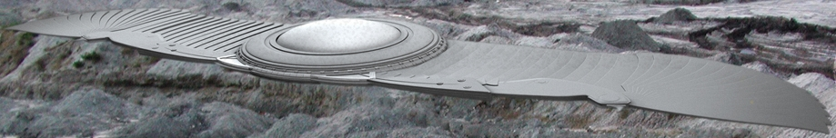

Link to Image
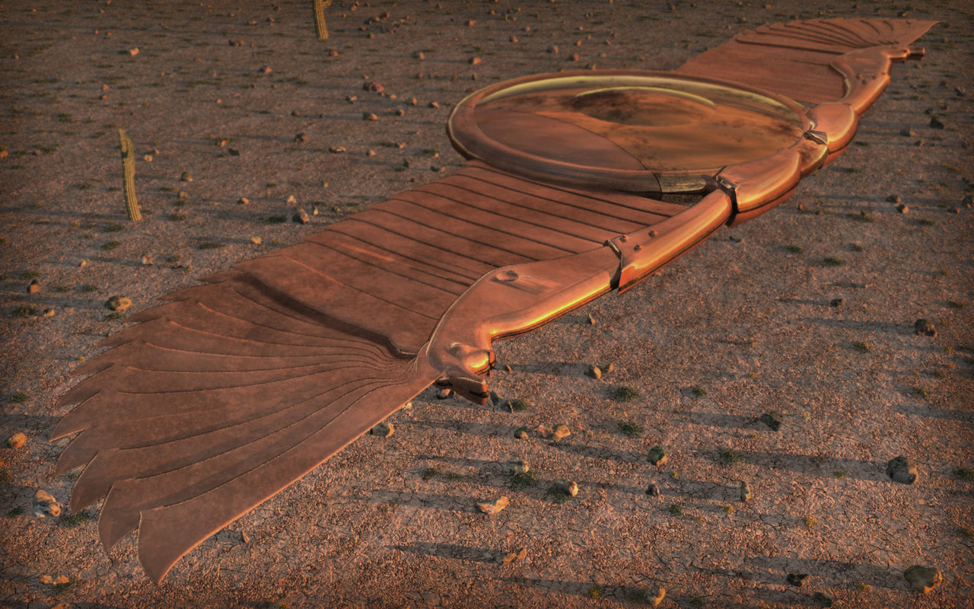
Link to Image
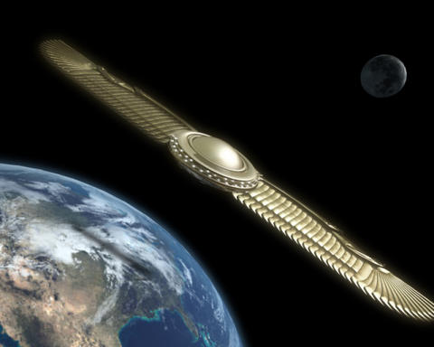

When Abgal lands the chariot and opens the hatch, a multitude was there to welcome him home, as heroes rushed in to get the gold, and Anu greeted him. The gold was quickly taken to the savants so that they could process it into the finest dust possible to launch into their atmosphere. They processed the gold for 1 Shar and tested it for 1 Shar. (2 Shars have passed since the first shipment of gold arrives on Nibiru. Let's not forget that, at this point, there are Nibirians on Earth who have been there for a total of 3 Shars when Abgal takes the first shipment of gold to their home planet. Therefore, they have now been on Earth for 5 Shars; 5 x 3,600 = 18,000 years) Now, they launch rockets with the gold dust on-board and dispersed it using the beams of crystals. (Does this sound like the origin of what we have grown to know as chemtrail techniques?) It works and everybody is happy as Anu sends good news to Earth and tells them to continue collecting the gold.

When Nibiru came close to the sun, in its orbit, the sun's heat caused the repaired breach to return. Anu then commands Abgal to return to Earth to get more gold to make the repair. He sends a pilot-helper with him. His name is Nungal. They also send more equipment which was stored in the bowels of the chariot during the trip. (Is this the origin of storing baggage in the belly of airplanes, ships, and buses?)

By the end of the Shar, Nungal takes another small shipment of gold to Nibiru. (Another Shar has passed. Now, the total number of Shars that Nibirians have been on Earth is 6; 6 x 3,600 = 21,600 years) E.A./Ea/Enki/Nudimmud know that Anu would be disappointed with such small amount of gold on this shipment. He and Alalu exchange words and decide they need to find another source. E.A./Ea/Enki/Nudimmud gets in a sky chamber, taking his scanner which would show where the gold is, and he examined the lands separated by oceans. Where he finds gold is where dry land was separated from dry land.

Excerpt: A description of the land
Where dry land from dry land apart was torn, Earth's innards were revealed;
Where the landmass the shape of a heart was given, in the lower part thereof, (Is this what we know to be Africa?)
Golden veins from Earth's innards were abundant!
Abzu, of Gold the Birthplace, E.A./Ea/Enki/Nudimmud to the region the name gave.
(Is this area what we know today as South Africa?)

E.A./Ea/Enki/Nudimmud sends word to Anu about his new find and tells him that the gold must come from the innards of Earth where it is abundant, and not from the waters. He also tells them the name he gave to the Region, Abzu. Everyone in the assembly agree but wonder how it will be extracted. Enlil speaks up and tells the assembly that Alalu and E.A./Ea/Enki/Nudimmud both were so sure that they would get enough from the waters, and it didn't work. He demands that E.A./Ea/Enki/Nudimmud provide proof of his find as well as a successful plan. Everyone in the assembly agreed with Enlil and Anu commanded that Enlil go to Earth and verify the find as well as put forth the plan. He also states that Enlil will be the commander of the mission. The assembly agrees. (Is this going to cause problems? Remember, it was promised to Alalu that he would be king on Earth, and he is already in the position of Commander of Eridu.) Anu sends word of the decision to Earth. Enlil departs for Earth with his chief lieutenant and pilot, Alalgar. The were each provided personal sky chambers for the mission.

When Enlil arrives on Earth E.A./Ea/Enki/Nudimmud is glad to see him but not so much Alalu as the heroes shouted with high expectations. Enlil immediately commands that the sky chambers be assembled. (Is this the origin of model airplanes and the like OR even the assembly line?) Enlil and Alalgar take a sky chamber and E.A./Ea/Enki/Nudimmud and Abgal take a sky chamber as the brothers go to survey the lands as E.A./Ea/Enki/Nudimmud leads them to the find in the Abzu/South Africa. When they make it to the Abzu/South Africa, Enlil tests the soil and finds gold. Enlil has now verified the find. They return to Eridu and discussed the situation. Enlil tells them that Eridu cannot continue alone and describes his plan.

Excerpt: Enlil's plan and solution to questions
More heroes to bring over, more settlements to establish,
The gold from Earth's innards to obtain, the gold from the admixture to separate,
By skyships and chariots to be carried, from landing places tasks to perform.
Who of the settlements in charge will be, who of the Abzu shall take command?
Thus was Ea of Enlil asking.
Who of enlarged Eridu shall take command, who the settlements shall oversee?
Thus was Alalu saying.
Who of the skyships and the landing place shall take command? So did Anzu inquire.
Let Anu come to Earth, let him decisions provide! Thus did Enlil say in answer. (Does Enlil know that Alalu will lose his position altogether with Anu making those major decisions? Is he "covering his own butt"?)

Nungal piloted the celestial chariot when Anu came to Earth to make the decisions regarding Enlil's plan. As they followed the route of the planets they circle Lahmu/Mars and Kingu/Moon. Anu wondered if there was gold on the Moon. They splash down on Earth and E.A./Ea/Nudimmud/Enki meets Anu in a reed boat built for his arrival. When they make it to Eridu, in the square, Enlil was standing in front of rows of heroes as their commander. He bows to Anu, and Anu hugs him. Alalu didn't know what to do, however, Anu greets him and says to him "Let us lock arms as comrades!" They do so. Then, the king is fed and taken to a reed hut built for him by E.A./Ea/Nudimmud/Enki and he retires for the night. (Did Anu arrive on Earth for the first time on a Friday? The 7th day of the week is on Saturday.)

The next day E.A./Ea/Nudimmud/Enki and Enlil presented their findings to Anu and discussed what they were doing and what needed to be done. Anu tells them that he wants to see the find for himself. That take him to the Abzu and when he sees it he agrees that it will be difficult to extract the gold because it was mingled with the rocks, but it must be extracted no matter how deep they have to dig. Anu commands his sons on how to proceed:
1) E.A./Ea/Nudimmud/Enki and Enlil would devise the tools and assign tasks to the heroes.
2) E.A./Ea/Nudimmud/Enki and Enlil would figure out how to separate the gold from the rocks and deliver it to Nibiru.
3) A landing place must be built and more heroes would be brought to Earth for assigned tasks.
E.A./Ea/Nudimmud/Enki and Enlil both bow their heads in agreement. After a few days, they all return to Eridu and held a council to assign tasks and duties.

E.A./Ea/Nudimmud/Enki wants to remain in Eridu since he was the one who established it, while other settlements were set up in the region. He also suggested re-naming the region the Edin, meaning Abode of the Upright Ones. He wanted to be commander of the Edin while Enlil would be the one over the gold mining operations.
Enlil was in disagreement stating that he was better at commanding and delegating, and he had the knowledge of skyships. He states that since E.A./Ea/Nudimmud/Enki discovered the Abzu and he should be the master of it.
Anu is listening to the exchange between the two as he thinks about their positions in his bloodline. There was a conflict that might disrupt the plan to obtain gold, consideration of succession must be removed from the scenario. So, Anu makes a suggestion:
"Who to Nibiru for the throne seat shall return, who the Edin shall command, who in the Abzu
shall be the master,
Let us three, I with you, by lots determine!"
The three of them clasped their hands together and cast lots to divide the tasks by lot.
Anu would return to Nibiru to remain on the throne, Enlil was allotted the Edin to be Lord of the Command, as indicated by his name and E.A./Ea/Nudimmud/Enki was allotted the Abzu.

Now that the domains are allotted the tasks were assigned:
Enlil was placed in charge of establishing more settlements and managing the skyships and their heroes.
He would be the leader of all lands to the shore of the seas. That was his domain.
E.A./Ea/Nudimmud/Enki's would be master of the Abzu and his domain would be lands beyond shore of the seas and oceans (the Deep on Earth).
Enlil agrees with the lots and bows in acceptance. E.A./Ea/Nudimmud/Enki was not happy at all, as his eyes filled with tears. He did not want to leave Eridu and the Edin. So, Anu lays down the law. He commands 3 things:
1) E.A./Ea/Nudimmud/Enki would retain his home in Eridu forever
2) Forever he would be remembered as the first to "splash down" on Earth
3) He would be known as Earth's master and his title would be Enki, meaning Earth's Master
Enlil bows in acceptance and assures his brother that he would be Earth's Master and himself would be Lord of the Command.
The three of them announced the decisions to the heroes in assembly. Anu assures them that success is in the making and he can now return to Nibiru with peace of mind. (At this point there is a wrinkle in the program that Anu and his sons have not addressed. Alalu has been cut completely out of the picture.)

Excerpt: Alalu is pissed and challenges Anu's decisions; then they battle
Forward toward Anu Alalu stepped. A grave matter has been forgotten! he shouted.
The mastery of Earth to me was allotted; that was the promise when the gold finds to Nibiru I
announced!
Nor have I the claim to Nibiru's throne forsaken,
By Anu to share all with his sons, it is a grave abomination!
Thus did Alalu Anu and the decision challenge.
Without words was Anu in the beginning, then with anger he spoke up:
By a second wrestling let our dispute be decided, let us the wrestling do here, let us do it now!
With disdain Alalu took off his clothing; likewise did Anu unrobe.
In nakedness did the two royals begin to grapple, a mighty struggle it was.
Alalu bent his knee, to the ground Alalu fell;
Anu on the chest of Alalu with his foot pressed down, victory in the wrestling thereby declaring.
By wrestling the decision was made; I am the king, to Nibiru Alalu shall not return!
So was Anu saying as he removed his foot from the fallen Alalu.
Up as a lightning Alalu from the ground arose. By the legs Anu he pulled down.
His mouth was wide open, swiftly he the malehood of Anu bit off,
The malehood of Anu did Alalu swallow!
In pained agony did Anu a cry to the heavens shout; to the ground wounded he fell.
Enki to the fallen Anu rushed, Enlil the laughing Alalu captive held.
Heroes Anu to his but carried, words of accursation against Alalu he uttered.
Let justice be done! Enlil to his lieutenant shouted. With your beam-weapon let Alalu be killed!
No! No! Enki fiercely shouted. Justice is within him, in his innards poison has entered!
They took Alalu to a reed hut, his hands and feet as a prisoner they bound.

Now, Anu was in his reed hut in pain as Enki tended to him. Alalu was in his reed hut spitting up. He was spitting up because his innards were impregnated by Anu's semen and his belly was swollen. On the 3rd day Anu's pain had subsided, yet his pride was hurt. He tells Enki and Enlil that he wished to return to Nibiru, but before he departs Alalu must be judged for his crime. (Is this the origin of the definition of crime? A crime is not a crime unless there is injury to someone or someone's property.)

Excerpt: Judgment of Alalu
By the laws of Nibiru seven judges were required, the highest of rank on them to preside.
In the square of Eridu the heroes were assembled the trial of Alalu to observe.
For the Seven Who judge, seven seats were provided; for Anu, presiding, the tallest seat was prepared.
To his right Enki was seated; Enlil was seated on Anu's left.
On Enki's right Anzu and Nungal were seated; Abgal and Alalgar to the left of Enlil sat.
Before these Seven Who judge Alalu was brought; his hands and feet were untied.
Enlil was first to speak: In fairness a wrestling match was held, Alalu the kingship to Anu
forfeited! What say you, Alalu? Enki him this question asked.
In fairness the wrestling match was held, the kingship I forfeited! Alalu said.
Having been vanquished, Alalu an abominable crime performed, the malehood of Anu he bit and
swallowed! Thus did Enlil the accusation of the crime make. Death is the punishment! Enlil was saying.
What say you, Alalu? Enki his father-by-marriage asked.
There was silence; Alalu the question did not answer.
We all the crime did witness! Alalgar was saying, judgment must be in accordance!
If words you wish to utter, speak before the judging! Enki to Alalu said.
In the silence Alalu slowly began to speak:
On Nibiru I was king, by right of succession I was reigning;
Anu was my cupbearer. The princes he aroused, to a wrestling he me challenged;
For nine counted circuits I was king on Nibiru, to my seed kingship was belonging.
On my throne seat Anu himself sat, to escape death to distant Earth I made a dangerous
journey.
Salvation for Nibiru I, Alalu, on the alien planet discovered!
Return to Nibiru I was promised, in fairness the throne to regain!
Then to Earth came Ea; the one by compromise the next to reign Nibiru he was designated.
Then came Enlil, the succession from Anu to himself claiming.
Then Anu came, by lots he tricked Ea; Enki, the Lord of Earth, he was proclaimed,
Of Earth, not of Nibiru, to be the master.
Then to Enlil command was granted, Enki to the distant Abzu was delegated.
My heart of all that was aching, my chest from shame and anger was bursting;
Then Anu his foot upon my chest placed, upon my aching heart he was treading!
In the silence Anu spoke up: By royal seed and law, by fair wrestling did I gain the throne.
My malehood you bit off and swallowed, my offspring line to discontinue!
Enlil spoke up: To the crime the accused admitted, let the judgment come,
Let death the punishment be!
Death! said Alalgar. Death! said Abgal. Death! said Nungal.
Death to Alalu by itself will be coming, what he had swallowed in his innards death will bring! Enki was saying.
Let Alalu for the rest of his days on Earth be in prison! Anzu was saying.
Their words Anu was contemplating; anger and pity both him engulfed.
To die in exile, let this be the judgment! Anu was saying.
In amazement the judges at each other glanced. What Anu was saying they wondered.
Neither on Earth nor on Nibiru shall the exiling be! Anu was saying.
On the way there is the Lahmu planet, with waters and an atmosphere it is endowed.
Enki, as Ea, thereon made a pause; of it as a way station have I been thinking.
Its netforce is less than that of Earth forceful, an advantage in wisdom to be considered;
In the celestial chariot Alalu shall be taken,
On my departing from Earth he with me shall make the journey.
Around the planet Lahmu we shall make circuits, to Alalu a sky chamber we shall provide,
To the planet Lahmu in it he will be descended.
Alone on a strange planet an exile he shall be,
His days to his last day by himself to count!
Thus did Anu words of judgment utter, in solemnity were the words intended.
By unanimity was this judgment upon Alalu imposed, in the presence of the heroes it was announced.
Let Nungal be my pilot to Nibiru, therefrom chariots bearing heroes again to Earth to pilot.
Let Anzu join for the journey, of the descent to Lahmu take charge!
So did Anu commandments utter. (Is this an account of the very first trial that has taken place on Earth?)

After Alalu's sentence was final, Anu tells Enlil that he must prepare a place on firm soil for landings and that he should be making plans on utilizing Lahmu/Mars as a way station. They enter the chariot, Anu limping, Alalu with hands tied. When they depart they orbit the Moon once, and when they get to Lahmu/Mars the circle it twice before making their descent, noticing the tall mountains and tears in the surface. They could see where Ea's chariot had once landed by a lakeside. As they prepared the sky chamber for Alalu's landing, its pilot Anzu tells them that he wishes to stay with Alalu and protect him until he dies. He reminds him that Alalu was once king on Nibiru and deserves a proper burial when he dies. In the process Anzu let them also know that he would make a name for himself by carrying out the deed.

Anu was amazed at the bravery of Anzu and honored his wish. He then makes a promise to Anzu and swore, with his hand raised, that on the next journey a chariot shall orbit Lahmu/Mars and lower its skyship and if he is found alive he shall be proclaimed the master of Lahmu/Mars and when a way station is established on Lahmu/Mars he will be its commander. Anzu agrees and says "So Be It". Next, they were given food and tools, Eagle's helmets and Fishes' suits and their skyship departed from the chariot. Alalu was king on Nibiru for 9 Shars and commanded Eridu, on Earth, for 8 Shars. In the 9th Shar his fate was to die in exile on Lahmu/Mars. (At this point 5 Shars have passed since the 2nd shipment of gold was delivered to Nibiru. The second shipment happened in the 6th Shar of Nibirians being on Earth, Alalu being the very first. The total number of Shars that Nibirians have been on Earth, at this particular point is:
2 - Alalu was here 2 Shars before E.A./Ea/Nudimmud/Enki arrives
+
8 - Alalu commanded Eridu for 8 Shars
+
1 - Alalu's fate is sealed in the 9th Shar
11 Shars; 11 x 3,600 = 39,600 years)

When Anu arrived back on Nibiru he gave account of what happened on Earth, not seeking a "pity-party" neither vengeance. The business at hand was the discussion. He outlined his vision to the assembled:
"Way stations from Nibiru to Earth to establish, all the Sun's family in one kingdom to
encompass!
The first on Lahmu to be fashioned, the Moon for the plans also to be considered;
On the other planets or their circling hosts stations to set up,
A chain a constant caravan of chariots to supply and safeguard,
The gold from Earth without interruptions to Nibiru bring, perchance gold elsewhere to also find!

The counselors, princes, and savant's all considered Anu's plans and saw a promise of Nibiru's salvation in them. So, they go to work:
1) the savants and commanders perfected their knowledge of the celestial gods/planets
2) they added a new vehicle, rocketships, to their fleet of chariots and skyships
3) heroes were selected and taught for the tasks
The plans were beamed over to Enki and Enlil and they were told to hurry preparations on Earth.

There was much discussion of what had happened and what is required to be done on Earth. Enki appoints Alalgar as overseer of Eridu and goes to the Abzu to determined where they would start mining the gold. Enki calculates the heroes needed as well as the tools required. Enki designs the machinery for the mission and request that they be fashioned on Nibiru:
1) an Earth Splitter to make a gash in the Earth and reach its innards by way of tunnels (Is this machinery a Trencher or a Tunnel-boring machine?)
2) That-Which-Crunches and That-Which-Crushes (Is this machinery a Rock Crusher?)
(Is Enki revealing that he is a Mechanical Engineer? Was the first, ever, mining equipment built on Nibiru and brought to Earth?)
Enki also asks the savants to think about other matters as he sent them a list regarding matters of the health and well-being of the heroes:
1) heroes were experiencing dizziness from the quick day and night cycles of Earth
2) the atmosphere was generally good, but wasn't balanced
3) heroes were complaining about the lack of variety of food
4) Enlil was having problems dealing with the heat on Earth

While Enki is making preparations in the Abzu, Enlil is surveying the Edin as he measured the valleys and plains when taking account of the mountains and rivers. He was seeking a place to establish a Landing Place for the rocketships. Because of the heat, he was also searching for shady and cool area. He takes a liking to snow covered mountains to the north of the Edin. There was a cedar forest growing there with the tallest trees he'd ever seen. (Is this a description of Lebanon and the Mount Ararat area?)

Link to Map | Link to Image
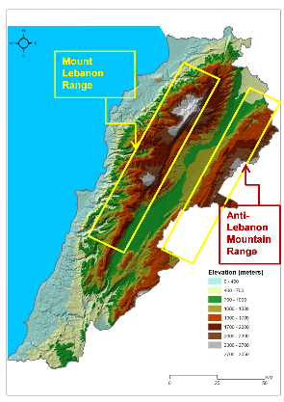 | 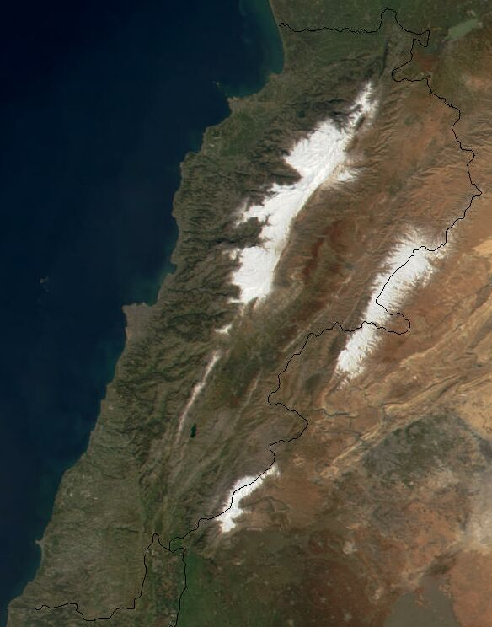

Link to Map | Link to Diagram
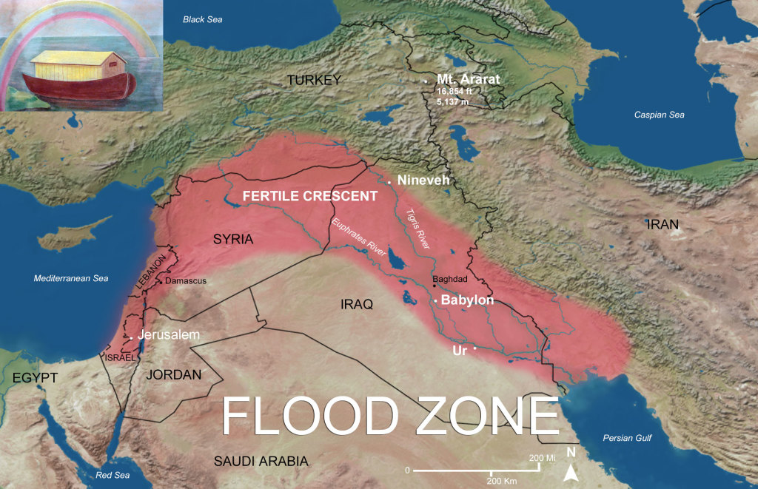 | 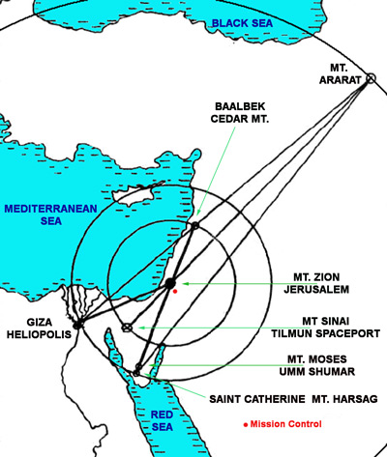
Excerpt: The landing place and Enlil's "spot"
There above a mountain valley with power beams the surface he flattened.
Great stones from the hillside the heroes quarried and to size cut.
To uphold the platform with skyships they carried and emplaced them.
With satisfaction did Enlil the handiwork consider,
A work beyond belief indeed it was, a structure of everlasting!
(Is this the first and only account of the use of laser equipment on Earth to cut trees and to grade the landscape?
(Is the origin of the remnants we now see in Baalbek, Lebanon? Is Enlil revealing that he was a structural engineer?)

An abode for himself, on the crest of the mountain, was his desire.
Of the tall trees in the cedar forest long beams were prepared,
Of them the construction of an abode for himself he decreed:
The Abode of the North Crest he named it.

Link #1 For Info on Baalbek Link #2 For Info on Baalbek

At this time, a new celestial chariot was preparing to leave Nibiru headed to Earth. It was transporting new kinds of rocketships and skyships that Enki had designed. Also, there was a fresh group of 50 heroes on board and among them were chosen females trained as doctors/nurses by Ninmah, meaning Exalted Lady, who was their commander.
Ninmah was a daughter of Anu and half sister, not full sister, of Enki and Enlil. (Who is the mother of Ninmah?)
"In succor and healing she was greatly learned, in the treating of ailments she excelled.
To the complaints from Earth she gave much attention, a healing was she preparing!"

Nungal, the pilot of the new celestial chariot, followed the course of previous chariots recorded on Tablets of Destinies. It safely reaches Lahmu/Mars and they land. A group of heroes follow a faint beaming/signal as Ninmah followed. They found Anzu, laying dead, by the lakeshore, as his helmet is beaming the signals. (Is this the account of the first use of GPS or tracking devices on Mars?) Ninmah touches his face and checks his heart. She removes the Pulser and the Emitter from their pouches. (the Emitter contains crystals that emit life-giving frequencies) She applies the Pulser and Emitter 60 times and on the 60th time, Anzu opened his eyes and moved his lips. Then Ninmah pours Water of Life upon his face and wet his lips. (Is this the account of the first, ever, use of a defribulator on Mars, and subsequently brought to Earth?) Next, she places the Food of Life into his mouth. Anzu then raises from the dead. (Is this the first, ever, account of a resurrection performed on Mars? What is the Water of Life? What is the Food of Life? Is this the origin of Water of Life talked about in the bible; John 4:10-26 and Revelation 21:6 and Revelation 22:1? Is this the origin of Bread of Life talked about in the bible; John 6:22-59?)

Excerpt: Alalu's burial site and the promise of Anu
About Alalu they him then inquired; of Alalu's death Anzu them told.
He led them to a great rock, from the plain heavenward protruding.
(Anzu is walking around and talking like nothing ever happened!! LOL)
There to them what had happened he was telling:
Alalu soon after the landing from unremitting pain to scream began.
From his mouth his innards he was spitting; in agony he peered over the wall!
(What wall? Apparently they had built a structure to live in while waiting for Alalu to die. But, what was the purpose of the wall? Was it some sort of a petition with the dwelling like in a hospital? Where did they get the materials to build a dwelling?)
Thus was Anzu to them saying.
He led them to a great rock, like a mountain from the plain heavenward rising.
In the great rock a cave I found, Alalu's corpse therein l hid,
Its entrance with stones I covered. So was Anzu to them saying.
They followed him to the rock, the stones they removed, the cave they entered.
Inside what of Alalu remained they found;
He who once on Nibiru a king was a pile of bones was in a cave now lying!
For the First time in our annals, a king not on Nibiru has died, not on Nibiru was he buried!
So did Ninmah say. Let him in peace for eternity rest! she was saying.
They the cave's entrance again with stones covered;
The image of Alalu upon the great rock mountain with beams they carved.
They showed him wearing an Eagle's helmet; his face they made uncovered.
Let the image of Alalu forever gaze toward Nibiru that he ruled,
Toward the Earth whose gold he discovered!
(Is this the account of the faces on Mars? Is this the revelation of how they cut and/or carved stone on Earth? Is this the first and only account of the use of laser equipment on Mars?)
So Ninmah, Exalted Lady, in the name of her father Anu did declare.
As for you, Anzu, to you Anu the king his promise shall be keeping!
Twenty heroes with you here shall remain, the way station's building to begin;
Rocketships from Earth the golden ores shall here deliver,
Celestial chariots from here the gold to Nibiru shall then transport.
Hundreds of heroes their abode on Lahmu shall make,
You, Anzu, shall be their commander!
Thus did the Great Lady, in the name of her father Anu, to Anzu say.
My life I owe to you, Great Lady! So was Anzu saying. My gratitude to Anu shall limits not have!
From the planet Lahmu the chariot departed; toward Earth the journey it continued.

5th Tablet
After "taking care of business" on Lahmu/Mars the chariot departs, heading for Earth. They make circuits around the Kingu/Moon exploring the possibility of a way station thereon. Then Nungal, the pilot, onward to Earth, make circuits/orbits around Earth to slow down for landing in the waters beside Eridu. Instead of having to wade or swim to dry land, they were able to leave the chariot and set foot on a quay that Enlil had built. Enlil and Enki greet Ninmah with hugs and lock arms with Nungal. They were greeted with shouts from the heroes present that were already on Earth. They unload the chariot of its cargo consisting of rocketships, skyships, tools that Enki designed, and all kinds of provisions. Ninmah tells Enki and Enlil about the events on Mars. They were both relatively disappointed. She reminds them that Anu's decision is final by saying "That is Anu's decision, his word is unalterable!"

Ninmah "whips" out seeds from her pouch as she tells her brothers that she had brought remedies for the illnesses that the heroes were experiencing. She tells them that the seeds must be sown in the soil in a cool place and nourished by warmth and water, and they will produce fruit by which an elixir shall be made for them to drink. (Is this the first account of wholistic or organic medicine in practice on Earth OR is this where "Big Mamma" learned to make her remedies?)

Excerpt: Enlil yields to "Baby Mama"
The place that for this is perfect I will to you show! Enlil to her said.
It is where the Landing Place was fashioned, where an abode of cedarwood I have made!
In Enlil's skyship the two of them, Enlil and Ninmah, skyward soared;
To the Landing Place in the snow-covered mountains, by the cedar forest, brother and sister
went.
On the great stone platform the skyship landed, to Enlil's abode they went.
Once inside, Enlil embraced her, with fervor he kissed Ninmah.
Oh my sister, my beloved! Enlil to her whispered. By her loins he grabbed her,
Into her womb his semen he did not pour.
Of our son Ninurta word I bring you! Ninmah to him softly said.
A young prince he is, for adventure he is ready, to join you on Earth he is prepared!
If here you stay, let us Ninurta our son bring over! Enlil to her said.
To the Landing Place heroes were arriving, rocketships by skyships to the platform they carried.
From the pouch of Ninmah the seeds were obtained, in the valleys soil they were sown,
A fruit from Nibiru on Earth to be grown!
In the skyship Enlil and Ninmah to Eridu returned.
On the way Enlil to her the landscape showed, the Edin's extent to her he showed,
From the skies Enlil to her his plans explained.
An everlasting plan have I designed! to her he was saying.
That which for all time construction shall determine I have laid out;
Away from Eridu, where dry land begins, my quarters shall be,
Laarsa (Larsa) will be its name, a place for directing it shall become.
On the banks of the Burannu (Buranuna/Euphrates), the River of Deep Waters, will it be located,
A twin thereof a city shall in future arise, Lagash I shall name it.
Between the two on the plans a line have I drawn,
Sixty leagues thereafter a healing city shall come into being, (3 U.S. miles = 1 league; 3 x 60 = 180 miles)
A city of your own it shall be, Shurubak (Shuruppak), the Haven City, I shall name it.
On the center line it shall be located, to the fourth city it shall be leading;
Nibru-ki (Nippur), Earth's Crossing Place, I will name it, a Bond Heaven-Earth in it I shall establish.
The Tablets of Destinies it shall house, all missions it will control!
With Eridu five cities there shall be counted, to eternity, they shall exist!
On a crystal tablet Enlil to Ninmah the master plan was showing;
On the tablet she saw more markings, of them of Enlil she inquired.
Beyond the five cities, a Chariot Place (Sippar) I shall henceforth build,
From Nibiru to Earth directly to arrive! Enlil to her was responding.
Why by Anu’s plans for Lahmu Enlil was bewildered Ninmah then understood.
My brother, magnificent is your plan for the Five cities! to him Ninmah was saying.
The creation of Shurubak, a city for healing, as my abode, for my own to be,
Is a matter for which grateful I am;
Beyond that plan, do not transgress your father, your brother too do not offend!
You are wise as well as beautiful! Enlil to her said.

Link to Map
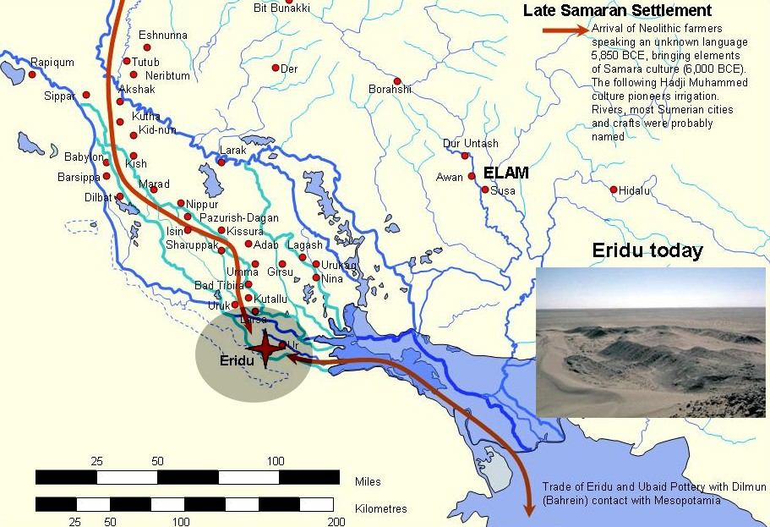

Link to Diagram
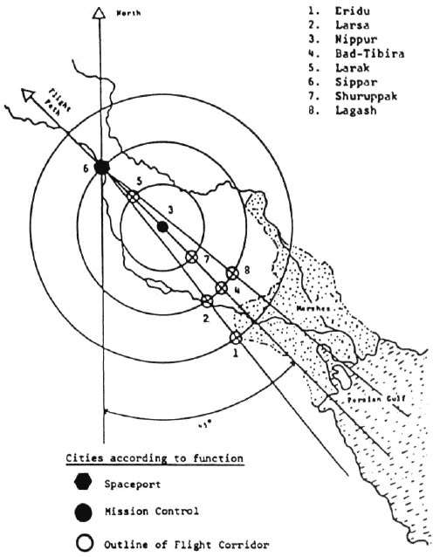

Link to Diagram
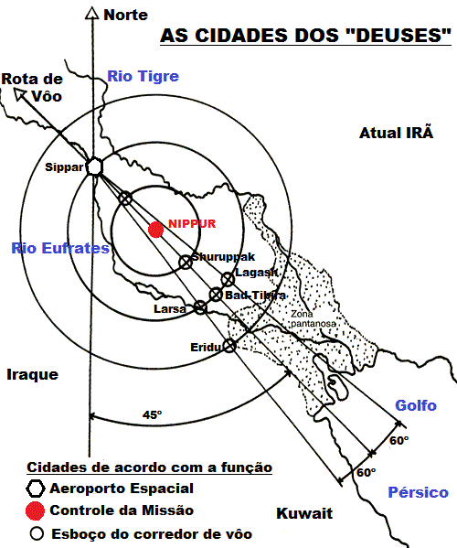

Meanwhile, Enki is trying to figure out where to build his house in the Abzu/South Africa. He measured the region and surveyed its districts. This land is described as distant from the Edin/Persian Gulf Area, rich, bursting with riches, perfect in fullness, and with mighty rivers rushing across the region. Enki builds his house near the rivers. This where Enki set up the gold mining operation. He first put in place the Earth Splitter and That-Which-Crunches and That-Which-Crushes. The plan was to mine the gold in South Africa, take it to the Landing Place in the cedar mountains by skyships, transport it to the way station on Lahmu/Mars, then on to Nibiru.

It was a busy time as the two brothers were putting things in place to execute their Father, Anu's, plans. More heroes were arriving, some assigned to the Edin and some assigned to the Abzu. Enlil had built Laarsa/Larsa and Lagash as well as Shurubak/Shurappak for Ninmah. She had a host of young female healers with her in her city. Enlil was also building Nibru-ki/Nippur, the Bond Heaven-Earth, as mission control. Enki was traveling back and forth from the Abzu to Eridu supervising. On Lahmu, the same thing was going on as construction was progressing and heroes were arriving. This activity lasted for 2 Shars (3,600 x 2 = 7,200 years). At this point, the Nibirians had been on Earth 13 Shars, including the time that Alalu was here alone (3,600 x 13 = 46,800 years).

Excerpt: Anu decrees who is who
Then, the big moment came, on a Seventh Day/Sabbath which had been established by Enki as a day of rest. Everywhere, heroes assembled as they overheard a message from Nibiru from Anu. They were assembled in the Edin where, Enlil was in command, including Ninmah and her host of young ones, as well as Alalgar who was the master of Eridu and Abgal, the commander of the Landing Place. In the Abzu, Enki, Isimud his vizier, Nungal the pilot, and all the heroes were assembled and listening. On Lahmu/Mars all the heroes stood with their commander, Anzu, and listened to Anu's message. There were 600 on Earth and 300 on Mars, a total of 900 heroes and their leaders. Here's the message:
"Heroes, of Nibiru you are the saviors! The fate of all is in your hands!
Your success shall for eternity be recorded, by glorious names you shall be called.
Those who on Earth are shall as Anunnaki be known, Those Who from Heaven to Earth Came!
Those who on Lahmu are, Igigi shall be named, Those Who Observe and See they shall be!
All that is required is ready: Let the gold start coming, let Nibiru be saved!"
(Is this the origin of what we know as Nationality?)
(From previous conversation we know that the Igigi, called the Grigori in the Book of Enoch, are the Fallen Angels, known as The Watchers. Remember when Ninmah told Anzu that he would have hundreds of heroes with him on Mars, did she already know who Anu was going to send to Mars? Was she referring to the 300 Fallen Angels, but just didn't tell Anzu who the 300 would be? Was it part of Anu's plan to send them to Mars to serve the Nibirians on their mission rather than leave the 20 heroes there? Remember, Enki tested the air quality on his way to Earth, and it was insufficient, but the water was good. Knowing this information, was Anu reducing the risk on heroes and increasing the efficiency of the operation by leaving only 21 heroes, including Anzu, on Mars and were they transferred to Earth as the 300 hundred were arriving? The air quality, more than likely, would not effect the Fallen Ones.)

With all the activity at this point we have to "PUMP THE BRAKES, PUMP THE BRAKES"! We have an instance where WE must ask the question; Is "the past meeting the future"? YOU be the judge. The deal is that there is a "little" background info on Enki, Enlil, and Ninmah:
1) they are all Anu's children
2) they all have different mothers
3) Enki's mother is Ninlul, a concubine
4) Enlil's mother is Antu, Anu's spouse, making Enlil the Legal Heir, even though he is not the Firstborn son, by the Law of Succession
5) Ninmah's mother is Nammu, a concubine, making her half sister of both Enki and Enlil.
Ninmah was the Firstborn daughter of Anu, indicated by her name-title, and described as beautiful, full of wisdom, and a quick learner. (PUMP THE BREAKS! We have a situation here, Ninmah is the "Firstborn" daughter with a capital F, the same as when a male child is Firstborn son. What does this mean? Remember one clue, Enki is Alalu's son-in-law.)
Anu chose Enki, who was named E.A./Ea at the time, to espouse Ninmah, thereby setting the stage for their offspring son to become the legal successor by the Law of the Seed, but she was "into" Enlil. They have a son together, and they name him Ninurta. (Is this why Enlil and Enki have "tension" between them?) This angered Anu, and as a result, he forbade her to ever marry. Enki "keeps it moving" and espouses a princess named Damkina. They have a son and heir, Marduk, meaning One In A Pure Place Born. (PUMP THE BRAKES! Damkina is referred to as a princess. That means her father had to be king at some point. That means her father is Alalu. Is that the real reason she stopped on Mars? The real "kicker" is that Ninmah is an attribute of Damkina. Remember, in the Celestial Battle, Tiamat had manifested 11 helpers and a Tablet of Destiny that she place on Kingu's chest. We know that the Nibirians later create beings by using their DNA with a earthling creature to create a Lulu/Primitive Worker to mine the gold. They didn't learn it when they arrived on Earth. Apparently they were doing it on Nibiru. Does this mean Alalu fathered Ninmah with Nammu? Was Ninmah some type of clone of Damkina? Here's a clue: Remember when Alalu and Anu made the deal for kingship? They agreed that his daughter would marry his son to continue the succession and part of that deal, found in other sources, was that Alalu had to give his daughter to Anu, as fealty. Looking at the etymology of fealty we can conclude that Alalu knew that Anu was correct in his explanation of his position within the bloodline, which was a more direct link than his. Alalu got his "arm twisted" in order to remain on the throne. He also knew that Anu would challenge him at some point, and he was right.)
Link #1 to Damkina Info Link #2 to Damkina Info Link #3 to Damkina Info
(Who was the mother of Ninmah?)
Link to Namma Info Link to Nammu Info
Enlil never married on Nibiru. He got married on Earth, however it was a weird sequence of events:
The account of that is one of rape, and exile, and love that brought forgiveness,
And of more sons that were only half brothers.

Excerpt: The account of Enlil's deviant behavior and marriage
On Earth it was summer; to his abode in the cedar forest Enlil retreated.
In the cedar forest was Enlil walking in the cool of the day;
In a cool mountain stream some of Ninmah's young ones, to the Landing Place assigned, were bathing.
By the beauty and grace of one, Sud was her name, Enlil was enchanted.
To his cedarwood abode Enlil her invited:
Come, partake with me in the elixir of Nibiru's fruit that grew here! So to her he said.
Sud into Enlil's abode entered, the elixir in a cup to her Enlil presented.
Sud drank, Enlil drank too; to her Enlil of intercourse was speaking.
Unwilling was the lass. My vagina is too little, it knows not copulation! to Enlil she was saying.
To her Enlil of kissing was speaking; unwilling was the lass:
My lips are too small, they know not kissing! to Enlil she was saying.
Enlil, laughed and embraced her, he laughed and he kissed her;
His semen into her womb he poured!
To Ninmah, Sud's commander, the immoral deed was reported.
Enlil, immoral one! For your deed judgment you shall face! So did Ninmah to Enlil in anger say.
In the presence of fifty Anunnaki Seven Who Judge were assembled,
Seven Who Judge on Enlil a punishment decreed:
Let Enlil from all cities be banished, to a Land of No Return let him exiled be!
In a sky chamber they made Enlil leave the Landing Place; Abgal was its pilot.
To a Land of No Return Enlil was taken, never to return!
In the sky chamber the two of them journeyed, to another land was their direction.
There, amidst forbidding mountains, at a place of desolation, Abgal the sky chamber landed.
This your place of exile shall be! Abgal to Enlil was saying.
Not perchance have I it chosen! to Enlil he was saying. A secret of Enki in it is hidden,
In the nearby cave Enki seven Weapons of Terror has hidden,
From Alalu's celestial chariot he had them removed.
Take the weapons into your possession, with the weapons your freedom attain!
So was Abgal to his commander saying; a secret of Enki to Enlil he did reveal!
Then from the secret place Abgal departed; Enlil alone was there left.
In the Edin Sud to Ninmah, her commander, words was speaking:
By Enlil's seed am I pregnant, a child of Enlil in my womb has been conceived!
Ninmah Sud's words to Enki conveyed; the Lord of Earth he was, on Earth he was supreme!
They summoned Sud before Seven Who judge: Will you take Enlil as your spouse?
they her asked.
Words of consent she uttered; the words by Abgal to Enlil in his exile were conveyed.
To espouse Sud Enlil from his exile was returned; by that did Enki and Ninmah to him
a pardon give.
Enlil's official spouse Sud was declared; on her the name-title Ninlil, Lady of the Command,
was bestowed.
Thereafter to Ninlil and Enlil a son was born; Nannar (FBNE), the Bright One, Ninlil him named.
He was the first of the Anunnaki on Earth to be conceived,
One of Nibiru's royal seed on an alien planet to be born!
Special Note: Throughout the text (FBNE) will represent "full-blooded" Nibirian born on Earth

Excerpt: Enki gets "sent home packin'; back to square one" (LOL)
It was after that that Enki to Ninmah was speaking: Come be with me in the Abzu!
In the midst of the Abzu, in a place of pure waters, an abode have I established.
With a bright metal, silver is its name, it is embellished,
With a deep blue stone, lapis lazuli, it is adorned;
Come Ninmah, be with me, your adoration of Enlil abandon!
To the Abzu, to the abode of Enki, Ninmah then journeyed;
Enki there to her words of loving spoke,
Of how for each other intended, sweet words to her he whispered.
You are still my beloved! to her he said, caressing.
He embraced her, he kissed her; she caused his phallus to water.
Enki his semen into the womb of Ninmah poured. Give me a son! Give me a son! he cried out.
She took the semen into her womb, the semen of Enki her impregnated.
One day of Nibiru was a month of Earth for her,
We have a math problem!
x = 360/30 (See section on Zodiac calculations to cross-check)

Two days, three days, four days of Nibiru like months of Earth they were,
Five and six and seven and eight days of months were completed;
The ninth count of motherhood was completed; Ninmah was in travail.
To a child she gave birth; the newborn was a female (FBNE);
On the banks of the river in the Abzu a daughter to Enki and Ninrnah was born!
Enki by a daughter was disappointed. Kiss the young one! to him Ninmah said.
Kiss the young one! Enki to his vizier Isimud said: A son I desired,
A son by my half sister I must have!
Again he kissed Ninmah, by her loins he grabbed her. his semen into her womb he poured.
Again she was with child, again a daughter to Enki she bore (FBNE).
A son, a son by you I must have! Enki to her cried out; Ninmah he kissed again.
Thereupon Ninmah against Enki a cursing tittered,
Whatever food he ate was poison in his innards; his jaw hurt, his tooth hurt, his ribs were
hurting. (Is this the first account of the use of "voodoom" or "working roots" on Earth?)
Isimud the Anunnaki summoned, to Ninmah for relief they were pleading.
To distance himself from Ninmah's vulva Enki by raised arm swore;
Link #1 to vulva definition Link #2 to vulva definition

Female External Genitalia (Vulva)
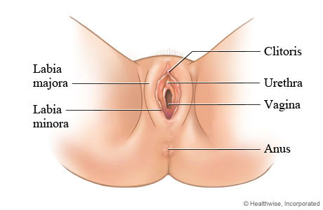

The external female genitalia (vulva) include:
The opening of the vagina (also called the birth canal). The vagina is part of the reproductive tract and extends from the womb (uterus) to outside the body.
The fleshy lips (labia majora and labia minora) around the vagina.
A small bump of tissue ( clitoris ) covered with a thin flap of tissue. The clitoris is the main source of sensations during sexual activity.
During a vaginal self-examination, you can also see the urethra, an opening that leads to the bladder, and the anus, the opening that leads to the colon.

One by one she his ailments removed, from her curse Enki was freed.
To the Edin Ninmah returned, never to be espoused; Anu's command was fulfilled!
To Earth Enki his spouse Damkina with their son Marduk summoned;
Ninki, Lady of Earth, the title she was granted.
By her and by concubines Enki five more sons had, these were their names:
Nergal (FBNE) and Gibil (FBNE), Ninagal (FBNE) and Ningishzidda (FBNE) , and
Dumuzi (FBNE) the youngest. (Marduk (FBN), Firstborn, makes a total of 6)

Special Note: Enki made a fatal mistake when he tried to "force" Ninmah to have a son with him. It was not her destiny to do so. If she was indeed a clone created by Damkina, she was destined to have a son by Enlil and not Enki. And if so, Ninmah was under the control of Damkina all along. Damkina was protecting her interest across-the-board.
Also, she used Ninmah to "check" Enki. He either was ignoring it or he was that much full of lust or both. Enki had what he desired all along!
(Is this evidence of the power that our ancestors possess? Is this an example of the power that our women have today, when used properly and wisely?)

Following these events Enlil and Ninmah summon their son, Ninurta (FBNE) to Earth. Later, Enlil and his spouse Ninlil have another son, Ishkur (FBNE), who was a full brother to Nannar. All 3 of Enlil's sons were full blooded Nibirians, none were born by a concubine. This was establishment of 2 clans on Earth, the Enlilites and the Enkiites. Their rivalries would later lead to wars.

Name Chart #1
Line of An (1st King on Nibiru) and his Spouse An.Tu - 3 sons: An.Ki, An.Ib, & Enuru
An.Ki  Brother to An.Ib & Enuru | An.Ib  Brother to An.Ki & Enuru  Father of An.Shar.Gal with spouse Nin.Ib  Uncle to Enama  Great Uncle to Anu | Enuru  Brother to An.Ki & An.Ib  Father of Enama with spouse Ninuru  Uncle to An.Shar.Gal  Great Uncle to Alam  Great, Great Uncle to Alalu
(NO SONS) | An.Shar.Gal  Grandson to An & An.Tu  Son of An.Ib  Father of Alam with concubine  Nephew to Enuru  1st Cousin to Enama  2nd Cousin to Anu | Enama  Grandson to An & An.Tu  Son of Enuru  Father of Anu with half-sister  Nephew to An.Ib  1st Cousin to An.Shar.Gal  2nd Cousin to Alam  3rd Cousin to Alalu
 | Alam  Great Grandson to An & An.Tu  Grandson of An.Ib  Son of An.Shar.Gal  Father of Alalu  2nd Cousin to Enama  3rd Cousin to Anu | Anu  Great Grandson to An & An.Tu  Grandson to Enuru  Son of Enama  Father of Enlil & Enki with spouse Antu  Great Nephew to An.Ib  2nd Cousin to An.Shar.Gal  3rd Cousin to Alam  4th Cousin to Alalu
 | Alalu  Great, Great Grandson to An & An.Tu  Great Grandson to An.Ib  Grandson to An.Shar.Gal  Son of Alam  4th Cousin to Anu  5th Cousin to Enlil & Enki  (NO SONS) | Enlil - Son of Anu & Antu; Legal Heir  Enki - Son of Anu & Ninlul; Firstborn son with a concubine  Great, Great Grandsons to An & An.Tu  Great Grandsons to Enuru  Grandsons to Enama

Here's where we need to resume the name chart: Name Chart #2 -- Enki adds 2 daughters & 5 sons. Enlil adds 2 sons.
(FBN) = Full-Blooded Nibirian, born on Nibiru (FBNE) = Full-Blooded Nibirian, born on Earth
(HBE) = Half-Blooded, born on Earth (FBM) = Full-Blooded Mankind
After Sati/Seth, 3rd son of Adapa & Titi, color change of names represents a child of that descendant
^{1, 2, .....} = generations down from parents

Line of Anu (10th King on Nibiru) and his Spouse Antu/ Namma?/ Nammu?
2 sons: Enki, the Firstborn son with a concubine, Enlil, Legal heir and son with spouse Antu
Firstborn daughter, Ninmah
Enki (FBN)  Damkina/Ninmah/Ninki his spouse  Son of Anu with Ninlul  Grandson to Enama  Great Grandson to Enuru  2X Great Grandson to An & An.Tu  Half-Brother to Enlil & Ninmah  Son-in-law to Alalu  5th cousin to Alalu  6th cousin to Ninmah | Enlil (FBN)  Ninlil/Sud his spouse  Son of Anu & Antu; Legal Heir  Grandson to Enama  Great Grandson to Enuru  2X Great Grandson to An & An.Tu  Half-Brother to Enki & Ninmah  5th cousin to Alalu  6th cousin to Ninmah | Ninmah (FBN)  Biological daughter of Alalu & Namma?/ Nammu?  Royal Stepdaughter to Anu  Step-Granddaughter To Enama  Great Step-Granddaughter  to Enuru  2X Great Step-Granddaughter to An & An.Tu  5th cousin to Anu  6th cousin to Enki & Enlil  Half -Sister to Enki & Enlil  Mother of Marduk  Mother of Ninurta  Alalu's Line  Granddaughter To Alam  Great Granddaughter To An.Shar.Gal  2X Great Granddaughter To An.Ib  3X Great Granddaughter to An & An.Tu
Marduk¹ (FBN)  Son of Enki with spouse Damkina/Ninmah/Ninki  Grandson to Anu & Antu  Great Grandson to Enama  2X Great Grandson to Enuru  3X Great Grandson to An & An.Tu  Nephew to Enlil  1st cousin to Ninurta, Nannar, Ishkur  6th cousin to Alalu  7th cousin to Ninmah | Ninurta¹ (FBN)  Son of Enlil with Ninmah  Grandson to Anu & Antu  Great Grandson to Enama  2X Great Grandson to Enuru  3X Great Grandson to An & An.Tu  Nephew to Enki  1st cousin to Marduk, 2 unknown daughters of Enki, Nergal, Gibil, Ninagal, Ningishzidda, Dumuzi  6th cousin to Alalu  7th cousin to Ninmah
2 daughters² with Ninmah, names unknown (FBNE)  Daughters to Enki  Granddaughters to Anu & Antu  Great Granddaughters to Enama  2X Great Granddaughters to Enuru  3X Great Granddaughters to An & An.Tu  Nieces to Enlil  1st cousins to Ninurta, Nannar, Ishkur  6th cousin to Alalu  7th cousin to Ninmah | Nannar² (FBNE)  1st Royal Nibirian born on Earth  Son of Enlil with spouse Ninlil  Grandson to Anu & Antu  Great Grandson to Enama  2X Great Grandson to Enuru  3X Great Grandson to An & An.Tu  Half-Brother to Ninurta  Nephew to Enki  1st cousin to Marduk, 2 unknown daughters of Enki, Nergal, Gibil, Ninagal, Ningishzidda, Dumuzi  6th cousin to Alalu  7th cousin to Ninmah
Nergal³ (FBNE)  Son of Enki with concubine  Grandson to Anu & Antu  Great Grandson to Enama  2X Great Grandson to Enuru  3X Great Grandson to An & An.Tu  Nephew to Enlil  1st cousin to Ninurta, Nannar, Ishkur  6th cousin to Alalu  7th cousin to Ninmah | Ishkur³ (FBNE)  Son of Enlil with spouse Ninlil  Grandson to Anu & Antu  Great Grandson to Enama  2X Great Grandson to Enuru  3X Great Grandson to An & An.Tu  Brother to Nannar  Half-Brother to Ninurta  Nephew to Enki  1st cousin to Marduk, 2 unknown daughters of Enki, Nergal, Gibil, Ninagal, Ningishzidda, Dumuzi  6th cousin to Alalu  7th cousin to Ninmah
Gibil⁴ (FBNE)
Son of Enki with concubine
Grandson to Anu & Antu
Great Grandson to Enama
2X Great Grandson to Enuru
3X Great Grandson to An & An.Tu
Nephew to Enlil
1st cousin to Ninurta, Nannar, Ishkur
6th cousin to Alalu
7th cousin to Ninmah
Ninagal⁵ (FBNE)
Son of Enki with concubine
Grandson to Anu & Antu
Great Grandson to Enama
2X Great Grandson to Enuru
3X Great Grandson to An & An.Tu
Nephew to Enlil
1st cousin to Ninurta, Nannar, Ishkur
6th cousin to Alalu
7th cousin to Ninmah
Ningishzidda⁶ (FBNE)
Son of Enki with spouse Damkina
Grandson to Anu & Antu
Great Grandson to Enama
2X Great Grandson to Enuru
3X Great Grandson to An & An.Tu
Nephew to Enlil
1st cousin to Ninurta, Nannar, Ishkur
6th cousin to Alalu
7th cousin to Ninmah
Dumuzi⁷ (FBNE)
Son of Enki with spouse Damkina
Grandson to Anu & Antu
Great Grandson to Enama
2X Great Grandson to Enuru
3X Great Grandson to An & An.Tu
Nephew to Enlil
1st cousin to Ninurta, Nannar, Ishkur
6th cousin to Alalu
7th cousin to Ninmah

Now things were rolling with the gold mining operation. Gold was delivered from the Abzu/South Africa to the Landing Place/Baalbek, Lebanon. The gold was transported in rocketships from the Landing Place to Lahmu/Mars, then in celestial chariots from Lahmu/Mars to Nibiru where they repaired its atmosphere once again.

At this time Enki builds his house in Eridu, described as being raised above the ground like a mountain, where Damkina dwelt and he taught wisdom to Marduk.
Enlil established the Bond Heaven-Earth in Nibru-ki and at its center he placed a tall pillar on a platform that could not be overturned. (Is this the description of the first obelisk built on Earth?)

Excerpt: A description of its functions:
From there beams were raised, the heart of all the lands they could search;
Its eyes could scan all the lands, its net unwanted approach impossible made.
(Is this a description of the first radar-type instrument that could emit a force field?)
In its lofty house a crown like chamber was the center, to distant heavens it peered;
Toward the horizon was its gaze, the heavenly zenith it perfected.
(Is this a description of some type of telescope or is the top portion used like a planetarium?)
In its dark hallowed chamber, by twelve emblems was the family of the Sun marked,
On ME's were the secret formulas of Sun and Moon, Nibiru and Earth,
and eight celestial gods recorded.
The Tablets of Destinies in the chamber their hues emitted,
With them Enlil all comings and goings oversaw.
(Is this describing a "holy" or consecrated area where the activity around all the 12 planets could be observed on the Tablets of Destinies that emitted their colors?)

The Anunnaki are starting to complain about the backbreaking work as they are also effected by Earth's cycles and small rations of the elixir. They were working hard both in the Edin and in the Abzu, however, the work in the Abzu was harder. They were complaining even though they were being rotated, a fresh crew would be brought from Nibiru as the old crew would be taken back to the home planet for a break. (Is this the origin of shift work?)
The Igigi are also complaining, and complaining the loudest because they did not have a resting place when they came to pick up the gold for transport to Mars. They were demanding a resting place.
Enlil and Enki consult Anu regarding the complaints of the Igigi and he tells them to bring Anzu to Earth and discuss it with him. Anzu comes to Earth and delivers the complaints to them. Enki suggests telling Anzu of the inner workings of the operation so that he would have a better understanding. They agree to show Anzu the operation in the Abzu/South Africa and the Bond Heaven-Earth/Nibru-ki.

They show Anzu "everything', including the "hallowed" chamber inside the tall pillar where the Tablets of Destinies were kept and promise relief to the Igigi. They trusted him because his ancestry was counted as royal seed. He was shown everything being done in the five cities and then they return to Nibru-ki to discuss the complaints of the Igigi. After seeing all that was going on, Anzu was secretly scheming to steal the Tablets of Destinies. He wanted to remove Enlil from command and rule the Igigi and the Anunnaki.
Enlil makes a mistake and lets Anzu guard the entrance of the tall pillar while he goes for a swim to cool off. He takes the Tablets of Destinies and quickly gets in a sky chamber and fly to the Landing Place where the Igigi were waiting for him to declare him king of Earth and Lahmu/Mars.

Enlil is stunned when he becomes speechless because of what is described as a power outage.

Excerpt: A description of a "power outage"
In the sanctuary of Nibru-ki the brilliance petered out, the humming quieted down,
Silence in the place prevailed, suspended were the sacred formulas.
Immediately he angrily speaks to Enki as he questions him about the ancestry of Anzu. Then the Anunnaki leaders gather to consult with Anu. He decrees the seize of Anzu and the return of the Tablets of Destinies.

The 3 Anunnaki leaders (Enlil, Enki, Ninmah) knew that Anzu was pretty much invincible with possession of the Tablets of Destinies and questioned who would retrieve them and bring Anzu to justice. Ninmah encouraged Ninurta to volunteer for the assignment and he accepts. He goes to the mountainside near the Landing Place where Anzu was hiding out. Anzu mocked Ninurta from his hideout:
The Tablets are my protection, invincible I am!
Lightning darts Ninurta at Anzu directed; the arrows could not approach Anzu, backward they turned.
(That didn't work. Back to the "drawing board".)
Enki and Enlil counsel Ninurta and arms him with a special weapon:
With your Whirlwind stir up a storm,
(a Whirlwind is a helicopter like aircraft)
Let the dust cover Anzu's face, let it the wings of his skybird ruffle!
For his son Enlil a mighty weapon fashioned, a Tillu missile it was;
(Is a Tillu missile a laser missile or a laser-guided missile?)
To your Stormer-weapon attach it, when wing to wing near, at Anzu shoot it!
Thus did Enlil his son Ninurta instruct.
When wing to wing near each other, let the missile fly as a lightning!
Ninurta returns to face Anzu and did exactly as instructed, and of course was successful. He retrieves the Tablets capture Anzu as the Igigi watched from the Mountaintop. Then Ninurta goes to the Landing Place and sets Abgal free (Abgal was commander of the Landing Place. He had been subdued by Anzu when he took over the Landing Place). The Igigi trembled and kissed his feet. The Tablet of Destinies were re-installed and everything returned to normal. Next is the judgment of Anzu.
(Was the "mountainside" and the "Mountaintop" referring to Mount Hermon, Israel or Mount Lebanon, Lebanon?)

Link to Image - Temple of Osiris at Abydos, Egypt

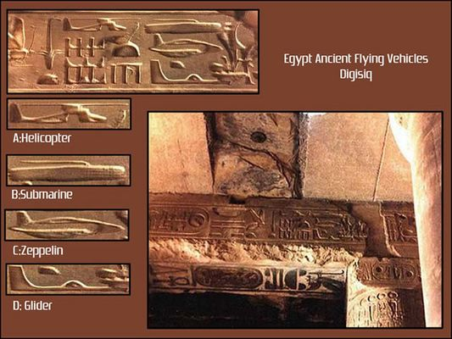

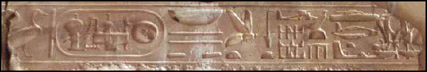

Excerpt: The Tablets are returned and Ninurta brings the offender to justice
To Nibru-ki he then returned, in its innermost chamber the Tablets were reinstalled.
Once again the brilliance therein returned, the hum of ME's in the Tablets was restored.
Before the Seven Who judge Anzu for a judgment was taken;
Enlil and Ninlil his spouse, Enki and his spouse Ninki, the one beforehand as Damkina known,
And the sons Nannar and Marduk were there; Ninmah also was in judging.
Ninurta of the evil deeds spoke: There was no justification, let death be the penalty! he said.
The Igigi by right were complaining, a rest place on Earth they do need! Marduk in counter
argued.
By his evil deed all the Anunnaki and Igigi Anzu did endanger! Enlil said.
Enki and Ninmah with Enlil agreed; the evil must be extinguished! they said.
To death by execution the seven judged Anzu;
With a killing ray Anzu's life breath was extinguished. Let his body to
the vultures be left! Ninurta said.
Let him on Lahmu be buried, in a cave next to Alalu be laid to rest! Enki was saying.
From the same ancestral seed the two of them were!
Let Marduk the body to Lahmu carry, let Marduk there as commander stay!
So was Enki to the judges suggesting. Let it so be! Enlil said.
(Is this series of events the first account of a "bounty hunter" on Earth?)

Anzu's execution left the Igigi subdued but the unrest was still brewing. The execution took place in the 25th Shar (3,600 x 25 = 90,000 years) Marduk is sent to Lahmu/Mars to keep an eye on the Igigi and to improve morale while Enki and Enlil concentrated on avoiding unrest on Earth. They agree that they were not rotating the heroes often enough. They ask Ninmah for counsel. When they saw that she had changed visage, which alarmed them both. They agree that gold shipments must be quicker to Nibiru.
Ninurta, who had knowledge of the innards of planets, chimed in and suggested that the gold be processed before sending it to Lahmu/Mars. It would make shipments lighter and save space on the chariots. That way they could "kill 2 birds with 1 stone". To get those results he suggested establishing a Metal City for smelting and refining the gold. They consult with Anu regarding Ninurta's plan and it is approved.
The build the Metal City with materials from Nibiru and equipped it with tools from Nibiru. (In previous instances rocketships, skyships, tools, and mining equipment were brought to Earth. Now materials and more tools are brought from Nibiru. Is this proof that the Nibirians had factories on Nibiru at that time?) Ninurta was assigned as the commander of the new Metal City, called Bad-Tibira, and the flow of gold increased. It took 3 Shars to build Bad-Tibira. (3,600 x 28 = 100,800 years)

At that time the "old heads" were being replace on Earth with the next generation. Among the "old heads" were Alalgar, Abgal, and Nungal. The young crew had no idea what they were getting themselves into and didn't know about what happened to their planet in Prior Times that required the Nibirians to be there. (PUMP THE BREAKS! Does this sound familiar? The parents not informing the children of their true history.) The young ones were excited about coming to Earth and cherished the adventure.
Gold shipments had increased and everything was running smoothly as Ninurta had planned. However, what was not expected was the unrest of the newcomers who worked in the Abzu. Enki was paying attention to other matters. He had his mind on differences between Nibiru and Earth and what was the cause of illnesses caused by Earth's cycles and atmosphere. Enki set up a study place, called House of Life, and furnished it with all manner of tools and equipment. Then he invites Ningishzidda to join him.

Excerpt: Enki and Ningishzidda "at the lab"
Sacred Formulas, tiny ME's, the secrets of life and death possessing they shaped,
(Is this a description of cylinder seals or clay tablets?) Link to View Cylinder Seals

Link to Image
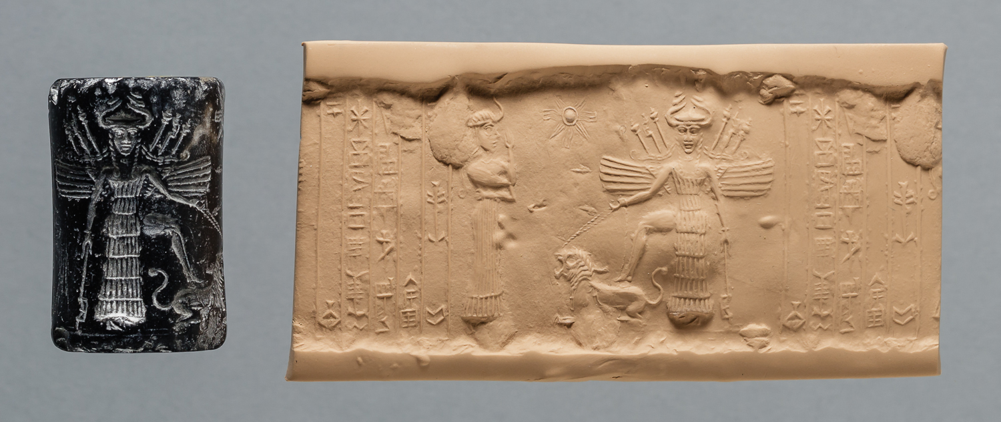

The mysteries of living and dying of Earth's creatures they to unravel sought.
With some living creatures Enki was especially enamored;
They lived among the tall trees, their front legs as hands they were using.
In the tall grasses of the steppes odd creatures were seen; erect they seemed to be walking.
Is this creature a chimpanzee, or a orangutan, or a gorilla, or a "bigfoot"?
Absorbed was Enki in those studies; what was among the Anunnaki brewing he noticed not.

Ninurta was the first to notice there was a problem. The amount of gold brought to Bad-Tibira had decreased. Ninurta was dispatched to the Abzu to investigate, as Ennugi, the commander of the Abzu accompanied him. Ninurta heard the complaints with his own ears. He reports his findings to Enki.

Enlil is summoned to the Abzu and was stationed in a house near the gold mines. At that time the Anunnaki workers were getting hostile and were agitating one another to rebel. They set their tools on fire and seize Ennugi, the commander, and made their way to Enlil's house. It was night as they surrounded Enlil's house as they held their burning tools up as torches. (Is this the first account of a lynch mob on Earth?) Kalkal, the gate guard, rushes in the house and awakes Nusku, Enlil's vizier (advisor), and Nusku goes in and tells Enlil the house has been surrounded by Anunnaki ready to battle. Enlil then summoned Enki and Ninurta and ask them "Is this hostility toward me?". He then asks the mob who instigated the rebellion. They stand together and say that each one of them have declared hostilities because the work is a burden.

Enlil sends word to Anu telling what is going on. Anu asks what Enlil is being accused of and Enki explains to him that its the work and not Enlil that is the problem. Enki tells Anu how they have been complaining on a daily basis. Anu tells Enki that the work must continue.
Enlil tells the Anunnaki to release Ennugi so that they can discuss the situation, and they release him. Ennugi tells them that the work has become unbearable since the Earth's heat has been rising.
Ninurta suggests rotating the workers. Enlil suggests Enki make new tools that would avoid the need for the Anunnaki to go into the tunnels. Enki responds by saying "let us summon Ningishzidda, I wish to take counsel with him".

Excerpt: Enki and Ningishzidda reveal their secret plan
They summoned Ningishzidda, from the House of Life he came;
With him Enki huddled, words amongst them they exchanged.
A solution is possible! Enki was saying:
Let us create a Lulu, a Primitive Worker, the hardship work to take over,
Let the Being the toil of the Anunnaki carry on his back!
Astounded were the besieged leaders, speechless indeed they were.
Whoever heard of a Being afresh created, a worker who the Anunnaki's work can do?
They summoned Ninmah, one who of healing and succor was much knowing.
Enki's words to her they repeated: Whoever of such a thing heard? they her asked,
The task is unheard of! she to Enki said. All beings from a seed have descended,
One being from another over aeons did develop, none from nothing ever came!
How right you are my sister! Enki said, smiling.
A secret of the Abzu let me to you all reveal:
The Being that we need, it already exists!
All that we have to do is put on it the mark of our essence,
Thereby a Lulu, a Primitive Worker, shall be created! So did Enki to them say.
Let us hereby a decision make, a blessing to my plan give:
To create a Primitive Worker, by the mark of our essence to fashion him!

6th Tablet
Excerpt: Enki describes what he found roaming around in the Abzu
"Creatures in the Abzu there are, Enki was saying, that walk erect on two legs, Their forelegs they use as arms, with hands they are provided. Among the animals of the steppe they live. They know not dressing in garments
They eat plants with their mouths, they drink water from lake and ditch. Shaggy with hair is their whole body, their head hair is like a lion's; With gazelles they jostle, with teeming creatures in the waters they delight!"
Enlil is in disbelief, and Ninmah is thrilled to hear of Enki's discovery. Enki takes Enlil and Ninmah to the "House of Life" where some of the beings were kept in "strong" cages. At the sight of Enki and the others they jumped up and banged on the cage bars, grunting and snorting. There were males and females. Is this the 1st account of what we know as a prison, laboratory, circus freak show, or even a zoo on Earth? Is this creature a chimpanzee, or a orangutan, or a gorilla, or a "bigfoot"?

After Enki shows Enlil and Ninmah the being, he reveals that Ningishzidda, his son, has tested their Fashioning Essence (DNA), and says " akin to ours it is, like two serpents it is entwined".
Enki explains how he plans to mix the DNA of the Annunaki with that of the Being from the Abzu to create a worker to replace Nibirians. Enlil reminds Enki of 2 important things:
1) - "On our planet, slavery has long ago been abolished"
2) - "you wish to bring a new creature into being, creation in the hands of the Father of All Beginning alone is held"

Enlil is strongly against Enki's plan and is arguing back and forth with Enki and Ninmah. He reminds them of two important things again:
1) - "it is against the rules of planetary journeying, against the rules of coming to Earth
2) - "the purpose for coming to Earth was to obtain gold to save Nibiru, not to replace the Father of All Beginning"
Ninurta, the son of Enlil & Ninmah, sides with Enlil and suggests making better tools rather than creating another being, because they have the knowledge and experience. "With that which in our essence was granted, tools and chariots we have perfected,
Mountains with terror weapons we shattered, skies with gold we are healing!"

They decide to take the matter to their father, the King, Anu. Anu puts the matter before the council on Nibiru to make a decision. It was a bitter discussion of Life and Death, and finally, they say " let Anu forsake the rules of planetary journeys, let Nibiru be saved"

In the House of Life (Laboratory), in the Abzu, Enki is explaining to Ninmah how to create the Being. He directs her to a place among the trees, a place of cages. In the cages were odd creatures like no one had ever seen. They had foreparts of one kind, hindparts of another. (Is this a Zoo?)

After showing Ninmah the creatures at the place of cages, they return to the House of Life (Laboratory), to a "clean place with brightness shining they led her" (Is this the 1st account of an "operating/surgical room" on Earth?). Ningishzidda was explaining to her the life-essence secrets and how to combine the essence from two kinds. She replied, "the creatures in the tree cages are too odd, monstrous they are". Enki agrees with Ninmah's observation and tells her "that is why we need your help to attain perfection, you can tell us in which womb to begin conception and in which womb birth should be given, the understanding of a mother is required. (Reminding Ninmah of the 2 daughters she & Enki had, he is playing on her emotions)

In trying to determine the best way to create the Primitive Worker, Ninmah is studying the sacred formulas on the ME's, and consulting Ningishzidda on how this and that were done.

Enki and Ningishzidda had already conducted experiments with the beings he had "discovered" in the Abzu, which were unsuccessful, to create the Primitive Worker before they got permission from Nibiru to do the same.

Ninmah examines the creatures in the tree cages and thinks about it and determines that by a male inseminating a female the essences are transmitted. Two entwined strands (DNA) separate and combine to make an offspring. Her advice was to "let a male Annunaki impregnate a two-legged female". Enki replies, "we have already tried that, it resulted in failure, there was no conceiving, there was no birth". Genesis 1:26-31
Enki and Ningishzidda had already conducted experiments with the beings he had "discovered" in the Abzu, which were unsuccessful, to create the Primitive Worker, before they got permission from Nibiru to do the same. Ninmah says "another way must be found" and states that "that which from Earth is the portion that must not be harmed", "it must be shaped by receiving our essence in graduations from the ME formulas of Nibiru".

Ninmah places the ovum of a female two-legged creature in a "crystal" vessel and with the ME Annunaki seed she impregnates the ovum. There was conception. (Is this the first case of artificial insemination on Earth?)

They were anxious to see the results of their work. When the time came for birth, there was no birth. "In desperation Ninmah a cutting made, that which was conceived with tongs she drew out. A living being it was!" Enki and Ningishzidda were excited. Ninmah held the newborn in her hands, she was not excited at the results.
Is this the first case of C-Section (Cesarean Section) on Earth?

Breakdown of the problems with experiments:
Problems with experiment #1 (Crystal bowl fertilized/impregnated ovum and placed back into womb of 2-legged female):
a: shaggy hair all over, foreparts like Earth creatures, hindparts more like Annunaki
b: grew faster, taller (not in the image of Annunaki)
c: hands not suited for tools, speech was only grunting sounds

Problems with experiment #2 (Same procedure in crystal bowl) This one was more in likeness of Annunaki:
a: appealing looks, hands suited for tools
b: senses were deficient; deaf, bad eyesight
Ninmah conducted 7 more artificial inseminations in crystal bowl, still having problems:
1) paralyzed feet
2) semen was dripping
3) trembling hands
4) malfunctioning liver
5) hands too short to reach mouth
6) lungs not suited for breathing
7) After 6 attempts they were bewildered and Ninmah said "I must try once more".
Again the newborn was deficient.

After 9 experiments Enki had observed what was good and what was bad. He determined that it was not the admixture but the vessel. Instead of using Nibiru crystal, use clay of Earth/clay of the Abzu.

Problems with experiment #1 (Clay vessel):
The newborn was the image of perfection, growing faster than child on Nibiru
a: limbs were suited for the tasks, knew not speech (grunts, snorts)

Ninmah's observation after the 10th attempt was that each time the insemination was done on Earth female, perhaps in order to be in image and likeness of Annunaki, the fertilized ovum should be placed in the womb of Annunaki female. Who shall it be, taking the chance of carrying a monster in her belly? Enki was headed to ask his wife Ninki if she would volunteer, but Ninmah came to her senses and volunteered to be the first Annunaki female to be artificially inseminated. Her words "the admixtures were made by me, reward and endangerment should be mine."

Experiment #11 -- Annunaki insemination
Earth female ovum mixed with Annunaki male essence in a clay vessel. Ninmah conceived! They wondered if the term would be 9 Earth months or 9 Nibiru months. Somewhere between she gave birth to a male. Enki slapped his hindparts and the newborn uttered proper sounds. Ninmah named him Adamu. (Is this the first account of the "butt-slapping" procedure at birth?)

Examination of Adamu:
a: Ears good shape, eyes not clogged
b: Limbs proper; hindparts like legs; foreparts shaped like hands
c: Dark black head hair, not shaggy like the wild ones
d: Smooth skin, smooth as Annunaki skin and like DARK RED BLOOD in color (like the clay of the Abzu)
e: his malehood; had foreskin on it (this was odd to the Annunaki). Enki declared that this would distinguish Earthlings from Annunaki.

After the examination of Adamu, he began to cry. Ninmah drew him to her chest and began to breast feed. (Is this the origin of the "Black Madonna and Child"?)

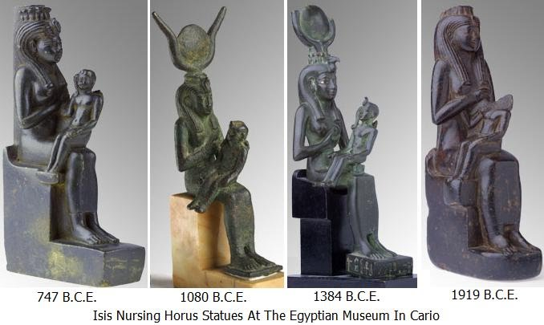

It is declared and decreed by Enki that Adamu would be the model to create Workers like him. However, Adamu would not be subject to working in the gold mines, like a Firstling, he would be protected. Ninmah is pleased at the decree.

Now they are pondering who will carry the fertilized ovums to create the Workers. Ninmah summons female healers from Shurubak, explains what is needed, and shows Adamu to them. She tells them that the task is not a commandment but a voluntary decision.

Seven Annunaki women volunteer to be artificially impregnated to create primitive workers after Ninmah/Ninhursag gave birth to Adamu -- One Who Like Earth's Clay Is.
This is the account of the seven volunteer Annunaki surrogates. Their names:
Ninimma
Shuzianna
Ninmada
Ninbara
Ninmug
Musardu
Ningunna

Ninmah conducts the procedure in 7 clay vessels with the essence of Adamu and the ovums of the 2-legged females. She cut his malepart to get a drop of his blood.
Ninmah/Ninhursag saying incantation as she was combining the admixture of the ovum of Earthlings and the life essence (DNA) as well as blood from the malepart of Adamu.
Ninmah's incantation:
"To a unity the 2 essences, one of Heaven, one of Earth, together be brought. That which is of Earth and that which is from Nibiru by a blood kinship shall be bonded." Ningishzidda recorded her words.
(Could this be the second account of VOODOOM OR VOODOO?)

Ninmah performs artificial insemination on the 7 volunteers and they give birth to 7 males. EVERYBODY IS EXCITED. Ningishzidda is saying, let the procedure be repeated and create 7 more to toil (work the gold mines). Enki interrupts the excitement and says "not 7 by 7 will be sufficient. it is too much to require of the volunteers. Ninmah agrees. Enki says "we have to fashion Female ones for the male counterparts, and let them procreate and give birth to Primitive Workers, thereby relieving Annunaki females"
After Ningishzidda advises Enki and Ninmah on what to do to create the female counterparts, Enki looks at Ninmah. Before she can say anything, he raises his hand and says, "let me summon Ninki, my spouse". They summon Ninki, show her Adamu and explain everything. Ninki is fascinated and agrees to volunteer for the procedure. This time, Enki performed the procedure on his spouse, Ninki.

This is the 2nd account of what we call C- Section: Ninmah performed it on Ninki in the 10th month as she had volunteered to be the surrogate for the female version of the 7 males who were previously created. (This time, Ninmah wore a head covering and gloves as she performed the procedure, and she did not use tongs.) Ninki named her Ti-Amat, the Mother of Life.

Examination of Ti-Amat (BORN by C-SECTION):
a: Ears good shape, eyes not clogged
b: Limbs proper; hindparts like legs; foreparts shaped like hands
c: Head hair like BEACH SANDS in color, not shaggy like the wild ones
d: Smooth skin, smooth as Annunaki skin and like DARK RED BLOOD in color (like the clay of the Abzu)
e: when slapped on her hindparts, the newborn uttered proper sounds

The life essence of Ti-Amat was mixed with the ovums of 7 2-legged females in clay vessels to create 7 counterparts for the 7 males that were created.
They made cages for the 7 and 7 and placed them among the trees. (Could this be another description of what we know as a ZOO, or is it a "breeding farm"?) Take note of the number of sunrays (14) in the images below. Is there a connection to these events that haven't been discussed or is it a connection that's been ignored? Just curios!!!

Link to Image
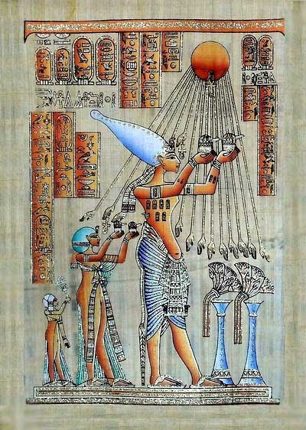

Link to Image | Link to Image
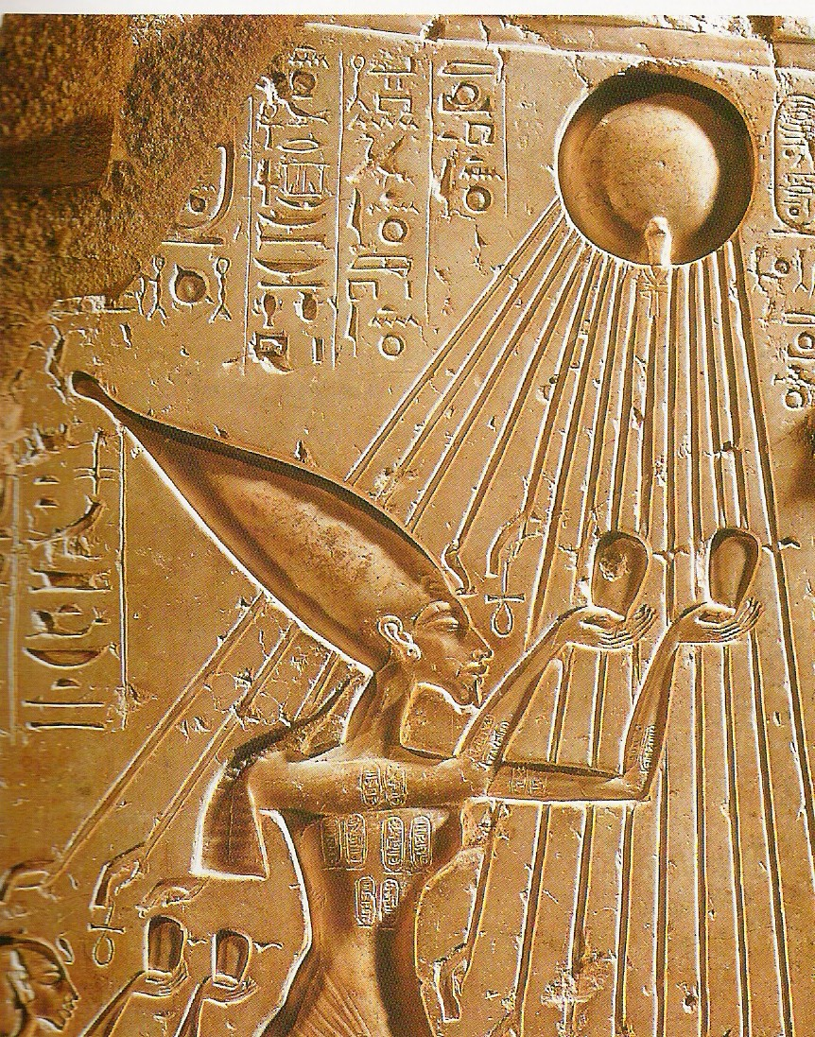 | 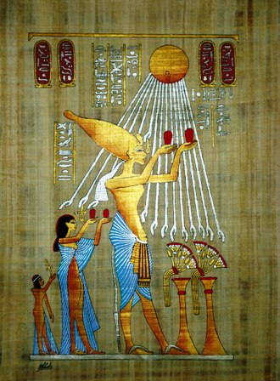

Link to Image
This image of the sun has 19 sunrays. Is this a representation of 19 universes?
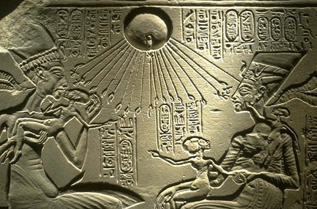
Link to Image
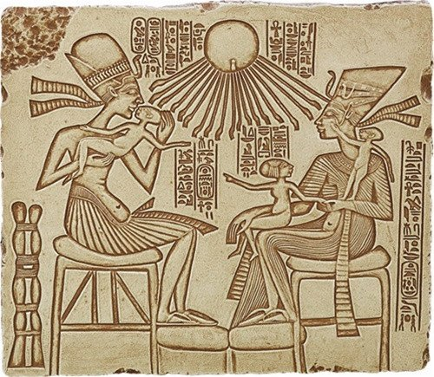
Akhenaton, Nefertiti, and Daughters Egyptian Portrait Relief

Everybody came to Eridu (in the Edin the city of Enki) to see Adamu & Ti-Amat. The Annunaki from the Landing Place, Enlil (his displeasure at the idea diminished when he saw them), Ninurta, Ninlil, Marduk came down from Mars way station to see.
(Could this be the 1st description of what we know as a sanctuary?)
The Igigi (Watchers) were very eager and excited to hear and see the models of the primitive workers - "agog"
"Our days of toil to end", they were saying.

After the "seven" and "seven" were created there was no conception and no birth-giving. Ningishzidda makes a couch of grass for himself and sat there day and night watching them. They were mating but not conceiving.
Ningishzidda separates the DNA of Adamu and Ti-Amat, who could not procreate.
The 23rd strand of DNA, procreation, was missing. Also 2 other bits or strands were missing that was present in Annunaki essence, one male and one female. (Does this represent 24 or 25 strands of DNA?) Ningishzidda performs this procedure at The House of Healing (is this a hospital?)
At this point Enki is very uneasy and anxious because he is wary of the situation of the workers in the gold mines.

Ningishzidda whispers to Enki and Ninmah and Ninmah sends all the women away that she was assisting.
(Why was Ninmah tending to just women and not both women and men?) Link to Credo Mutwa Video

Link to Map
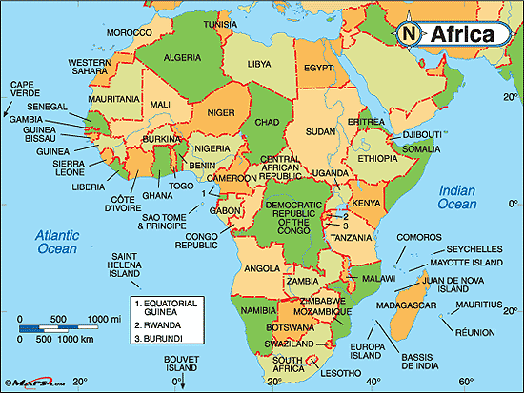
Link to Map
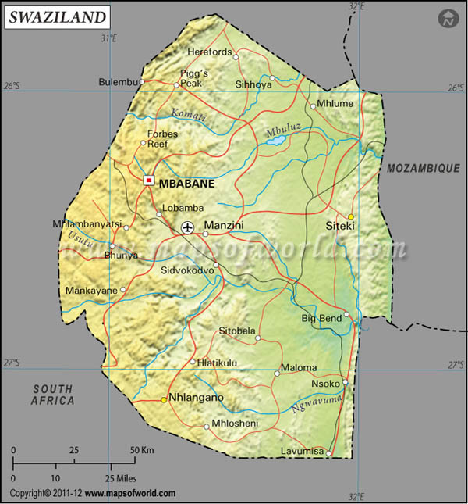

Link to Map
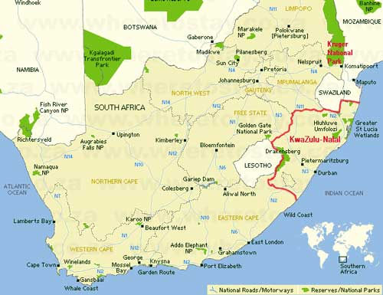
Link to Map
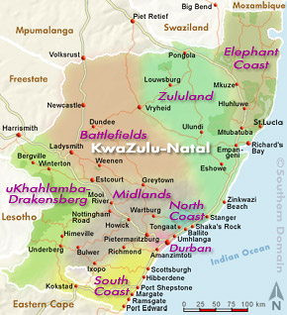

Link to Images
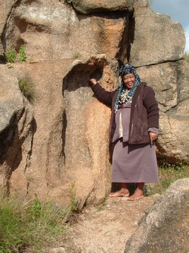 | 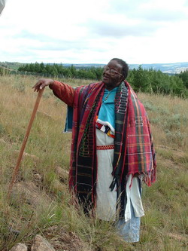

Ningishzidda put the 2 Earthlings, Enki, and Ninmah in a deep sleep, and in a state of numbness. Then he extracted the life essence of Enki and Ninmah from their rib and inserted it into the ribs of the male and female Earthlings.
After the rib procedure Adamu and Ti-Amat were placed in the Edin to roam freely. They become aware of their nakedness and Ti-Amat makes aprons for themselves. Enlil is angry when he sees Adamu and Ti-Amat wearing aprons. (Is this the account in the Bible when YHWH was walking in the garden in the cool of the day and asked Adam, where are you?) Genesis 2:18-25 A closer look -- Genesis 1:26-31
Enlil is livid when he finds out that they gave Adamu and Ti-Amat the ability to procreate. Ningishzidda tries to calm him down by telling him that procreation is the only thing they added, and assured him that they did not give them the "branch of Long Living". He "chews out" Enki, blames him for everything, and expelled Adamu and Ti-Amat from the Edin and to the Abzu where Enki placed them in an enclosure and left them to freely know (procreate/have sex) each other. (Could an increased life cycle be the 25th or 26th strand of DNA?)
In the reliefs below, the object that looks like a flower is referred to as the tree of life and is actually a date palm.

Link#1 to Date Palm Info Link#2 to Date Palm Info

Link to Images - Tree of Life or Date Tree?
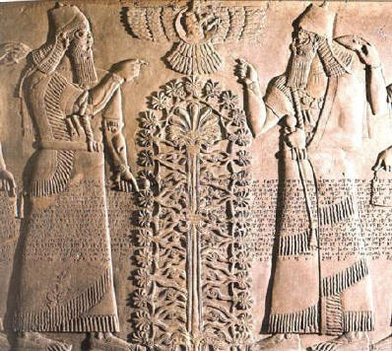 | 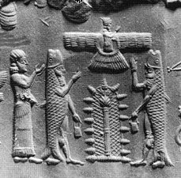
 | Link to Image & Info
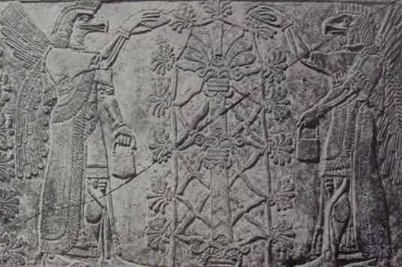 | 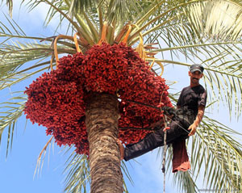
Link to Image & Info | Link to Image & Info
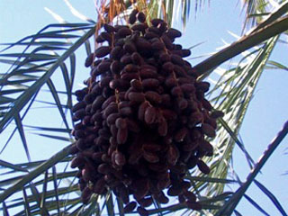 | 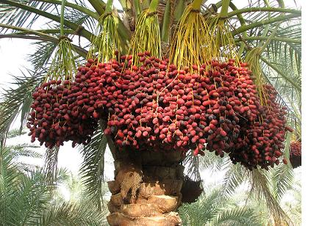
Link to Image & Info | Link to Image & Info
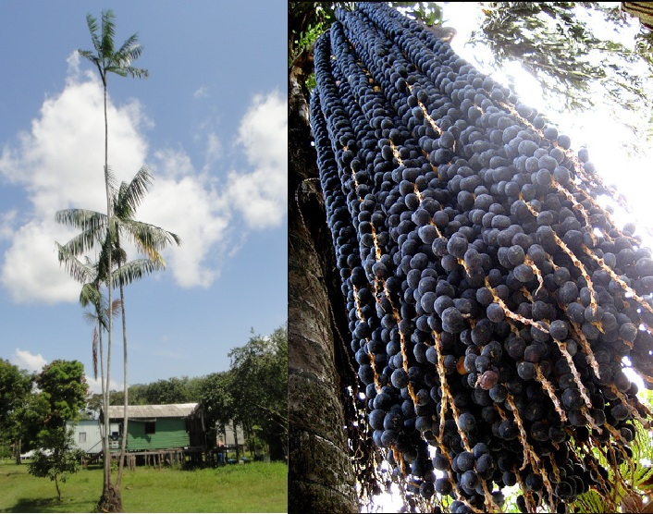 | 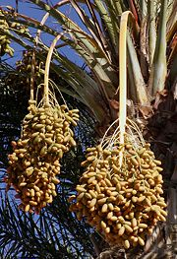

7th Tablet
The Primitive Workers were intelligent and comprehended commandments. "Everything" was going good. They were eager to be with the Annunaki and toiled well for food rations.
(Is this the origin of panhandling "will work for food" concept?)
The Earthlings were proliferating and the Annunaki were espousing and procreating. The life cycles of Annunaki were quickened by Earth's cycles. (In other words the Annunaki were aging faster than they would on Nibiru.)
Nannar & Ningal birthed a daughter and a son, Inanna, Utu. They were the progenitors of the Annunaki 3rd generation on Earth.

During the time of Inanna & Utu, the 3rd generation on Earth, several things were happening:
1) Earth was warming up
2) volcanoes were erupting
3) earthquakes
In the Lower World, the snow white-hued place (Is this Antarctica?) , the Earth was grumbling
In response to these events, Enki established a place for observing at the tip of the Abzu and entrusted command of it to his son Nergal & his spouse Ereshkigal ( Is this the first account of what we know as an observatory?). Nergal had no idea what was happening.
Also, in Nibru-ki, the place of the Bond Heaven-Earth, Enlil was watching and comparing the celestial motions to the ME's of the Tablets of Destinies. He tells Enki, "there is turmoil in the heavens!"
4) Dust storms on Lahmu/Mars as reported by Marduk to Enki
5) brimstones (comets, meteors, etc.) were falling upon the Earth (causing darkness on a clear day), Kingu (the Moon), and Lahmu/Mars. Enlil & Enki beamed a message to Anu
saying "the Earth & Moon & Lahmu are facing an unknown calamity"
6) the family of the Sun were taking stations
7) the celestials of whom Earth is 7th were choosing places in a row
NIBIRU IS APPROACHING!!
As Nibiru was returning to its distant abode, the heavenly havoc was calmed. The stony missiles ceased raining upon the Earth and Lahmu.
Next, Enki & Enlil with Marduk & Ninurta surveyed the damage.
Enki surveyed the foundations of the Earth. He measured the depth of the oceans and scanned the mountains of gold and copper in Earth's far corners. (Are these descriptions characteristics of a "flat" Earth?) Enki's survey determined that there would be no shortage of gold.
In the Edin, Ninurta was the surveyor. The Landing Platform was intact (is this proof that Annunaki constructions were/are earthquake proof?); fiery liquids(lava) was pouring in the valleys of the north as Ninurta was discovering sulfuric mists and bitumens (a black viscous mixture of hydrocarbons obtained naturally or as a residue from petroleum distillation. It is used for road surfacing and roofing.)

80 Shars, time elapsed since first splashdown of the Annunaki on the mission to mine gold (80 x 3600 = 288,000) 288,000 years the mission lasted before they had to make adjustments to include some of the original plans. Could this be the 1st account of timekeeping other than pregnancy terms during the creation experiments?

After the calamity Marduk told Enki he wanted to return to Earth. Enlil showed them the original plans, on crystal tablet, of the spaceport to be built in the Edin, near Bad-Tibira (Metal City, place where the gold ores are smelted and refined), where gold would be transported from Earth directly to Nibiru.

Enki agreed with Enlil's plan but pointed out a problem with it. The problem was the fact that Earth's gravitational pull was greater than that of the moon, which would cause the ships to expend more energy enroute to Nibiru. Before rushing a decision on the matter they agreed to examine an alternative, the Moon, which has a lesser gravitational pull than Earth, which would require little effort to ascend and descend to Nibiru. This is possible new way station. Now you have Enlil wanting the way station to built at Bad-Tibira and Enki wanting it to be built on the Moon.

Enlil and Enki sends (beams) the two plans to Anu who puts them before the counselors and savants to consider, and beams back to Enlil and Enki to "let the Moon be first examined". Enki was happy about the decision, for he was always fascinated by the Moon, and wished to uncover secrets it held from the Beginning. So, in a rocketship Enki & Marduk go to the Moon.

Enki & Marduk orbit the Moon 3 times as they observed damage caused by the dragon. (Is this the origin of the epithet of Nibiru being called the "dragon"?) They land the rocketship in the midst of a place of rolling hills, and from there they could observe the Earth and the expanse of the heavens. They had to wear "Eagle's helmets" because the atmosphere was insufficient for breathing. With ease they walked about. (Does this mean there was no gravity on the moon?) The moon was dry and desolate, unsuitable for a way station. Marduk is ready to return to Earth. Enki persuades Marduk to stay to observe how the Moon circles the Earth and how the Earth circles the Sun. They made the rocketship their dwelling. For one circuit of Earth, for three circuits on the Moon they remained.

Enki & Marduk observations while on the Moon:
Its motions about the Earth they measured, the duration of a month they calculated. For six circuits of Earth, for twelve circuits about the Sun, Earth's year they measured. How the two were entwined, causing the luminaries to disappear, they recorded. Then to the Sun's quarter they attention gave, the paths of Mummu and Lahamu they studied. With the Earth and the Moon, Lahmu the Sun's second quarter constituted, Six were the celestials of the Lower Waters. So was Enki to Marduk explaining. Six were the celestials of the Upper Waters, beyond the bar, the Hammered Bracelet, they were: Anshar and Kishar, Anu and Nudimmud, Gaga and Nibiru; these were the six others, Twelve were they in all, of twelve did the Sun and its family make the count.

Marduk asks his father, Enki, about the recent upheavals/events they witnessed/experienced. Marduk asks why the 7 celestials "in a row have taken places" (why the 7 planets have aligned). Enki marked out the positions of Earth & Moon on a chart. By the motions (orbit) of Nibiru he outlined the width of the great band, and named it THE WAY OF ANU. By the circuit of the heavens, Enki drew images of 12 constellations and, in the Great Bank, he paired each one with Sun's family of 12. To each he designated a station and named them.(Is Enki creating what we know to be the Zodiac?) Below The Way Of Anu, where Nibiru approaches the Sun, Enki designed another bandlike way and calls it THE WAY OF ENKI, and allotted 12 constellations by their shapes. The heavens above the Way of Anu, the Upper Tier, THE WAY OF ENLIL he called, therein too the stars into twelve constellations he assembled. 36 were the stars' constellations, in the Three Ways were they located. So will the Earth's position designated as around the Sun it travels!

Link to Diagram
The numbers given for the Way of Enlil are so paired as to show that this Sumerian segment of the northern skies stretched over 60 degrees from the North Pole, bordering on the Way of Anu at 30 degrees above the equator. The Way of Anu was equidistant on both sides of the equator, reaching to 30 degrees south below the equator.
Then, farther south and farthest away from the North Pole, lay the Way of Ea - that part of Earth and of the celestial globe that lay between 30 degrees south and the South Pole.

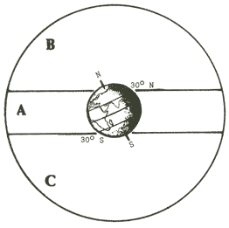
A. The Way of Anu, the celestial band of the Sun, planets and the constellations of the Zodiac
B. The way of Enlil, the northern skies
C. The Way of Ea, the southern skies

Link to Image
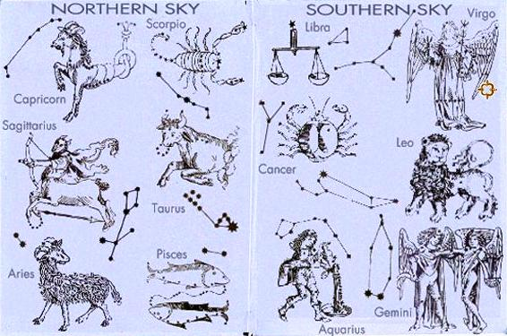

Enki explains to Marduk how time was being measured. When Enki came to earth it was the end of the Station of the Fishes (Pisces on the Zodiac) called by Enki, He of the Water.

Following the shared knowledge, Father to Son, Enki to Marduk, an even deeper conversation occurs between Enki and Marduk when Enki tells Marduk to extend his own teachings and understanding:
Marduk:
But on Earth and on Nibiru, knowledge and rulership are separated! So did Marduk to his father say.
Enki:
My son! My son! What is that you do not know, what is it that you are missing? to him Enki was
saying.
The secrets of the heavens, the secrets of the Earth with you have I shared!
Marduk:
Alas, my father! Marduk was saying. There was agony in his voice.
When the Anunnaki in the Abzu the toil ceased and the Primitive Worker you set to fashion,
Not my mother but Ninmah, the mother of Ninurta, to assist you was summoned,
Not I but Ningishzidda, of me the younger, to help you was invited,
With them, not with me, your knowledge of life and death did you share!
Enki:
My son! Enki to Marduk responded. To you command was given of the Igigi and Lahmu to be
supreme!
Marduk:
Alas, my father! to him Marduk was saying. Of supremacy by fate we are deprived!
You, my father, are Anu's Firstborn; yet Enlil, not you, is the Legal Heir;
You, my father, were first to splash down and Eridu establish,
Yet Eridu is in Enlil's domain, yours is in the distant Abzu.
I am your Firstborn, by your legitimate spouse on Nibiru was I born,
Yet the gold in the city of Ninurta is assembled, therefrom to send or to withhold,
The survival of Nibiru is in his hands, in my hands it is not.
Now to Earth we are returning; what will my task be,
Am I to fame and kingship fated, or again to humiliated be?
Enki:
In silence did Enki embrace his son, on the desolate Moon to him a promise made:
Of that of which I have been deprived your future lot shall be!
Your celestial time will come, a station mine adjoining yours shall be!(Keep eye out for Zodiac sign next to Pisces, Aquarius or Aries?)

While Enki and Marduk are having a time on the Moon, Enlil is communicating with Anu and letting him know that Enki and Marduk have been gone to the Moon for countless circuits and he doesn't know what they are up to. Meanwhile, on Earth, no plans are being implemented and on Mars the Igigi were in turmoil. He's telling Anu that the Way Station on Mars has been abandoned by Marduk and the Igigi are eager to hear and/or see what is going on. Dust storms have damaged the Way Station and no one on Earth knows how much damage there is. The Place of the Chariots (Spaceport) in the Edin must be established, Enlil says to Anu.
Enlil is trying to persuade Anu to go ahead with the Spaceport in the Edin, near Bad-Tibira, and assign Ninurta, Enlil's son, as first commander. Anu considered his words and tells Enlil that Marduk and Enki are headed back to Earth.(how did he know that?) Anu also tells Enlil that they must first take into consideration the findings of Enki & Marduk regarding the Moon. When they return to Earth they report conditions on the Moon and determined that a way station on the Moon is unfeasible. Anu then gives the approval of building the PLACE OF THE CHARIOTS.

Enki wants Marduk to be commander of the new spaceport (Gateway to Heaven) and Enlil wants Ninurta to be the commander. Anu sees this creating a rivalry between his sons and decides that the 3rd Generation would command the new spaceport. Anu designated Utu as commander, Sippar (Bird City) is the name and location where it would be built.

Construction started in the 81st Shar, following the plans of Enlil. Nibru-ki was in the center, a Navel of the Earth by Enlil it was designated,
As on circles by their place and distances the olden cities were located,
Like an arrow from the Lower Sea toward the mountains pointing they were arrayed.
A line on the twin peaks of Arrata (Mt. Ararat), to the skies in the north reaching, he drew,
Where the pointing arrow the Arrata line intersected,
The place for Sippar, the Earth's Place of the Chariots, he marked out;
To it the arrow directly led, it from Nibru-ki was by an equal circle precisely located! Sippar is completed in the 82nd Shar (82 x 3600 = 295,200 Annunaki years on Earth).

Link to Diagram
Utu is initiated as commander of Sippar (spaceport) and is given his Eagle's helmet and decorated with Eagle's wings. ( Is this the origin of wings on the uniforms of pilots or ranks of those military branches such as Air Force?)

Link to Pictures of Artifacts and More | Link to Image
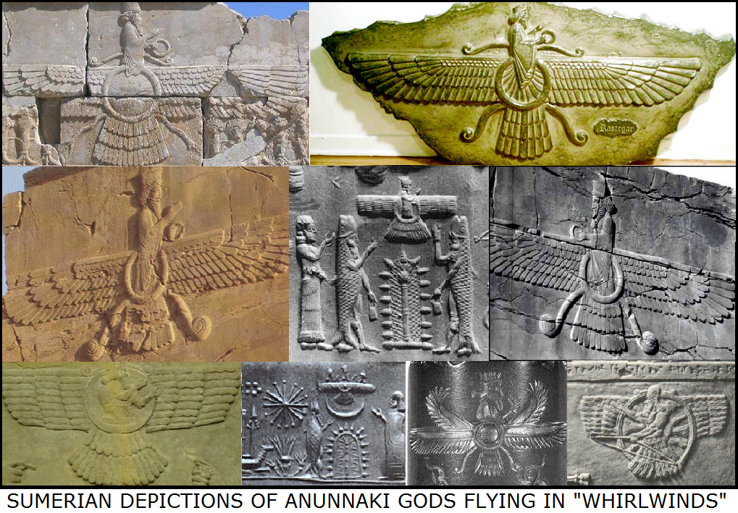 | 

Link to Image
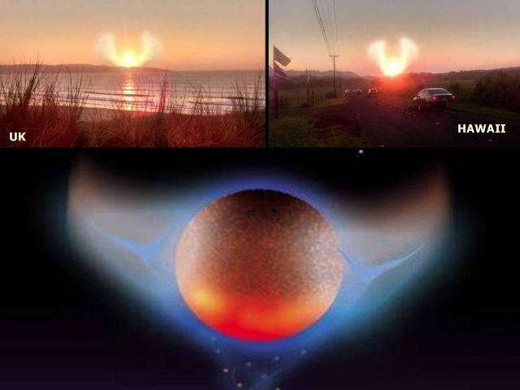

Link to View More Patches OR Link on each Patch
 |  |  | 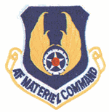

They had a celebration, and Anunitu, Enlil's granddaughter, singing and dancing presented manna for Anu. (Is this the origin of manna mentioned in the bible?) Anu promises the assembled that as there is enough gold stored on Nibiru, they can return home. Anu then returns to Nibiru carrying pure gold.
Link #1 to Anunitu Info Link #2 to Anunitu Info
(The ancient Mesopotamians called the powder 'shem-an-na' (highward fire-stone) and the Egyptians described it as 'mfkzt', while the Alexandrians venerated it as the Paradise Stone. Manna is mentioned 19 times in the Bible: 5 times in Exodus 16:15, 31, 33, & 35 twice; 3 times in Numbers 11:6, 7, & 9; 2 times in Deuteronomy 8:3 & 16; 2 times in Joshua 5:12 twice; 1 time in Nehemiah 9:20; 1 time in Psalms 78:24; 3 times in John 6:31, 49, & 58; 1 time in Hebrews 9:4; 1 time in Revelation 2:17)

Link to Manna in Exodus Link to Manna in Numbers Link to Manna in Deuteronomy
Link to Manna in Joshua Link to Manna in Nehemiah Link to Manna in Psalms
Link to Manna in John Link to Manna in Hebrews Link to Manna in Revelation

Link #1 to Info on Manna Link #2 to Info on Manna Link #3 to Info on Manna

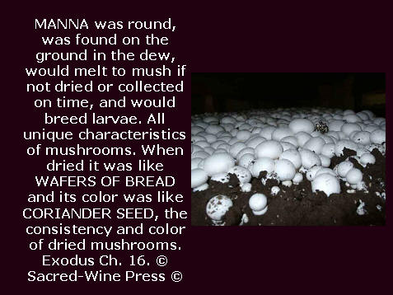  manna #1 | 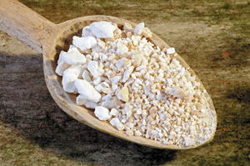  manna #2 | 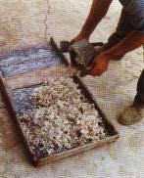  manna #3 | 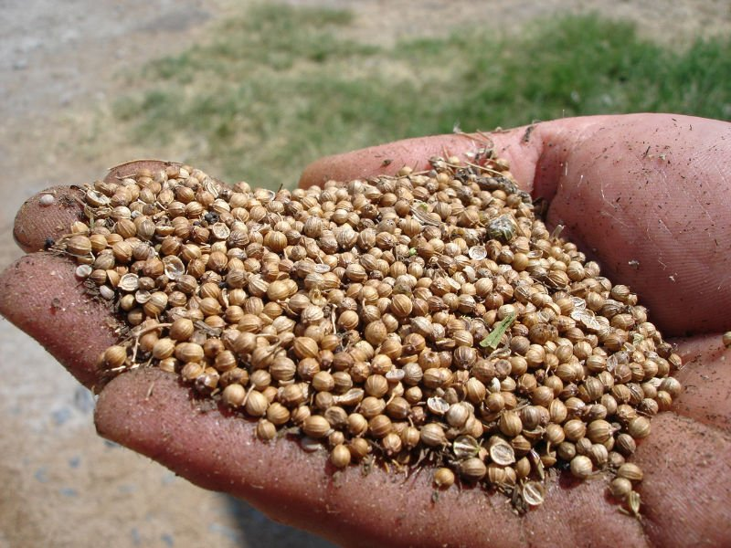  manna #4

Ninurta retained command of Bad-Tibira (Metal City) and Utu was commander of the Igigi, some on Mars, some on Earth. Now, Marduk has no assignment. He did not return to Lahmu, neither did he go to the Abzu with his father Enki. He wished to roam over all the lands, in his skyship, to comprehend the Earth.

Annunaki heroes were complaining because primitive workers were confined to the Abzu and they wanted and needed help in the Edin. "For forty Shars was relief only to the Abzu provided! The heroes in the Edin shouted, Our toil has increased beyond endurance, let us have the Workers too!" (40 x 3,600 = 144,000 144,000/50 = 2,880)[Did the heroes in the Edin miss 2,880 Jubilees by not getting any relief from their toils?]
Ninurta took matters in his own hands and led 50 heroes on an armed kidnapping expedition to bring some of the Earthlings to the Edin to help them with their work. This angered both Enlil and Enki.
Enlil tells Ninurta that he has overturned his expulsion of Adamu and Ti-Amat from the Edin. Enlil tells his father, what happened in the Abzu will not happen in the Edin, and after a few more Shars it won't matter, in hopes that the mission will be complete and they will return to Nibiru.

In the Edin, the Anunnaki were impressed with the intelligence and understanding of commands possessed by the Earthlings. They took over all manner of chores, and performed all tasks unclothed. They were constantly mating and quickly proliferating. In a 3600-year period (Shar) the earthlings were growing in numbers 4 or more generations. The Earthlings were growing in numbers so rapidly that there was becoming a food shortage for the Annunaki. Even though there was a shortage, the Earthlings would forage for food.

After Enlil in angry words tells Enki that everything is his fault and he must find a solution. Enki has a scheme to create a Civilized Man, but is not certain on how to make it happen. He is observing the offspring of the Earthlings and notices that they are regressing back toward their wild forebearers. "By their repeated copulations, back toward their wild forebears they were degraded!" Yet another problem with the experiments. "What by the life essence has not been combined?" was the question he pondered.

Excerpt: Enki is on the prowl
Enki in the marshlands looked about, on the rivers he sailed and observed;
With him was only Isimud, his vizier, who secrets kept.
On the river's bank, bathing and frolicking Earthlings he noticed;
Two females among them were wild with beauty, firm were their breasts.
Their sight the phallus of Enki caused to water, a burning desire he had.
Shall I not kiss the young ones? Enki his vizier Isimud was asking.
I the boat will hither row, kiss the young ones! Isimud to Enki was saying.
The boat thereto Isimud directed, from the boat to dry land Enki stepped.
A young one to him Enki called, a tree fruit she to him offered.
Enki bent down, the young one lie embraced, on her lips he kissed her;
Sweet were her lips, firm with ripeness were her breasts.
Into her womb he poured his semen, in a mating he knew her.
Into her womb she took the holy semen, by the semen of the lord Enki she was impregnated.

The second young one to him Enki called, berries from the field she him offered.
Enki bent down, the young one he embraced, on her lips he kissed her;
Sweet were her lips, firm with ripeness were her breasts.
Into her womb he poured his semen, in a mating he knew her.
Into her womb she took the holy semen, by the semen of the lord Enki she was impregnated.
(Is the offering of tree fruit and berries by the earthling females the origin of the concept of Satan and Eve and the forbidden fruit?)
After impregnating 2 earthlings, Enki instructed his vizier (advisor), Isimud, to stay with them to see if they were indeed pregnant and witness the children born.

Excerpt: Isimud witness the births
Isimud by the young ones sat down; by the fourth count their bulges appeared.
By the tenth count, the ninth having been completed,
The first young one squatted and birth gave, by her a male child was born;
The second young one squatted and birth gave, by her a female child was born.

Link to Info on Squatting During Birth
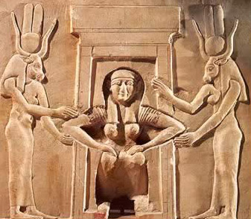  A squatting woman giving birth, assisted by two goddesses (Hathor and Taweret), from the Temple of Hathor at Dendera | 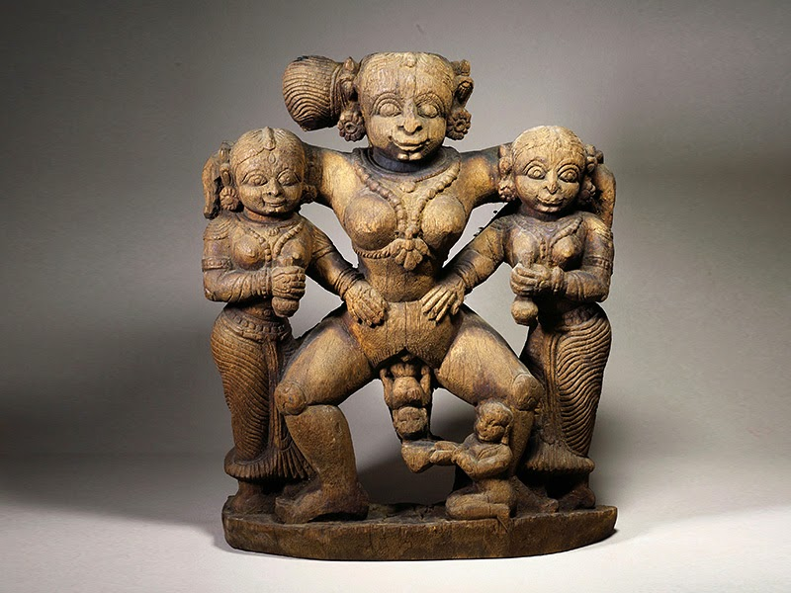  In this South Indian carving, for example, a woman gives birth in a standing squat, holding on to women on each side of her. The midwife's size below shows her relative unimportance in the artist's mind compared to the mother. Notice that the mother is shown as the largest and most powerful figure in the carving, probably as a commentary on the power of the birthing woman.
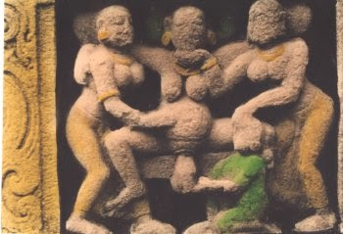  In this carving from ancient Egypt, the mother also gives birth while holding onto attendants on either side. She uses a stool for stability but her position is very much a supported squat. | 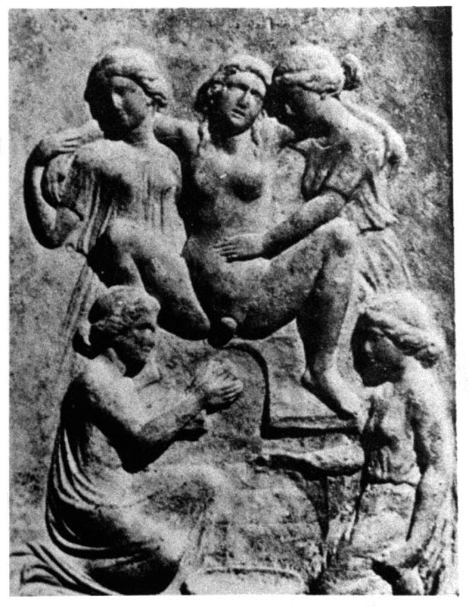  In this ancient Greek relief, a woman is shown squatting on a birth stool with arms around helpers on each side while the midwife catches the baby from below.

The Gracious Ones, Dawn and Dusk, (known in legends), because they were born on the same day, one at dawn and one at dusk. They were born in the 93rd Shar (93 x 3600 = 334,800 years on Earth). The children Enki fathered by two earthlings were kept secret by he and his vizier. Enki had brought forth CIVILIZED MAN. They would say they found them among bulrushes in reed baskets.
Isimud brings the news to Enki that the 2 births were completed. Enki was ecstatic saying "I have brought Civilized Man into being!" Then Enki instructs Isimud to let the mothers nurture the newborns then bring them to his household. Also, tell everyone you found them among the bulrushes in reed baskets.
Ninki took a liking to the newborns and raised them as her own children. They were unlike all other Earthling children. They grew up slower, were quicker in understanding, endowed with intelligence, capable of speaking words. (Is this the 1st account of an adoption on Earth? This is the first time that newborns were recognized as children. Is this evidence of discrimination or are artificially inseminated births considered creation of monsters?)
Ninki names the children:
Adapa - the Foundling (HBE)
Titi - One with Life (HBE)
Children fathered by Enki with two young earthling females

Special Note: Throughout the text (HBE) will represent "half-blooded" Anunnaki born on Earth

Enki taught Adapa record keeping
Ninki, his spouse, taught Titi all manner of crafts
Enki called them Civilized Man

Name Chart #1
Line of An (1st King on Nibiru) and his Spouse An.Tu - 3 sons: An.Ki, An.Ib, & Enuru
An.Ki  Brother to An.Ib & Enuru | An.Ib  Brother to An.Ki & Enuru  Father of An.Shar.Gal with spouse Nin.Ib  Uncle to Enama  Great Uncle to Anu | Enuru  Brother to An.Ki & An.Ib  Father of Enama with spouse Ninuru  Uncle to An.Shar.Gal  Great Uncle to Alam  Great, Great Uncle to Alalu
(NO SONS) | An.Shar.Gal  Grandson to An & An.Tu  Son of An.Ib  Father of Alam with concubine  Nephew to Enuru  1st Cousin to Enama  2nd Cousin to Anu | Enama  Grandson to An & An.Tu  Son of Enuru  Father of Anu with half-sister  Nephew to An.Ib  1st Cousin to An.Shar.Gal  2nd Cousin to Alam  3rd Cousin to Alalu
 | Alam  Great Grandson to An & An.Tu  Grandson of An.Ib  Son of An.Shar.Gal  Father of Alalu  2nd Cousin to Enama  3rd Cousin to Anu | Anu  Great Grandson to An & An.Tu  Grandson to Enuru  Son of Enama  Father of Enlil & Enki with spouse Antu  Great Nephew to An.Ib  2nd Cousin to An.Shar.Gal  3rd Cousin to Alam  4th Cousin to Alalu
 | Alalu  Great, Great Grandson to An & An.Tu  Great Grandson to An.Ib  Grandson to An.Shar.Gal  Son of Alam  4th Cousin to Anu  5th Cousin to Enlil & Enki  (NO SONS) | Enlil - Son of Anu & Antu; Legal Heir  Enki - Son of Anu & Ninlul; Firstborn son with a concubine  Great, Great Grandsons to An & An.Tu  Great Grandsons to Enuru  Grandsons to Enama

Here's where we need to resume the name chart: Name Chart #3 -- More children born on Earth -- Enlil gains 2 grandchildren, the experiments begin, & Enki's family stretches down to Enshi/Enosh/Enos
(FBN) = Full-Blooded Nibirian, born on Nibiru (FBNE) = Full-Blooded Nibirian, born on Earth
(HBE) = Half-Blooded, born on Earth (FBM) = Full-Blooded Mankind
After Sati/Seth, 3rd son of Adapa & Titi, color change of names represents a child of that descendant
^{1, 2, .....} = generations down from parents

More children on Earth by Enki, Enlil, Ninmah and their children
E.A/Ea/Nudimmud/Enki (Nibiru)  Damkina/Ninmah/Ninki his spouse  Son of Anu with Ninlul  Grandson to Enama  Great Grandson to Enuru  2X Great Grandson to An & An.Tu  Half-Brother to Enlil & Ninmah  Son-in-law to Alalu  5th cousin to Alalu  6th cousin to Ninmah  Father of Adamu & Ti-Amat using artificial insemination  Grandfather to the 7 males and 7 females  Father of Adapa & Titi  Grandfather to Enshi | Enlil (Nibiru)  Ninlil/Sud his spouse  Son of Anu & Antu; Legal Heir  Grandson to Enama  Great Grandson to Enuru  2X Great Grandson to An & An.Tu  Half-Brother to Enki & Ninmah  Uncle to Marduk, 2 unknown daughters of Enki, Nergal, Gibil, Ninagal, Ningishzidda, Dumuzi  5th cousin to Alalu  6th cousin to Ninmah  Uncle to Adamu & Ti-Amat  Uncle to Adapa & Titi  Grandfather to Inanna & Utu  2X Great Uncle to Enshi | Ninmah (Nibiru)  Biological daughter of Alalu & Namma?/ Nammu?  Royal Stepdaughter to Anu  Step-Granddaughter To Enama  Great Step-Granddaughter  to Enuru  2X Great Step-Granddaughter to An & An.Tu  5th cousin to Anu  6th cousin to Enki & Enlil  Half -Sister to Enki & Enlil  Mother of Marduk  Mother of Ninurta  Alalu's Line  Granddaughter To Alam  Great Granddaughter To An.Shar.Gal  2X Great Granddaughter To An.Ib  3X Great Granddaughter to An & An.Tu  Experiments  Surrogate Mother of Adamu  Aunt to 7 males
Marduk¹ (FBN)  Son of Enki with spouse Damkina/Ninmah/Ninki  Grandson to Anu & Antu  Great Grandson to Enama  2X Great Grandson to Enuru  3X Great Grandson to An & An.Tu  Nephew to Enlil  1st cousin to Ninurta, Nannar, Ishkur  2nd cousin to Inanna & Utu  6th cousin to Alalu  7th cousin to Ninmah  Half - Brother to Adamu  Uncle to Adamu blood 7 males  Half - Brother to Adapa & Titi  Uncle to Ka-In/Cain, Abael/Abel, & Sati/Seth  Great Uncle to Enshi | Ninurta¹ (FBN)  Son of Enlil with Ninmah  Grandson to Anu & Antu  Great Grandson to Enama  2X Great Grandson to Enuru  3X Great Grandson to An & An.Tu  Nephew to Enki  Uncle to Inanna & Utu  1st cousin to Marduk, 2 unknown daughters of Enki, Nergal, Gibil, Ninagal, Ningishzidda, Dumuzi  6th cousin to Alalu  7th cousin to Ninmah  1st cousin to Adamu  2nd cousin to Adamu blood 7 males  1st cousin to Adapa & Titi  2nd cousin to Ka-In/Cain, Abael/Abel, & Sati/Seth  3rd cousin to Enshi | Adamu (HBE)  (artificial insemination using Enki's blood/DNA)  Surrogate son of Ninmah  Half-Brother to Marduk, 2 unknown daughters of Enki, Nergal, Gibil, Ninagal, Ningishzidda, Dumuzi  1st cousin to Ninurta, Nannar, Ishkur  Half - Brother to Adapa & Titi  Uncle to Ka-In/Cain, Abael/Abel, & Sati/Seth
2 daughters² with Ninmah, names unknown
(FBNE)
Daughters to Enki with Ninmah
Granddaughters to Anu & Antu
Great Granddaughters to Enama
2X Great Granddaughters to Enuru
3X Great Granddaughters to An & An.Tu
Nieces to Enlil
1st cousins to Ninurta, Nannar, Ishkur
2nd cousin to Inanna & Utu
6th cousin to Alalu
7th cousin to Ninmah
Half - Sisters to Adamu
Aunts to Adamu blood 7 males
Half - Sisters to Adapa & Titi
Aunts to Ka-In/Cain, Abael/Abel, & Sati/Seth
Great Aunts to Enshi
Nergal³ (FBNE)  Son of Enki with concubine  Grandson to Anu & Antu  Great Grandson to Enama  2X Great Grandson to Enuru  3X Great Grandson to An & An.Tu  Nephew to Enlil  1st cousin to Ninurta, Nannar, Ishkur  2nd cousin to Inanna & Utu  6th cousin to Alalu  7th cousin to Ninmah  Half - Brother to Adamu  Uncle to Adamu blood 7 males  Half - Brother to Adapa & Titi  Uncle to Ka-In/Cain, Abael/Abel, & Sati/Seth  Great Uncle to Enshi | Nannar² (FBNE)  1st Royal Nibirian born on Earth  Ningal was his spouse  Son of Enlil with spouse Ninlil/Sud  Grandson to Anu & Antu  Great Grandson to Enama  2X Great Grandson to Enuru  3X Great Grandson to An & An.Tu  Half-Brother to Ninurta  Nephew to Enki  1st cousin to Marduk, 2 unknown daughters of Enki, Nergal, Gibil, Ninagal, Ningishzidda, Dumuzi  6th cousin to Alalu  7th cousin to Ninmah  1st cousin to Adamu  2nd cousin to Adamu blood 7 males  Father of Inanna & Utu  1st cousin to Adapa & Titi  2nd cousin to Ka-In/Cain, Abael/Abel, & Sati/Seth  3rd cousin to Enshi | 7 surrogates (HBE)  blood/DNA from Adamu  Ninimma - male, no name  Shuzianna - male, no name  Ninmada - male, no name  Ninbara - male, no name  Ninmug - male, no name  Musardu - male, no name  Ningunna - male, no name  7 males are Nephews to Marduk, 2 unknown daughters of Enki, Nergal, Gibil, Ninagal, Ningishzidda, Dumuzi  2nd cousin to Ninurta, Nannar, Ishkur  Sons to Adamu  1st cousin to Ka-In/Cain,  Abael/Abel, & Sati/Seth  2nd cousin to Enshi
Gibil⁴ (FBNE)  Son of Enki with concubine  Grandson to Anu & Antu  Great Grandson to Enama  2X Great Grandson to Enuru  3X Great Grandson to An & An.Tu  Nephew to Enlil  1st cousin to Ninurta, Nannar, Ishkur  6th cousin to Alalu  7th cousin to Ninmah  Half - Brother to Adamu  Uncle to Adamu blood 7 males  Half - Brother to Adapa & Titi  Uncle to Ka-In/Cain, Abael/Abel, & Sati/Seth  Great Uncle to Enshi | Inanna/Anunitu/Ishtar¹  (FBNE)  Daughter of Nannar with spouse Ningal  Granddaughter to Enlil & Ninlil/Sud  Great Granddaughter to Anu & Antu  2X Great Granddaughter to Enama  3X Great Granddaughter to Enuru  4X Great Granddaughter to An & An.Tu  2nd cousin to Marduk, 2 unknown daughters of Enki, Nergal, Gibil, Ninagal, Ningishzidda, Dumuzi  7th cousin to Alalu  8th cousin to Ninmah  2nd cousin to Adamu  2nd cousin to Adapa & Titi  3rd cousin to Ka-In/Cain, Abael/Abel & Sati/Seth  4th cousin to Enshi
Ninagal⁵ (FBNE)  Son of Enki with concubine  Grandson to Anu & Antu  Great Grandson to Enama  2X Great Grandson to Enuru  3X Great Grandson to An & An.Tu  Nephew to Enlil  1st cousin to Ninurta, Nannar, Ishkur  6th cousin to Alalu  7th cousin to Ninmah  Half - Brother to Adamu  Uncle to Adamu blood 7 males  Half - Brother to Adapa & Titi  Uncle to Ka-In/Cain, Abael/Abel, & Sati/Seth  Great Uncle to Enshi | Utu² (FBNE)  Son of Nannar with spouse Ningal  Grandson to Enlil & Ninlil/Sud  Great Grandson to Anu & Antu  2X Great Grandson to Enama  3X Great Grandson to Enuru  4X Great Grandson to An & An.Tu  2nd cousin to Marduk, 2 unknown daughters of Enki, Nergal, Gibil, Ninagal, Ningishzidda, Dumuzi  7th cousin to Alalu  8th cousin to Ninmah  2nd cousin to Adamu  2nd cousin to Adapa & Titi  3rd cousin to Ka-In/Cain, Abael/Abel & Sati/Seth  4th cousin to Enshi
Ningishzidda⁶ (FBNE)  Son of Enki with spouse Damkina  Grandson to Anu & Antu  Great Grandson to Enama  2X Great Grandson to Enuru  3X Great Grandson to An & An.Tu  Nephew to Enlil  1st cousin to Ninurta, Nannar, Ishkur  6th cousin to Alalu  7th cousin to Ninmah  Half - Brother to Adamu  Uncle to Adamu blood 7 males  Half - Brother to Adapa & Titi  Uncle to Ka-In/Cain, Abael/Abel, & Sati/Seth  Great Uncle to Enshi | Ishkur³ (FBNE)  Son of Enlil with spouse Ninlil/Sud  2nd Royal Nibirian born on Earth  Grandson to Anu & Antu  Great Grandson to Enama  2X Great Grandson to Enuru  3X Great Grandson to An & An.Tu  Brother to Nannar  Half-Brother to Ninurta  Uncle to Inanna & Utu  Nephew to Enki  1st cousin to Marduk, 2 unknown daughters of Enki, Nergal, Gibil, Ninagal, Ningishzidda, Dumuzi  6th cousin to Alalu  7th cousin to Ninmah  1st cousin to Adamu  2nd cousin to Adamu blood 7 males  1st cousin to Adapa & Titi  2nd cousin to Ka-In/Cain, Abael/Abel, & Sati/Seth  3rd cousin to Enshi
Dumuzi/ Tammuz⁷ (FBNE)
Son of Enki with spouse Damkina
Grandson to Anu & Antu
Great Grandson to Enama
2X Great Grandson to Enuru
3X Great Grandson to An & An.Tu
Nephew to Enlil
1st cousin to Ninurta, Nannar, Ishkur
6th cousin to Alalu
7th cousin to Ninmah
Half - Brother to Adamu
Uncle to Adamu blood 7 males
Half - Brother to Adapa & Titi
Uncle to Ka-In/Cain, Abael/Abel, & Sati/Seth
Great Uncle to Enshi
Adamu⁸ (HBE)
(artificial insemination using Enki's blood/DNA)
Surrogate son to Enki with Ninmah
Grandson to Anu & Antu
Great Grandson to Enama
2X Great Grandson to Enuru
3X Great Grandson to An & An.Tu
Half-Brother to Marduk, 2 unknown daughters of Enki, Nergal, Gibil, Ninagal, Ningishzidda, Dumuzi
Nephew to Enlil
1st cousin to Ninurta, Nannar, Ishkur
2nd cousin to Inanna & Utu
Half-Brother to Adapa & Titi
Uncle to Ka-In/Cain, Abael/Abel, & Sati/Seth
Great Uncle to Enshi
Ti-Amat⁹ (HBE)
(artificial insemination using Enki's blood/DNA with spouse Damkina/Ninki)
Daughter of Enki with spouse Damkina/Ninki
Granddaughter to Anu & Antu
Great Granddaughter to Enama
2X Great Granddaughter to Enuru
3X Great Granddaughter to An & An.Tu
Niece to Enlil
1st cousin to Ninurta, Nannar, Ishkur
6th cousin to Alalu
7th cousin to Ninmah
Half - Sister to Adamu, Adapa & Titi
Aunt to Ka-In/Cain, Abael/Abel, & Sati/Seth
Aunt to Adamu blood 7 males
Mother for 7 surrogates (HBE) using her own
blood/DNA resulting in 7 females for the 7 males
2nd cousin to Inanna & Utu
Great Aunt to Enshi
Adapa¹⁰ (HBE)
Son of Enki with concubine Earthling
Grandson to Anu & Antu
Great Grandson to Enama
2X Great Grandson to Enuru
3X Great Grandson to An & An.Tu
Half-Brother to Marduk, 2 unknown daughters of Enki, Nergal, Gibil, Ninagal, Ningishzidda, Dumuzi
Nephew to Enlil
1st cousin to Ninurta, Nannar, Ishkur
2nd cousin to Inanna & Utu
7th cousin to Alalu
8th cousin to Ninmah
Half-Brother to Adamu & Ti-Amat
Father to Ka-In/Cain, Abael/Abel, & Sati/Seth
Father of 60 unnamed children after Abael/Abel's death
Grandfather to Enshi
Titi¹¹ (HBE)
Daughter of Enki with concubine Earthling
Granddaughter to Anu & Antu
Great Granddaughter to Enama
2X Great Granddaughter to Enuru
3X Great Granddaughter to An & An.Tu
Half-Sister to Marduk, 2 unknown daughters of Enki, Nergal, Gibil, Ninagal, Ningishzidda, Dumuzi
Niece to Enlil
1st cousin to Ninurta, Nannar, Ishkur
2nd cousin to Inanna & Utu
7th cousin to Alalu
8th cousin to Ninmah
Half-Sister to Adamu & Ti-Amat
Mother to Ka-In/Cain, Abael/Abel, & Sati/Seth
Mother of 60 unnamed children after Abael/Abel's death
Grandmother to Enshi
Abael/Abel¹ (FBM)
Son of Adapa & Titi
Grandson to Enki
Great Grandson to Anu & Antu
2X Great Grandson to Enama
3X Great Grandson to Enuru
4X Great Grandson to An & An.Tu
Twin Brother to Ka-In
Nephew to Marduk, 2 unknown daughters of Enki, Nergal, Gibil, Ninagal, Ningishzidda, Dumuzi
Nephew to Adamu & Ti-Amat
Great Nephew to Enlil
2nd cousin to Ninurta, Nannar, Ishkur
3rd cousin to Inanna & Utu
8th cousin to Alalu
9th cousin to Ninmah
Uncle to Enshi
Ka-In/Cain² (FBM)
his spouse Awan
(sister to Azura, Sati/Seth, Ka-in, & Abael)
Son of Adapa & Titi
Grandson to Enki
Great Grandson to Anu & Antu
2X Great Grandson to Enama
3X Great Grandson to Enuru
4X Great Grandson to An & An.Tu
Twin Brother to Abael
Nephew to Marduk, 2 unknown daughters of Enki, Nergal, Gibil, Ninagal, Ningishzidda, Dumuzi
Nephew to Adamu & Ti-Amat
Great Nephew to Enlil
2nd cousin to Ninurta, Nannar, Ishkur
3rd cousin to Inanna & Utu
8th cousin to Alalu
9th cousin to Ninmah
Uncle to Enshi
Sati/Seth³ (FBM)
his spouse Azura
(sister to Awan, Sati/Seth, Ka-in, & Abael)
Father of Enshi & Noam
Son of Adapa & Titi
Brother to Ka-in & Abael
Nephew to Marduk, 2 unknown daughters of Enki, Nergal, Gibil, Ninagal, Ningishzidda, Dumuzi
Nephew to Adamu
Nephew to Ti-Amat
Great Nephew to Enlil
2nd cousin to Ninurta, Nannar, Ishkur
3rd cousin to Inanna & Utu
8th cousin to Alalu
9th cousin to Ninmah
Enshi/Enosh (FBM)
his spouse Noam (sister)
Son of Sati/Seth with his spouse Azura
Grandson to Adapa & Titi
Great Grandson to Enki
2X Great Grandson to Anu & Antu
3X Great Grandson to Enama
4X Great Grandson to Enuru
5X Great Grandson to An & An.Tu
Nephew to Ka-in, Abael, Awan, Azura
Great Nephew to Marduk, 2 unknown daughters of Enki, Nergal, Gibil, Ninagal, Ningishzidda, Dumuzi
Great Nephew to Adamu
Great Nephew to Ti-Amat
2X Great Nephew to Enlil
3rd cousin to Ninurta, Nannar, Ishkur
4th cousin to Inanna & Utu
9th cousin to Alalu
10th cousin to Ninmah

Enki was proud of the achievements as he shows Isimud and says "A new kind of Earthling from my seed has been created, in my image and after my likeness! From seed they food will grow, from ewes sheep they will shepherd, Anunnaki and Earthlings henceforth shall be satiated!" Enki sends word to Enlil and he comes from Nibru-ki to Eridu. Enki tells Enlil of how they learn quickly and can be taught craftwork.

Enki planned to bring seed to be sown and ewes to raise sheep so that the new breed (Civilized Man) could be taught farming and shepherding, thus the Earthlings and the Annunaki would be satiated. Enlil tells Enki: "Akin to us Anunnaki in many ways, indeed they are! Enlil to his brother said. A wonder of wonders it is, in the wilderness by themselves to have come about!" Then he summons Isimud to verify Enki's story. He tells Enlil that he 'found them among the bulrushes in reed baskets' as he had been instructed by Enki. Enlil could only shake his head in amazement.

Enlil suggests that they send word to Anu of the new breed of Earthling on Earth has emerged, a Civilized Man has the Earth itself brought forth. They beam the news to Anu and suggest that seed that can be sown and ewes that become sheep be sent to Earth so that Anunnaki and Earthlings could become satiated.

Anu lets his sons know that from one specie to another a birth can happen, but a Civilized Man from the Adamu appearing so quickly is unheard of. So he wishes to see for himself.

The question on Nibiru was that if they could proliferate or procreate and grow in number. While contemplating the question, Adapa and Titi mated and gave birth to twins, Ka-in (FBM) and Abael (FBM). When Anu heard this he wanted to see Adapa and instructed his sons to send him to Nibiru.
Special Note: (FBM) represents "full-blooded" Mankind

8th Tablet
Neither Enlil nor Enki were pleased that their father, Anu, had ordered them to send Adapa to Nibiru.
Enlil's statement on the matter:
"Whoever of this would have thought,
That by a Primitive Worker fashioning, like us the being would become,
With knowledge, endowed, between Heaven and Earth will travel!
On Nibiru the waters of long life he will drink, the food of long life eat,
Like one of us Anunnaki shall the one of Earth become!"

Enlil and Enki were thinking of how to get around sending Adapa to Nibiru and Ninmah reminds them that the command of Anu cannot be avoided.
THE WORDS OF THE KING CANNOT BE ALTERED!

It was decided that Enki's sons, Ningishzidda and Dumuzi would accompany Adapa on the trip to Nibiru. Ninmah agreed with the decision. It would be the first time for them to see Nibiru, for they were born on Earth. And, perhaps maybe they would find brides for themselves while on Nibiru.

Excerpt: Ilabrat comes to Earth for Adapa
When the next celestial chamber from Nibiru did arrive in Sippar, Ilabrat, a vizier of Anu, from the chamber stepped off. I have come to fetch the Earthling Adapa! So to the leaders he said.
(Celestial Chamber = Is this the device used in StarTrek? "Beam me up Scottie")

Adapa's instructions from Enki regarding his trip to Nibiru:
Adapa, to Nibiru, the planet whence we had come, you will be going,
Before Anu our king you will come, to his majesty you will be presented;
Before him you shall bow. Speak only when asked, to questions short answers give!
New clothing you will be given; the new garments put on.
A bread on Earth not found they to you will give; the bread is death, do not eat!
In a chalice an elixir to drink they to you will give; the elixir is death, do not drink! Genesis 2:16-17
With you Ningishzidda and Dumuzi my sons will journey, to their words hearken, and you shall live!
After the 3 (Adapa (HBE), Ningishzidda (FBNE), Dumuzi (FBNE)) got instructions they departed for Sippar, the Place of the Celestial Chariots (Spaceport). When they arrive they present themselves to Ilabrat. Ningishzidda and Dumuzi wore the garb of Igigi (Watchers). Adapa's unkept hair was shaven, a helmet as that of an Eagle he was given, and instead of his loincloth he was given a tight-fitting vestment to wear. He was placed between Ningishzidda and Dumuzi. When the Celestial Chariot took flight Adapa, in fright cowered and cried out: "The Eagle without wings is soaring!"(Is this the first description of a rocket ship?)

When they were 3 leagues into their flight, Adapa cowered and cried out "Take me back". Ningishzidda, the wise one, put his hand on the neck of Adapa and calmed him instantly from his fright of flying. (Spock from Star Trek could perform the same thing!)

Anu was offended when Adapa rejected their hospitality of the offering of food and drink. Ningishzidda gives him the secret sealed tablet sent by Enki.
Anu asks Ilabrat and Dumuzi why Adapa was instructed not to eat or drink. They don't know. When Ningishzidda is asked, he gives Anu the secret tablet and says, "Perchance in this lies the answer".

Excerpt: Anu finds out truth about Adapa & Titi (HBE Grandchildren)
In his private chamber Anu the tablet's seal broke open,
Into the scanner the tablet he inserted, it, a message from Enki to decipher.
(Is this the 1st account of the use of a flashdrive or a CD?)
Adapa by my seed to an Earthling woman was born! So did the message from Enki say.
Likewise was Titi by another Earthling woman of my seed conceived.
With wisdom and speech they are endowed; with Nibiru's long lifetime they are not.
The bread of long-living he should not eat, the elixir of long life he should not drink.
To live and die on Earth Adapa must return, mortality his lot must be,
By the sowing and shepherding by his offspring on Earth satiation shall be!

Anu didn't know whether to be angry or laugh at what his son, Ea and Enki, had done. Anu sends Adapa back to Earth and allows his other 2 grandsons to stay longer. Anu asks Ningishzidda if he knew what was on the secret tablet. He said no, but he could guess, because he had tested the life essence of Adapa and knew he was Enki's seed (his brother).
Anu declares Ningishzidda as teacher of Civilized 'Mankind'. (Now, who is 'Man' and who is 'Mankind'? Remember, the words of the king cannot be altered.)
On the journey back to Earth, Ningishzidda teaches Adapa about the planet gods, about the Sun and Earth
Special Note: Now, there are 3 groups/nations on Earth 1) Anunnaki, 2) Earthlings, and 3) Mankind.

Enki tells Enlil and Ninmah about what transpired on Nibiru regarding Adapa's trip to see Anu. He also told them of his cohabitation with the Earthling females. "No rules have I broken, our satiation I have ensured." Enlil was angry and replied, "No rules did you break, the fates of Anunnaki and Earthlings by a rash deed you determined. Now the lot is cast, destiny by fate is overtaken." He turned and left them standing.
Marduk was summoned to Eridu by his mother, Damkina.

Enki and Ningishzidda had agreed not to tell Marduk everything about the trip to Nibiru.

Marduk was impressed by Adapa & Titi. He wanted to be teacher of the twins, Ka-in and Abael. Enlil suggests letting Marduk teach one and Ninurta teach the other. This is how they decided:

Excerpt: Who was teaching who, and who was teaching what
"In Eridu Ningishzidda with Adapa and Titi stayed, numbers and writing Adapa he taught.
The twin who was first in birth Ninurta to Bad-Tibira, his city, took,
Ka-in, He Who in the Field Food Grows, he called him.
To dig canals for watering he taught him, sowing and reaping he was teaching.
A plow from the wood of trees Ninurta for Ka-in made, with it a tiller of the land to be.
(depicted on reliefs on walls of temples in Egypt; said to be Enki)

Link to Picture of Relief

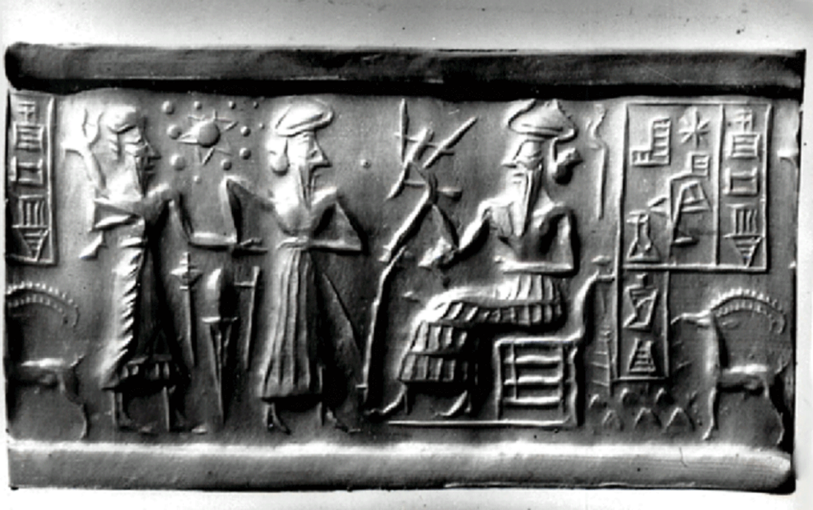

The other brother, son of Adapa, by Marduk to the meadows was taken,
Abael, He of the Watered Meadows, his name was thereafter called.
How to build stalls Marduk him taught; for shepherding to start, the return of Dumuzi they awaited.
When the Shar was completed, Dumuzi to Earth returned,
The essence seed of sheep, ewes for the growing with him he brought,
Four-legged animals of Nibiru to another planet, the Earth, he conveyed!
93rd Shar (93 x 3600 = 334,800 years on Earth)
His return with essence seed and ewes was cause for much celebration,
Into the care of his father Enki Dumuzi with his precious cargo returned.
The leaders then got together, how to proceed with the new breed they considered:
Never before was there a ewe on Earth, a lamb has never to Earth from the heavens been
dropped,
A she-goat has never before to her kid given birth,
Weaving of sheep's wool has never before been established!"

After the decision of who would be mentors for Ka-in and Abael, the 4 leaders/creators (Enki and Enlil, Ninmah and Ningishzidda) decided to establish a Creation Chamber, a House of Fashioning.

Excerpt: The 4 Creators establish a Creation Chamber
"Upon the pure mound of the Landing Place, in the Cedar Mountains, it was established, Near where the elixir seeds by Ninmah brought were planted there was the Creation Chamber established, There was the multiplying of the grains and of the ewes on Earth begun." (Cedar Mountains is referring to Lebanon, but the Landing Place (Baalbek), was Northeast of mission control, which was Mt. Zion/Jerusalem)

When the 1st crops reaped and the 1st sheep matured, Enlil proclaimed a decree of Celebration of the Firsts. (Is this the origin of what we know biblically as First Fruits?) Ka-in and Abael placed their offerings at the feet of both Enlil & Enki, guided by Ninurta & Marduk. (Is this the origin of "None can come to the father but by me?" or "offering of the First Fruits"?)
Enlil gave a joyful blessing to both Ka-in and Abael for their offerings.
Enki embraced Marduk, and raised the lamb for all to see and said: "Meat for eating, wool for wearing to Earth have come!"
After the celebration Ka-in was not happy because Enki failed to recognize his offering by blessing it.
Genesis 4:1-5 This creates a rift between the 2 brothers and now Abael is boasting in presence of Ka-in (throw it up in his face).
Now the brothers are boasting about who provides for the Anunnaki as if one is more important than the other. This goes on throughout the wintertime. Then, summertime comes, and there is a drought.

When the drought comes in the summertime Abael, drives his sheep into the fields of Ka-in to drink water from the Furrows and canals. Ka-in commands Abael to move his flocks away. They utter words of accusation toward one another. Here is how the fight got started.

Excerpt: Ka-in and Abael fighting
"They spat on each other, with their fists they fought."
This is where anger gets out of hand. Brothers spitting on each other then there is a fist fight. [Is this the origin of spitting on someone out of envy/jealousy or anger?] Ka-in stoned Abael to death. Genesis 4:8

Titi was the first to know what happened between Ka-in & Abael by premonition. She saw in a dream-vision, Abael's blood in the hand of Ka-in. She woke Adapa and told him of her dream-vision. That morning they departed for Eridu. In the field they find Ka-in sitting by Abael, who was dead. Titi was agonized and Adapa spread mud on his head. (What did the spreading of mud on his head represent?) After the death of Abael Adapa & Titi mourned for 30 days and 30 nights) Adapa returns to Eridu and tells Enki what happened. Enki confronts Ka-in and tells him "Accursed you shall be! From the Edin you must depart, among Anunnaki and Civilized Earthlings you shall not stay. Genesis 4:9-11 As to Abael, in the fields his body cannot for the wild birds remain;
As the Anunnaki custom is, he in a grave, below a stone pile, shall be buried."(Is this the origin of putting a stone pile on top of a dead body as burial procedure?) Enki shows Adapa & Titi how to bury Abael. They did not know the custom.

Ka-in is brought to Eridu for judgment and Enki wishes to pronounce the exile sentence. Marduk wants him put to death. Ninurta wants him to be sentenced by the Seven Who Judge. Marduk disagrees with Ninurta's assertion because Ka-in was not born on Nibiru. Marduk reminds Ninurta of the action taken against Anzu. Ninurta had put Anzu to death for stealing the Tablet of Destinies. This silenced Ninurta.
Enki breaks the ranting by Marduk by asking to have a word with him in private. When in private he tells Marduk how Adapa & Titi were conceived. (Remember that Enki & Ningishzidda had agreed not to tell Marduk everything when Adapa had made his trip to Nibiru and returned to Earth). He also tells him that "A new phase of Anunnaki presence on this planet was welcomed and approved;
Now that Abael has been slain, and if Ka-in too shall be extinguished,
Satiation to an end would come, mutinies will be repeated, all that was achieved shall crumble!
No wonder that to Abael a liking you took, the son of your half brother he was! (Marduk finds out that Adapa is his brother and Ka-in is his nephew)
Now, on the other one have pity, let the line of Adapa survive!
Marduk responded saying "Of your lovemaking prowess much to me was rumored, now of that convinced I am!
Indeed, let Ka-in's life be spared, to the ends of the Earth let him be banished!"

Ka-in was exiled to the "Land of Wandering" Eastward of the Edin. Ningishzidda, before Ka-in was banished, altered his DNA so that he could not grow a beard. Genesis 4:15 (How did this happen: Was there an Avatar involved or was there some type of injection taken or did Ka-in just accept his punishment "like a man"?) Afterwards Ka-in left for the "Land of Wandering" (Land of Nod) with his sister Awan as a spouse. (Is everyone who cannot grow facial hair from the line of Ka-in?)
(Is this Awan the one known as the daughter of Eve/Awa? Is Titi actually Eve/Awa or Lilith?)

Eve/Awa -- Link to Eve/Awa Info
Born: Garden of Eden
Spouse: Adam
Children: Seth, Cain, Abel, Awan, Azura
Grandchildren: Enos, Enoch, Noam
Great grandchildren: Kenan, Irad-- Son of Enoch, Mualeleth, Barakiel
Genesis 5:4
Links to gain insight on Lilith
Link #1 to Lilith Info Link #2 to Lilith Info Link #3 to Lilith Info Link #4 to Lilith Info Link #5 to Lilith Info
Genesis 1:26-29 Genesis 2:4-8 Genesis 2:18-25 Genesis 3:1-24 Genesis 5:1-2

Link to Maps
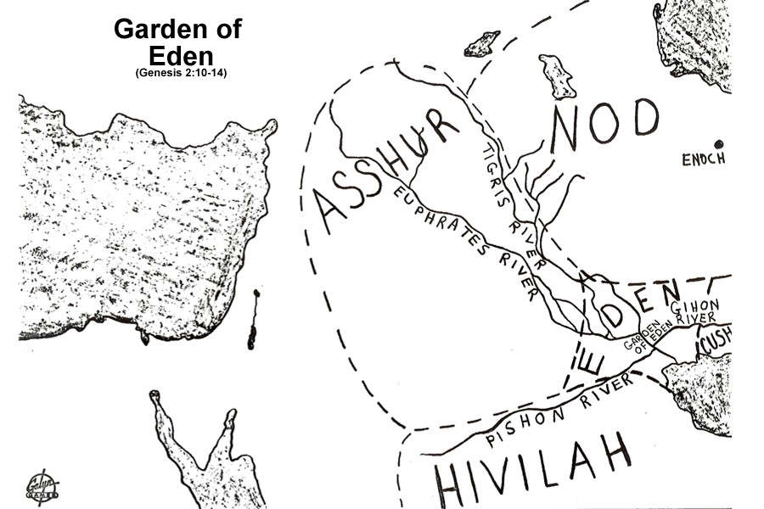

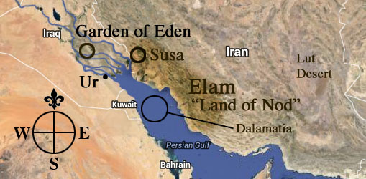

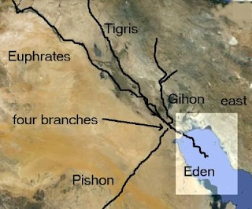

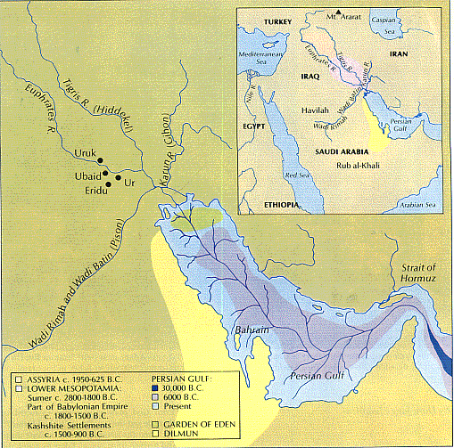

Now the Annunaki had another problem. Who was going to farm and who was going to shepherd? They agreed that Adapa and Titi would proliferate or produce more children. (Is this the origin of "Breeding Slaves for the Plantation"?)

With the blessing of Enki, Adapa and Titi had 30 daughters and finally in the 95th Shar (95 x 3600 = 342,000) they had a son, Sati/Seth (He Who Life Binds Again) Jubilees 4:7, Genesis 5:3. By him were Adapa's generations counted. In all Adapa & Titi had 30 sons and 30 daughters. They were all tillers/farmers and shepherds. (Reminder: After the death of Abael Adapa & Titi mourned for 30 days and 30 nights)

In the 97th Shar (97 x 3600 = 349,200) , Sati/Seth and his spouse Azura (his sister) had a son by the name of Enshi/Enos/Enosh (Master of Humanity) Jubilees 4:11, Genesis 5:6. Adapa taught him writing and numbers and who the Annunaki were and all about Nibiru.

After the teachings of Adapa were finished, Enshi was taken to the sons of Enlil to be taught the secrets of the Annunaki. Nannar, Enlil's eldest, taught him how to make oils for annointing. Ishkur, Enlil's youngest, taught him how to prepare the elixir from the Inbu fruits. (Could this be a reference to the origin of different species of the date palm fruit? Is this a reference to Numbers 13 where Moses sent 12 Israelites in to spy out the land of Canaan and when they returned they brought back pomegranates, figs, and grapes that had to be carried on a staff by 2 men?) Since that time Civilized Man called the Annunaki "lords" and that was the beginning of the rites of worship of the Annunaki. Link#1 to Date Palm Info Link#2 to Date Palm Info

Link to Image & Info | Link to Image & Info
Link to Image & Info | Link to Image & Info
Link to Map & Info
Figure 19. Geographical distribution of date palm in the world
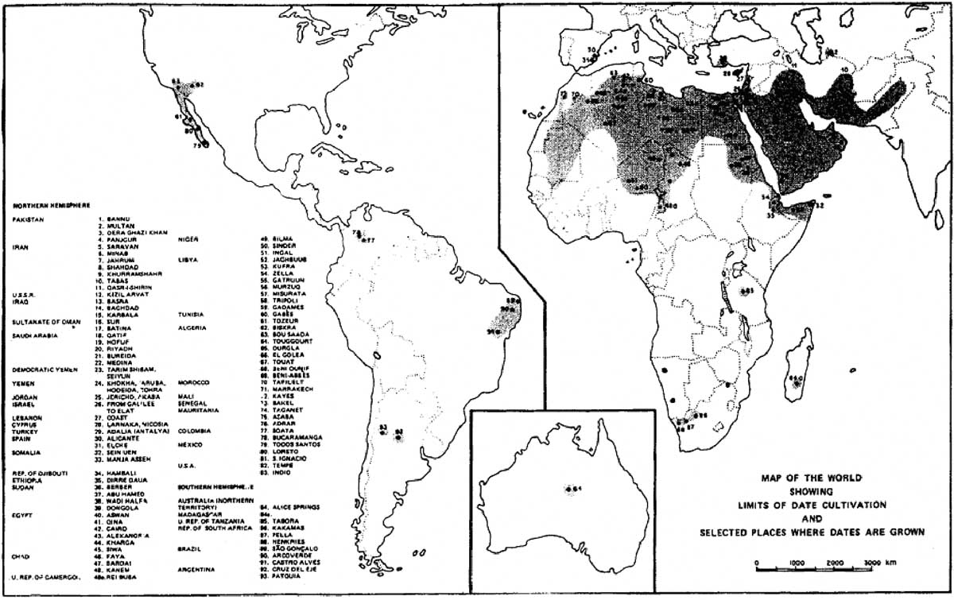

Enshi has a son by his sister Noam. His name is Kunin/Cainan/Kenan (He of the Kilns) Jubilees 4:13, Genesis 5:10. He was taught by Ninurta in Bad-Tibira smelting and refining. He and his offspring, this was their lot beginning in the 98th Shar. (98 x 3600 = 352,800)

In the 99th Shar (99 x 3600 = 356,400) Kunin had a son by his half sister Mualit, Malalu/Mahalaleel (He Who Plays) Jubilees 4:14, Genesis 5:12. He excelled in music an song. Ninurta made for him a stringed harp and a flute. Malalu, along with his daughters, played hymns and sang to Ninurta. (Is this the first account of what we know to be a "musician/entertainer" on Earth?)

In the 100th Shar (100 x 3600 = 360,000), Malalu had a son with his spouse Dunna/Dinah. She was the niece of his father, and his first cousin. Their firstborn was a son, Irid/Jared (He of the Sweet Waters) Jubilees 4:15, Genesis 5:15. He was taught by Dumuzi how to dig wells to provide water for flocks in distant meadows. The wells turned out to be a meeting place for shepherds and maidens, where espousing and proliferation by Civilized Mankind abounded. Irid met his spouse, his mother's niece, or his first cousin, at one of the wells. Her name was Baraka. NOTE: Irid = Jared , Father of Enkime/Enoch

In the days of Irid, the Igigi (Watchers) were coming to Earth more frequently instead of observing from the heavens. They wanted to see what on Earth was going on.

Irid & Baraka have a son at the end of the 102nd Shar (102 x 3600 = 367,200). His name was Enki-Me (Enki ME Understanding)/Enoch, as it was recorded in the annals. Jubilees 4:17, Genesis 5:19 He was wise and intelligent. Enki took a liking to him and taught him everything he had taught Adapa and more. (There is a discrepancy in the Book of Jubilees as to who is the father of Enoch. Jubilees 4:9, Is it Cain and Awan OR Jubilees 4:16, Jared and Baraka OR is it both revealing that there was 2 Enochs.)

All the things Enki taught Enkime/Enoch: Jubilees 4:17-19
Of the family of the Sun and the twelve celestial gods Enki him was teaching, And how the months by the Moon were counted and the years by the Sun, And how by Nibiru the Shars were counted, and how the counts by Enki were combined, How the lord Enki the circle of the heavens to twelve parts divided, A constellation to each one how Enki assigned, twelve stations in a grand circle he arranged, (Is this confirmation that Enki designed the Zodiac?) How to honor the twelve Anunnaki great leaders by names the stations were called. To explore the heavens Enkime was eager; two celestial journeys he did make.

Enkime/Enoch was sent to be with Marduk in the "Landing Place". From there, on Lahmu, Marduk took him to the moon and taught him everything that Enki, his father, had taught him. When they returned to Earth, Enkime was sent to Sippar to be taught by Utu at the Place of the Chariots (Spaceport).

Utu gave Enkime/Enoch a tablet to write down what he was learning. Utu installed Enkime as Prince of Earthlings. He taught him the rites, to begin the functions of priesthood. Enkime/Enoch resided in Sippar with his spouse and half sister, Edinni/Edna. In the 104th Shar (104 x 3600 = 374,400) they had a son, Matushal/Methuselah (Who by the Bright Waters Raised) Jubilees 4:20, Genesis 5:21. Is this "Methuselah"? And is Enkime "Enoch"?

Excerpt: Enkime/Enoch's 2nd journey to the heavens
After the birth of Matushal, Marduk took Enkime/Enoch on his 2nd journey to the heavens. In a celestial chariot heavenward they soared, toward the Sun and away from it they circled.
To visit the Igigi on Lahmu by Marduk he was taken,
To him the Igigi a liking took, of Civilized Earthlings from him they learned.
Of him it is in the Annals said that to the heavens he departed,
That in the heavens he stayed till the end of his days. Hebrews 11:5

Enoch's immediate family (Google/Wikipedia): Link to Enoch Info
Children: Metheluselah, Naamah, Barakil
Parents: Baraka, Jared
Grandparents: Mahalalel, Dinah, Rashujal
Grandchildren: Lamech, Betenos, Rakel
Note: Enoch had a daughter, Sarpanit. Not mentioned from this source but mentioned later in the 9th Tablet. In defiance of his parents, Marduk married her.

Excerpt: Enkime/Enoch's work before going to the heavens
Before Enkime for the heavens departed, all that in the heavens he was taught.
In writings Enkime a record made, for his sons to know he wrote it;
All that is in the heavens in the family of the Sun he wrote down,
And about the quarters of the Earth and its lands and its rivers too
To the hands of Matushal, his firstborn son, the writings he entrusted,
With his brothers Ragim and Gaidad to study and abide by.
In the one hundred and fourth Shar was Matushal born,
To the Igigi troubles and what Marduk had done he was a witness.

Sons of Enkime/Enoch:
Matushal/ Metheluselah - Firstborn
Ragim
Gaidad
Link #1 Sons of Enoch - Google Link #2 Sons of Enoch - Bible - Genesis 5:22 Link #3 Sons of Enoch - Jubilees 4:20 Link #4 Sons of Enoch - Torah - Bereishit (Genesis) 4:18 Link #5 Sons of Enoch - Geni.com

Matushal married Ednat and she gave him a son, Lu-Mach/Lamech (Mighty Man) Jubilees 4:27, Genesis 5:25, who served the Annunaki as a workmaster, enforcing the quotas, and reducing the rations.
During the time of Lu-Mach, Adapa expires. On his deathbed, he requested that "all his sons and sons of sons assemble themselves to him" so that he could bless them and speak words to them before death. When everyone had gathered, Adapa asks for Ka-in, his firstborn. Sati goes to Enki and tells of Adapa's wish. Ninurta gets in his "Bird of Heaven" (Is this a helicopter?), he goes and fetches Ka-in and brings him before Adapa, his father. Upon his arrival, Adapa calls for Ka-in and Sati to come before him, Ka-in the firstborn on the right, Sati/Seth on the left.

And the eyesight of Adapa having failed, for recognition his sons' faces he touched;
And the face of Ka-in on the right was beardless, and the face of Sati on the left with beard was.
(Is the inability to grow facial hair a sign to identify that one is a descendant of Ka-in/Cain?)

On his deathbed, Adapa blesses his son Sati/Seth and tells him of a great calamity that his family will survive and that his seed will fill the Earth. He tells Ka-in/Cain that he is deprived of his birthright for killing his brother Abael, but seven nations shall come from his seed and thrive in a distant land. And, finally, because he stoned his brother to death, a stone shall be his end.
START HERE ON CALL

Excerpt: Adapa's transition and burial
And when Adapa finished these words saying, his hands dropped and he sighed and said:
Now summon my spouse Titi/Eve/Awa/Lilith and all the sons and all the daughters,
And after my spirit leaves me, to my birthplace by the river carry me,
And with my face toward the rising Sun there bury me.
Like a wounded beast Titi/Eve/Awa/Lilith cried out, to her knees by Adapa's side she fell.
And the two sons of Adapa, Ka-in and Sati, in a cloth his body wrapped,
In a cave by the banks of the river, by Titi shown, Adapa they buried.
Adapa was born in the middle of the 93rd Shar and died at the end of the 108th Shar (108 x 3600 = 388,800). Adapa lived 14.5 Shars (14.5 x 3600 = 52,200 years)

Excerpt: Adapa's prophesy fulfilled
A long life for an Earthling he had; the life cycle of Enki he did not have.
And after Adapa was buried, Ka-in to his mother and brother farewell bade.
Ninurta in his Bird of Heaven to the land of wandering him returned.
And in a distant realm Ka-in had sons and daughters,
And he for them a city built, and as he was building, by a falling stone he was killed.
In the Edin Lu-Mach as a workmaster the Anunnaki served,

Name Chart #1
Line of An (1st King on Nibiru) and his Spouse An.Tu - 3 sons: An.Ki, An.Ib, & Enuru
An.Ki  Brother to An.Ib & Enuru | An.Ib  Brother to An.Ki & Enuru  Father of An.Shar.Gal with spouse Nin.Ib  Uncle to Enama  Great Uncle to Anu | Enuru  Brother to An.Ki & An.Ib  Father of Enama with spouse Ninuru  Uncle to An.Shar.Gal  Great Uncle to Alam  Great, Great Uncle to Alalu
(NO SONS) | An.Shar.Gal  Grandson to An & An.Tu  Son of An.Ib  Father of Alam with concubine  Nephew to Enuru  1st Cousin to Enama  2nd Cousin to Anu | Enama  Grandson to An & An.Tu  Son of Enuru  Father of Anu with half-sister  Nephew to An.Ib  1st Cousin to An.Shar.Gal  2nd Cousin to Alam  3rd Cousin to Alalu
 | Alam  Great Grandson to An & An.Tu  Grandson of An.Ib  Son of An.Shar.Gal  Father of Alalu  2nd Cousin to Enama  3rd Cousin to Anu | Anu  Great Grandson to An & An.Tu  Grandson to Enuru  Son of Enama  Father of Enlil & Enki with spouse Antu  Great Nephew to An.Ib  2nd Cousin to An.Shar.Gal  3rd Cousin to Alam  4th Cousin to Alalu
 | Alalu  Great, Great Grandson to An & An.Tu  Great Grandson to An.Ib  Grandson to An.Shar.Gal  Son of Alam  4th Cousin to Anu  5th Cousin to Enlil & Enki  (NO SONS) | Enlil - Son of Anu & Antu; Legal Heir  Enki - Son of Anu & Ninlul; Firstborn son with a concubine  Great, Great Grandsons to An & An.Tu  Great Grandsons to Enuru  Grandsons to Enama

Here's where we need to resume the name chart: Name Chart #4 -- More children born on Earth from Enshi/Enosh/Enos to Matushal/Methuselah
(FBN) = Full-Blooded Nibirian, born on Nibiru (FBNE) = Full-Blooded Nibirian, born on Earth
(HBE) = Half-Blooded, born on Earth (FBM) = Full-Blooded Mankind
After Sati/Seth, 3rd son of Adapa & Titi, color change of names represents a child of that descendant
^{1, 2, .....} = generations down from parents

More children on Earth by Enki, Enlil, Ninmah and their children
E.A/Ea/Nudimmud/Enki (Nibiru)  Damkina/Ninmah/Ninki his spouse  Son of Anu with Ninlul  Grandson to Enama  Great Grandson to Enuru  2X Great Grandson to An & An.Tu  Half-Brother to Enlil & Ninmah  Son-in-law to Alalu  5th cousin to Alalu  6th cousin to Ninmah  Father of Adamu & Ti-Amat using artificial insemination  Grandfather to the 7 males and 7 females  Father of Adapa & Titi  Grandfather to Ka-In/Cain, Abael/Abel, & Sati/Seth  Great Grandfather to Enshi  2X Great Grandfather to Kunin  3X Great Grandfather to Malalu  4X Great Grandfather to Irid/Jared  5X Great Grandfather to Enki-ME/Enoch  6X Great Grandfather to Matushal | Enlil (Nibiru)  Ninlil/Sud his spouse  Son of Anu & Antu; Legal Heir  Grandson to Enama  Great Grandson to Enuru  2X Great Grandson to An & An.Tu  Half-Brother to Enki & Ninmah  Uncle to Marduk, 2 unknown daughters of Enki, Nergal, Gibil, Ninagal, Ningishzidda, Dumuzi  5th cousin to Alalu  6th cousin to Ninmah  Uncle to Adamu & Ti-Amat  Uncle to Adapa & Titi  Grandfather to Inanna & Utu  2X Great Uncle to Enshi  3X Great Uncle to Kunin  4X Great Uncle to Malalu  5X Great Uncle to Irid/Jared  6X Great Uncle to Enki-ME/Enoch  7X Great Uncle to Matushal | Ninmah (Nibiru)  Biological daughter of Alalu & Namma?/ Nammu?  Royal Stepdaughter to Anu  5th cousin to Anu  6th cousin to Enki & Enlil  Half -Sister to Enki & Enlil  2X Great Step-Granddaughter to An & An.Tu  Great Step-Granddaughter  to Enuru  Step-Granddaughter To Enama  Mother of Marduk  Mother of Ninurta  Alalu's Line  Granddaughter To Alam  Great Granddaughter To An.Shar.Gal  2X Great Granddaughter To An.Ib  3X Great Granddaughter to An & An.Tu  Experiments  Surrogate Mother of Adamu  Aunt to 7 males
Marduk¹ (FBN)  Son of Enki with spouse Damkina/Ninmah/Ninki  Grandson to Anu & Antu  Great Grandson to Enama  2X Great Grandson to Enuru  3X Great Grandson to An & An.Tu  Nephew to Enlil  1st cousin to Ninurta, Nannar, Ishkur  2nd cousin to Inanna & Utu  6th cousin to Alalu  7th cousin to Ninmah  Half - Brother to Adamu  Uncle to Adamu blood 7 males  Half - Brother to Adapa & Titi  Uncle to Ka-In/Cain, Abael/Abel, & Sati/Seth  Great Uncle to Enshi  2X Great Uncle to Kunin  3X Great Uncle to Malalu  4X Great Uncle to Irid/Jared  5X Great Uncle to Enki-ME/Enoch  6X Great Uncle to Matushal | Ninurta¹ (FBN)  Son of Enlil with Ninmah  Grandson to Anu & Antu  Great Grandson to Enama  2X Great Grandson to Enuru  3X Great Grandson to An & An.Tu  Nephew to Enki  Uncle to Inanna & Utu  1st cousin to Marduk, 2 unknown daughters of Enki, Nergal, Gibil, Ninagal, Ningishzidda, Dumuzi  6th cousin to Alalu  7th cousin to Ninmah  1st cousin to Adamu  2nd cousin to Adamu blood 7 males  1st cousin to Adapa & Titi  2nd cousin to Ka-In/Cain, Abael/Abel, & Sati/Seth  3rd cousin to Enshi  4th cousin to Kunin  5th cousin to Malalu  6th cousin to Irid/Jared  7th cousin to Enki-ME/Enoch  8th cousin to Matushal | Adamu (HBE)  (artificial insemination using Enki's blood/DNA)  Surrogate son of Ninmah  Half-Brother to Marduk, 2 unknown daughters of Enki, Nergal, Gibil, Ninagal, Ningishzidda, Dumuzi  1st cousin to Ninurta, Nannar, Ishkur  Half - Brother to Adapa & Titi  Uncle to Ka-In/Cain, Abael/Abel, & Sati/Seth  Great Uncle to Enshi  2X Great Uncle to Kunin  3X Great Uncle to Malalu  4X Great Uncle to Irid/Jared  5X Great Uncle to Enki-ME/Enoch  6X Great Uncle to Matushal
2 daughters² with Ninmah, names unknown
(FBNE)
Daughters to Enki with Ninmah
Granddaughters to Anu & Antu
Great Granddaughters to Enama
2X Great Granddaughters to Enuru
3X Great Granddaughters to An & An.Tu
Nieces to Enlil
1st cousins to Ninurta, Nannar, Ishkur
2nd cousin to Inanna & Utu
6th cousin to Alalu
7th cousin to Ninmah
Half - Sisters to Adamu
Aunts to Adamu blood 7 males
Half - Sisters to Adapa & Titi
Aunts to Ka-In/Cain, Abael/Abel, & Sati/Seth
Great Aunts to Enshi
2X Great Aunts to Kunin
3X Great Aunts to Malalu
4X Great Aunts to Irid/Jared
5X Great Aunts to Enki-ME/Enoch
6X Great Aunts to Matushal
Nergal³ (FBNE)  Son of Enki with concubine  Grandson to Anu & Antu  Great Grandson to Enama  2X Great Grandson to Enuru  3X Great Grandson to An & An.Tu  Nephew to Enlil  1st cousin to Ninurta, Nannar, Ishkur  2nd cousin to Inanna & Utu  6th cousin to Alalu  7th cousin to Ninmah  Half - Brother to Adamu  Uncle to Adamu blood 7 males  Half - Brother to Adapa & Titi  Uncle to Ka-In/Cain, Abael/Abel, & Sati/Seth  Great Uncle to Enshi  2X Great Uncle to Kunin  3X Great Uncle to Malalu  4X Great Uncle to Irid/Jared  5X Great Uncle to Enki-ME/Enoch  6X Great Uncle to Matushal | Nannar² (FBNE)  1st Royal Nibirian born on Earth  Father of Inanna & Utu  Son of Enlil with spouse Ninlil/Sud  Grandson to Anu & Antu  Great Grandson to Enama  2X Great Grandson to Enuru  3X Great Grandson to An & An.Tu  Half-Brother to Ninurta  Nephew to Enki  1st cousin to Marduk, 2 unknown daughters of Enki, Nergal, Gibil, Ninagal, Ningishzidda, Dumuzi  6th cousin to Alalu  7th cousin to Ninmah  1st cousin to Adamu  2nd cousin to Adamu blood 7 males  1st cousin to Adapa & Titi  2nd cousin to Ka-In/Cain, Abael/Abel, & Sati/Seth  3rd cousin to Enshi  4th cousin to Kunin  5th cousin to Malalu  6th cousin to Irid/Jared  7th cousin to Enki-ME/Enoch  8th cousin to Matushal | 7 surrogates (HBE)  blood/DNA from Adamu  Ninimma - male, no name  Shuzianna - male, no name  Ninmada - male, no name  Ninbara - male, no name  Ninmug - male, no name  Musardu - male, no name  Ningunna - male, no name  7 males are Nephews to Marduk, 2 unknown daughters of Enki, Nergal, Gibil, Ninagal, Ningishzidda, Dumuzi  2nd cousin to Ninurta, Nannar, Ishkur  Sons to Adamu  1st cousin to Ka-In/Cain,  Abael/Abel, & Sati/Seth  2nd cousin to Enshi  3rd cousin to Kunin  4th cousin to Malalu  5th cousin to Irid/Jared  6th cousin to Enki-ME/Enoch  7th cousin to Matushal
Gibil⁴ (FBNE)  Son of Enki with concubine  Grandson to Anu & Antu  Great Grandson to Enama  2X Great Grandson to Enuru  3X Great Grandson to An & An.Tu  Nephew to Enlil  1st cousin to Ninurta, Nannar, Ishkur  2nd cousin to Inanna & Utu  6th cousin to Alalu  7th cousin to Ninmah  Half - Brother to Adamu  Uncle to Adamu blood 7 males  Half - Brother to Adapa & Titi  Uncle to Ka-In/Cain, Abael/Abel, & Sati/Seth  Great Uncle to Enshi  2X Great Uncle to Kunin  3X Great Uncle to Malalu  4X Great Uncle to Irid/Jared  5X Great Uncle to Enki-ME/Enoch  6X Great Uncle to Matushal | Inanna/Anunitu/Ishtar¹  (FBNE)  Daughter of Nannar with spouse Ningal  Niece to Ninurta & Ishkur  Granddaughter to Enlil & Ninlil/Sud  Great Granddaughter to Anu & Antu  2X Great Granddaughter to Enama  3X Great Granddaughter to Enuru  4X Great Granddaughter to An & An.Tu  2nd cousin to Marduk, 2 unknown daughters of Enki, Nergal, Gibil, Ninagal, Ningishzidda, Dumuzi  7th cousin to Alalu  8th cousin to Ninmah  2nd cousin to Adamu  2nd cousin to Adapa & Titi  3rd cousin to Ka-In/Cain, Abael/Abel & Sati/Seth  4th cousin to Enshi  5th cousin to Kunin  6th cousin to Malalu  7th cousin to Irid/Jared  8th cousin to Enki-ME/Enoch  9th cousin to Matushal
Ninagal⁵ (FBNE)  Son of Enki with concubine  Grandson to Anu & Antu  Great Grandson to Enama  2X Great Grandson to Enuru  3X Great Grandson to An & An.Tu  Nephew to Enlil  1st cousin to Ninurta, Nannar, Ishkur  2nd cousin to Inanna & Utu  6th cousin to Alalu  7th cousin to Ninmah  Half - Brother to Adamu  Uncle to Adamu blood 7 males  Half - Brother to Adapa & Titi  Uncle to Ka-In/Cain, Abael/Abel, & Sati/Seth  Great Uncle to Enshi  2X Great Uncle to Kunin  3X Great Uncle to Malalu  4X Great Uncle to Irid/Jared  5X Great Uncle to Enki-ME/Enoch  6X Great Uncle to Matushal | Utu² (FBNE)  Son of Nannar with spouse Ningal  Nephew to Ninurta & Ishkur  Grandson to Enlil & Ninlil/Sud  Great Grandson to Anu & Antu  2X Great Grandson to Enama  3X Great Grandson to Enuru  4X Great Grandson to An & An.Tu  2nd cousin to Marduk, 2 unknown daughters of Enki, Nergal, Gibil, Ninagal, Ningishzidda, Dumuzi  7th cousin to Alalu  8th cousin to Ninmah  2nd cousin to Adamu  2nd cousin to Adapa & Titi  3rd cousin to Ka-In/Cain, Abael/Abel & Sati/Seth  4th cousin to Enshi  5th cousin to Kunin  6th cousin to Malalu  7th cousin to Irid/Jared  8th cousin to Enki-ME/Enoch  9th cousin to Matushal
Ningishzidda⁶ (FBNE)  Son of Enki with spouse Damkina  Grandson to Anu & Antu  Great Grandson to Enama  2X Great Grandson to Enuru  3X Great Grandson to An & An.Tu  Nephew to Enlil  1st cousin to Ninurta, Nannar, Ishkur  2nd cousin to Inanna & Utu  6th cousin to Alalu  7th cousin to Ninmah  Half - Brother to Adamu  Uncle to Adamu blood 7 males  Half - Brother to Adapa & Titi  Uncle to Ka-In/Cain, Abael/Abel, & Sati/Seth  Great Uncle to Enshi  2X Great Uncle to Kunin  3X Great Uncle to Malalu  4X Great Uncle to Irid/Jared  5X Great Uncle to Enki-ME/Enoch  6X Great Uncle to Matushal | Ishkur³ (FBNE)  Son of Enlil with spouse Ninlil/Sud  2nd Royal Nibirian born on Earth  Grandson to Anu & Antu  Great Grandson to Enama  2X Great Grandson to Enuru  3X Great Grandson to An & An.Tu  Brother to Nannar  Half-Brother to Ninurta  Uncle to Inanna & Utu  Nephew to Enki  1st cousin to Marduk, 2 unknown daughters of Enki, Nergal, Gibil, Ninagal, Ningishzidda, Dumuzi  6th cousin to Alalu  7th cousin to Ninmah  1st cousin to Adamu  2nd cousin to Adamu blood 7 males  1st cousin to Adapa & Titi  2nd cousin to Ka-In/Cain, Abael/Abel, & Sati/Seth  3rd cousin to Enshi  4th cousin to Kunin  5th cousin to Malalu  6th cousin to Irid/Jared  7th cousin to Enki-ME/Enoch  8th cousin to Matushal
Dumuzi/ Tammuz⁷ (FBNE)
Son of Enki with spouse Damkina
Grandson to Anu & Antu
Great Grandson to Enama
2X Great Grandson to Enuru
3X Great Grandson to An & An.Tu
Nephew to Enlil
1st cousin to Ninurta, Nannar, Ishkur
2nd cousin to Inanna & Utu
6th cousin to Alalu
7th cousin to Ninmah
Half - Brother to Adamu
Uncle to Adamu blood 7 males
Half - Brother to Adapa & Titi
Uncle to Ka-In/Cain, Abael/Abel, & Sati/Seth
Great Uncle to Enshi
2X Great Uncle to Kunin
3X Great Uncle to Malalu
4X Great Uncle to Irid/Jared
5X Great Uncle to Enki-ME/Enoch
6X Great Uncle to Matushal
Adamu⁸ (HBE)
(artificial insemination using Enki's blood/DNA)
Surrogate son to Enki with Ninmah
Grandson to Anu & Antu
Great Grandson to Enama
2X Great Grandson to Enuru
3X Great Grandson to An & An.Tu
Half-Brother to Marduk, 2 unknown daughters of Enki, Nergal, Gibil, Ninagal, Ningishzidda, Dumuzi
Nephew to Enlil
1st cousin to Ninurta, Nannar, Ishkur
2nd cousin to Inanna & Utu
Half-Brother to Adapa & Titi
Uncle to Ka-In/Cain, Abael/Abel, & Sati/Seth
Great Uncle to Enshi
2X Great Uncle to Kunin
3X Great Uncle to Malalu
4X Great Uncle to Irid/Jared
5X Great Uncle to Enki-ME/Enoch
6X Great Uncle to Matushal
Ti-Amat⁹ (HBE)
(artificial insemination using Enki's blood/DNA with spouse Damkina/Ninki)
Daughter of Enki with spouse Damkina/Ninki
Granddaughter to Anu & Antu
Great Granddaughter to Enama
2X Great Granddaughter to Enuru
3X Great Granddaughter to An & An.Tu
Niece to Enlil
1st cousin to Ninurta, Nannar, Ishkur
6th cousin to Alalu
7th cousin to Ninmah
Half - Sister to Adamu, Adapa & Titi
Aunt to Ka-In/Cain, Abael/Abel, & Sati/Seth
Aunt to Adamu blood 7 males
Mother for 7 surrogates (HB; Earth) using her own
blood/DNA resulting in 7 females for the 7 males
2nd cousin to Inanna & Utu
Great Aunt to Enshi
2X Great Aunt to Kunin
3X Great Aunt to Malalu
4X Great Aunt to Irid/Jared
5X Great Aunt to Enki-ME/Enoch
6X Great Aunt to Matushal
Adapa¹⁰ (FBM)
Son of Enki with concubine Earthling
Grandson to Anu & Antu
Great Grandson to Enama
2X Great Grandson to Enuru
3X Great Grandson to An & An.Tu
Half-Brother to Marduk, 2 unknown daughters of Enki, Nergal, Gibil, Ninagal, Ningishzidda, Dumuzi
Nephew to Enlil
1st cousin to Ninurta, Nannar, Ishkur
2nd cousin to Inanna & Utu
7th cousin to Alalu
8th cousin to Ninmah
Half-Brother to Adamu & Ti-Amat
Father to Ka-In/Cain, Abael/Abel, & Sati/Seth
Father of 60 unnamed children after Abael/Abel's death
Grandfather to Enshi
Great Grandfather to Kunin
2X Great Grandfather to Malalu
3X Great Grandfather to Irid/Jared
4X Great Grandfather to Enki-ME/Enoch
5X Great Grandfather to Matushal
Titi¹¹ (FBM)
Daughter of Enki with concubine Earthling
Granddaughter to Anu & Antu
Great Granddaughter to Enama
2X Great Granddaughter to Enuru
3X Great Granddaughter to An & An.Tu
Half-Sister to Marduk, 2 unknown daughters of Enki, Nergal, Gibil, Ninagal, Ningishzidda, Dumuzi
Niece to Enlil
1st cousin to Ninurta, Nannar, Ishkur
2nd cousin to Inanna & Utu
7th cousin to Alalu
8th cousin to Ninmah
Half-Sister to Adamu & Ti-Amat
Mother to Ka-In/Cain, Abael/Abel, & Sati/Seth
Mother of 60 unnamed children after Abael/Abel's death
Grandmother to Enshi
Great Grandmother to Kunin
2X Great Grandmother to Malalu
3X Great Grandmother to Irid/Jared
4X Great Grandmother to Enki-ME/Enoch
5X Great Grandmother to Matushal
Abael/Abel¹ (FBM)
Son of Adapa & Titi
Grandson to Enki
Great Grandson to Anu & Antu
2X Great Grandson to Enama
3X Great Grandson to Enuru
4X Great Grandson to An & An.Tu
Twin Brother to Ka-In
Nephew to Marduk, 2 unknown daughters of Enki, Nergal, Gibil, Ninagal, Ningishzidda, Dumuzi
Nephew to Adamu & Ti-Amat
Great Nephew to Enlil
2nd cousin to Ninurta, Nannar, Ishkur
3rd cousin to Inanna & Utu
8th cousin to Alalu
9th cousin to Ninmah
Uncle to Enshi
Great Uncle to Kunin
2X Great Uncle to Malalu
3X Great Uncle to Irid/Jared
4X Great Uncle to Enki-ME/Enoch
5X Great Uncle to Matushal
Ka-In/Cain² (FBM)
his spouse Awan
(sister to Azura, Sati/Seth, Ka-in, & Abael)
Son of Adapa & Titi
Grandson to Enki
Great Grandson to Anu & Antu
2X Great Grandson to Enama
3X Great Grandson to Enuru
4X Great Grandson to An & An.Tu
Twin Brother to Abael
Nephew to Marduk, 2 unknown daughters of Enki, Nergal, Gibil, Ninagal, Ningishzidda, Dumuzi
Nephew to Adamu & Ti-Amat
Great Nephew to Enlil
2nd cousin to Ninurta, Nannar, Ishkur
3rd cousin to Inanna & Utu
8th cousin to Alalu
9th cousin to Ninmah
Uncle to Enshi
Great Uncle to Kunin
2X Great Uncle to Malalu
3X Great Uncle to Irid/Jared
4X Great Uncle to Enki-ME/Enoch
5X Great Uncle to Matushal
Sati/Seth³ (FBM)
his spouse Azura
(sister to Awan, Sati/Seth, Ka-in, & Abael)
Son of Adapa & Titi
Grandson to Enki
Great Grandson to Anu & Antu
2X Great Grandson to Enama
3X Great Grandson to Enuru
4X Great Grandson to An & An.Tu
Twin Brother to Abael
Nephew to Marduk, 2 unknown daughters of Enki, Nergal, Gibil, Ninagal, Ningishzidda, Dumuzi
Nephew to Adamu & Ti-Amat
Great Nephew to Enlil
3rd cousin to Ninurta, Nannar, Ishkur
4th cousin to Inanna & Utu
8th cousin to Alalu
9th cousin to Ninmah
Father of Enshi & Noam
Grandfather to Kunin
Great Grandfather to Malalu
2X Great Grandfather to Irid/Jared
3X Great Grandfather to Enki-ME/Enoch
4X Great Grandfather to Matushal
Enshi/Enosh/Enos¹ (FBM)
his spouse Noam (sister)
Son of Sati/Seth with his spouse Azura
Father to Kunin/Cainan/Kenan
Grandson to Adapa & Titi
Great Grandson to Enki
2X Great Grandson to Anu & Antu
3X Great Grandson to Enama
4X Great Grandson to Enuru
5X Great Grandson to An & An.Tu
Nephew to Ka-in, Abael, Awan, Azura,
Great Nephew to Marduk, 2 unknown daughters of Enki, Nergal, Gibil, Ninagal, Ningishzidda, Dumuzi
2X Great Nephew to Enlil
3rd cousin to Ninurta, Nannar, Ishkur
4th cousin to Inanna & Utu
9th cousin to Alalu
10th cousin to Ninmah
Great Nephew to Adamu & Ti-Amat
Kunin/Cainan/Kenan² (FBM)
his spouse Mualit/Mualeleth (half-sister)
Father to Malalu/Mahalalel
Son of Enshi with his spouse Noam
Grandson to Sati/Seth & Azura
Great Grandson to Adapa & Titi
2X Great Grandson to Enki
3X Great Grandson to Anu & Antu
4X Great Grandson to Enama
5X Great Grandson to Enuru
6X Great Grandson to An & An.Tu
Great Nephew to Ka-in, Abael, Awan, Azura, Sati/Seth
2X Great Nephew to Marduk, 2 unknown daughters of Enki, Nergal, Gibil, Ninagal, Ningishzidda, Dumuzi
3X Great Nephew to Enlil
4th cousin to Ninurta, Nannar, Ishkur
5th cousin to Inanna & Utu
10th cousin to Alalu
11th cousin to Ninmah
2X Great Nephew to Adamu & Ti-Amat
Malalu/Mahalalel³ (FBM)
his spouse Dunna/DinaH (first cousin; niece to Kunin)
Son of Kunin with his spouse Mualit
Father to Irid/Jared
Grandson to Enshi & Noam
Great Grandson to Sati/Seth & Azura
2X Great Grandson to Adapa & Titi
3X Great Grandson to Enki
4X Great Grandson to Anu & Antu
5X Great Grandson to Enama
6X Great Grandson to Enuru
7X Great Grandson to An & An.Tu
2X Great Nephew to Ka-in, Abael, Awan, Azura, Sati/Seth
3X Great Nephew to Marduk, 2 unknown daughters of Enki, Nergal, Gibil, Ninagal, Ningishzidda, Dumuzi
4X Great Nephew to Enlil
5th cousin to Ninurta, Nannar, Ishkur
6th cousin to Inanna & Utu
7X Great Grandson to An & An.Tu
6X Great Grandson to Enuru
5X Great Grandson to Enama
4X Great Grandson to Anu & Antu
3X Great Grandson to Enki
2X Great Grandson of Adapa & Titi
Great Grandson to Sati/Seth & Azura
11th cousin to Alalu
12th cousin to Ninmah
3X Great Nephew to Adamu & Ti-Amat
Irid/Jared⁴ (FBM)
his spouse Baraka (first cousin; niece to Dunna)
Son of Malalu with his spouse Dunna
Father to Enki-ME/Enoch
Grandson to Kunin & Mualit
Great Grandson to Enshi & Noam
2X Great Grandson to Sati/Seth & Azura
3X Great Grandson to Adapa & Titi
4X Great Grandson to Enki
5X Great Grandson to Anu & Antu
6X Great Grandson to Enama
7X Great Grandson to Enuru
8X Great Grandson to An & An.Tu
3X Great Nephew to Ka-in, Abael, Awan, Azura, Sati/Seth
4X Great Nephew to Marduk, 2 unknown daughters of Enki, Nergal, Gibil, Ninagal, Ningishzidda, Dumuzi
5X Great Nephew to Enlil
6th cousin to Ninurta, Nannar, Ishkur
7th cousin to Inanna & Utu
12th cousin to Alalu
13th cousin to Ninmah
4X Great Nephew to Adamu & Ti-Amat
Enki-ME/Enoch⁵ (FBM)
his spouse Edinni/Edna (half-sister)
Son of Irid/Jared with his spouse Baraka
Father to Matushal/Methuselah
Grandson to Malalu & Dunna
Great Grandson to Kunin & Mualit
2X Great Grandson to Enshi & Noam
3X Great Grandson to Sati/Seth & Azura
4X Great Grandson to Adapa & Titi
5X Great Grandson to Enki
6X Great Grandson to Anu & Antu
7X Great Grandson to Enama
8X Great Grandson to Enuru
9X Great Grandson to An & An.Tu
4X Great Nephew to Ka-in, Abael, Awan, Azura, Sati/Seth
5X Great Nephew to Marduk, 2 unknown daughters of Enki, Nergal, Gibil, Ninagal, Ningishzidda, Dumuzi
6X Great Nephew to Enlil
7th cousin to Ninurta, Nannar, Ishkur
8th cousin to Inanna & Utu
13th cousin to Alalu
14th cousin to Ninmah
5X Great Nephew to Adamu & Ti-Amat
Matushal/Methuselah⁶ (FBM)
his spouse Ednat
Son of Enki-Me with his spouse Edinni
Father to Lu-Mach/Lamech
Grandson to Irid/Jared & Baraka
Great Grandson to Malalu & Dunna
2X Great Grandson to Kunin & Mualit
3X Great Grandson to Enshi & Noam
4X Great Grandson to Sati/Seth & Azura
5X Great Grandson to Adapa & Titi
6X Great Grandson to Enki
7X Great Grandson to Anu & Antu
8X Great Grandson to Enama
9X Great Grandson to Enuru
10X Great Grandson to An & An.Tu
5X Great Nephew to Ka-in, Abael, Awan, Azura, Sati/Seth
6X Great Nephew to Marduk, 2 unknown daughters of Enki, Nergal, Gibil, Ninagal, Ningishzidda, Dumuzi
7X Great Nephew to Enlil
8th cousin to Ninurta, Nannar, Ishkur
9th cousin to Inanna & Utu
14th cousin to Alalu
15th cousin to Ninmah
6X Great Nephew to Adamu & Ti-Amat

9th Tablet
In the Abzu, at the tip, facing the Whiteland (Antarctica?) they installed observation instruments and Nergal, the son of Enki, and his spouse Ereshkigal were put in charge. (This is the 2nd account of the Annunaki establishing an observatory)
Ninurta was assigned to the Land Beyond the Seas (Australia or Americas?) to establish a Bond Heaven-Earth.
(Arabian Sea, Laccadive Sea (Sri Lanka), Indian Ocean, Atlantic Ocean, Pacific Ocean)
Marduk was given the task of pacifying the restless Igigi on Lahmu/Mars. Until they could determine the cause of the hardships the way station had to remain.
Enlil, Enki, and Ninmah observe each other: They looked at each other and thought of how old the others looked.

Link to Map
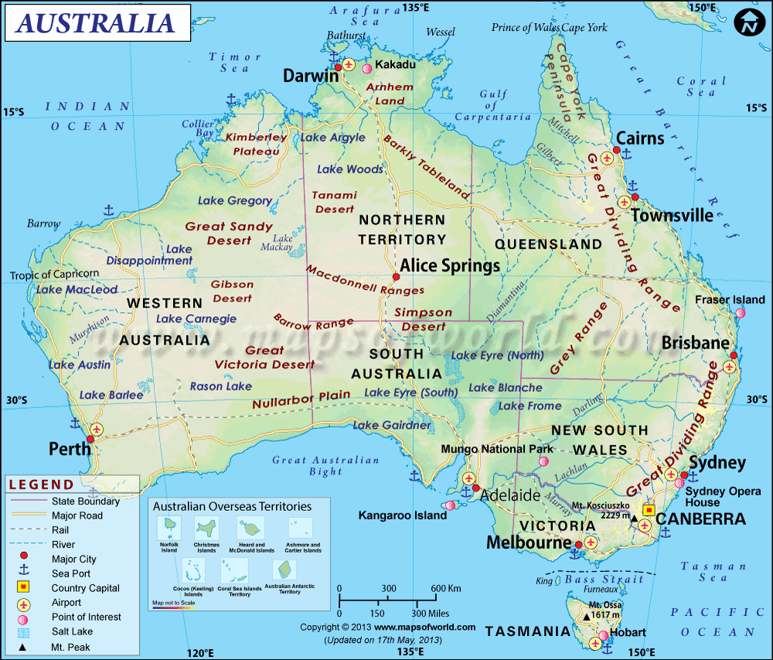

Link to Map
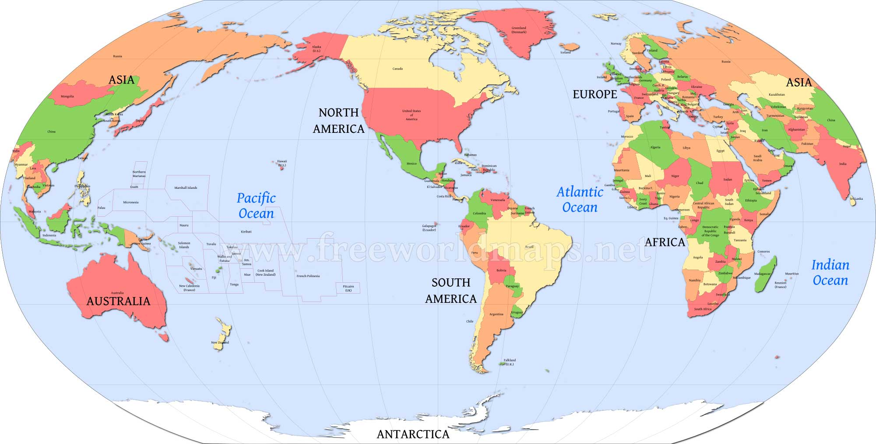

Enki reflects on when he first arrived on Earth saying:
"I was then a dashing leader; now bearded, tired, and old I am!"
At this point, Enki had been on Earth for over 100 Shars (100 x 3600 = 360,000 + years)
Enlil reflects on when he first arrived on Earth saying:
"An enthusiastic hero I was, for command and adventure ready! Enlil then said.
Now I have children who have children, all on Earth born;
Old on Earth we became, but those on Earth born are even older sooner!
Ninmah reflects on when he first arrived on Earth saying:
"As for me, an old sheep they call me!"

Excerpt: 3 leaders' conversation after reminiscing
While the others have been coming and going, turns on Earth to serve taking,
We the leaders have stayed and stayed! Perchance it is time to leave! So did Enlil say.
Of that did I often wonder, to them Enki was saying. Each time one of us three to revisit Nibiru
wished, Word from Nibiru always our corning thereto prevented!
Of that I too did wonder, Enlil was saying: Is it a thing on Nibiru, a thing on Earth?
Perchance the life cycles that differ it concerns, so was Ninmah saying.
To watch and see what transpires, the three leaders decided.
At that time Fate, or was it Destiny? in its hands the matters took.

Enlil's 3 sons have married.
Ninurta: Ba'u a young daughter of Anu
Nannar: Ningal
Ishkur: Shala

Enki's son Nergal, married Enlil's granddaughter, Ereshkigal. He had threatened to kill her in order to get her consent.
Nergal was younger than Marduk, but married before he did. The other 4 had not married yet. (It was Annunaki custom that the younger children deferred getting married until after the firstborn was married?)
Marduk sees this and comes to Enki to tell him of his plans to marry Sarpanit, a descendant of Adapa, the daughter of Enkime/Enoch. Enki was unhappy about it because she was an Earthling. Marduk reminded him that she was his offspring, being the father of Adapa.

Marduk tells his mother Ninki that when he was travelling with Enkime/Enoch and teaching him of heaven and Earth he witnessed with his own eyes what Enki, his father had once said:
"Step by step on this planet a Primitive Being, one like us to be, we have created,
In our image and in our likeness Civilized Earthling is, except for the long life, he is we!"

Excerpt: Marduk defies his parents wishes regarding marriage to an Earthling.
Enki, and his spouse, Ninki's conversation with Marduk:
"If our son this shall do, to Nibiru with his spouse he would never go,
His princely rights on Nibiru he forever will forsake!
To this Marduk with a bitter laughter responded: My rights on Nibiru are nonexistent,
Even on Earth my rights as Firstborn have been trampled.
This indeed is my decision: From prince a king on Earth become, the master of this planet!
Let it so be! Ninki said. Let it so be! Enki also said."

Matushal was happy that Marduk wanted to marry his sister.

When Enlil and Ninmah/Ninhursag heard what was going on, they were also upset and disapproved of Marduk's plan to marry an Earthling. They consulted the King, Anu on the matter. Anu consulted his advisors and the Savants. There was no rule on the books that forbade Marduk's actions. However, Anu decreed that he could marry, but would no longer be a prince on Nibiru.

Enki, Enlil and Marduk accepted the word of Anu. Ninki says, "Let there be a wedding celebration in Eridu". Enlil, as commander, replies and announced "In the Edin Marduk and his bride cannot stay". Enki says to Enlil "Let us make a gift to Marduk and his bride, A domain of their own, away from the Edin, in another land.

Excerpt: A domain for Marduk and Sarpanit is designated
A domain of their own, away from the Edin, in another land! So did Enki to Enlil say.
Of Marduk being sent away Enlil with consent to himself was thinking:
To what land, of what domain, are you speaking? Enlil to his brother Enki said.
A domain above the Abzu, in the land that the Upper Sea reaches,
One that by waters from the Edin is separated, that by ships can be reached!
So did Enki to Enlil say. Let it so be! Enlil said. (Is the area described here what we know to be Nile Valley or Lower and Upper Egypt? Remember that Osiris is the grandson of Enki and the son of Marduk.)

Ninki made the arrangements for the wedding celebration. The ceremony was announced by the sound of a copper drum. (Is this the origin of the gong?) Ninki's sisters presented the bride to her spouse with 7 tambourines. (Is this the origin of bridesmaids?)

Excerpt: Who attended the wedding celebration for Marduk and Sarpanit
A great multitude of Civilized Earthlings in Eridu assembled, like a coronation to them the wedding was. Young Anunnaki also attended, Igigi from Lahmu in great numbers came. To celebrate our leader's wedding, of Nibiru and Earth a union, to witness we came! So did the Igigi their arrival in large numbers explain.
1/3 of the Igigi stayed on Lahmu/Mars and 2/3 of them came to Earth. There was 300 in all, therefore, 100 stayed on Lahmu/Mars and 200 came to Earth. Their explanation was that they wanted to be with their leader and attend his wedding celebration.

Excerpt: The plot of the Igigi - why they really came to Earth
Unbeknownst to Enki and Enlil was their secret: To abduct and have conjugation was their plot.
Unbeknownst to the leaders on Earth, a multitude of the Igigi on Lahmu got together,
What to Marduk permitted is from us too should not be deprived! to each other they said.
Enough of suffering and loneliness, of not offspring ever having! was their slogan.
During their comings and goings between Lahmu and Earth,
The daughters of the Earthlings, the Adapite Females as them they called,
They saw and after them they lusted; and to each other the plotters said:
Come, let us choose wives from among the Adapite Females, and children beget!
One among them, Shamgaz/Shamgaza his name was, their leader became.
Even if none of you agrees, I alone the deed shall do! to the others he said.
If a penalty for this sin shall be imposed, I alone for all of you shall it bear!
One by one others in the plot joined together, by an oath together to do it they swore. (Is this the origin of taking an oath?)

Excerpt: The plot of the Igigi is executed
Upon the great platform in the Cedar Mountains they came down.
(Is this the spaceport near Mt. Sinai, at Tilmun or Mt. Hermon in Lebanon or Mt. Zion at Jerusalem?)
From there to Eridu they journeyed, among the toiling Earthlings they passed,
Together with the Earthling throng (part of huge crowd) in Eridu they arrived.
After the wedding ceremony of Marduk and Sarpanit had taken place,
By a signal prearranged Shamgaz to the others a sign gave.
An Earthling maiden each one of the lgigi seized, by force they them abducted,
To the Landing Place in the Cedar Mountains the lgigi with the females went,
Into a stronghold the place they made, to the leaders a challenge they issued:
Enough of deprivation and not having offspring! The Adapite daughters to marry we wish.
Your blessing to this you must give, else by fire all on Earth destroy we will!
Alarmed the leaders were, of Marduk, the lgigi commander, charge to take they demanded.
If in the matter I a solution must seek, with the Igigi my heart in agreement is!
So did Marduk to the others say. What I have done from them cannot be deprived!

Link to Map Below | Link to Map Below
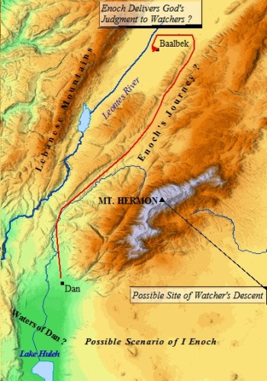 | 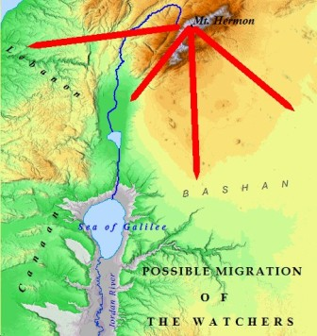

Link to Map Below
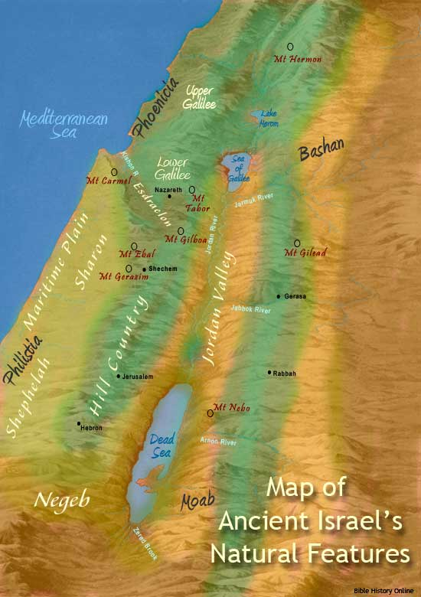

Link to Map Below
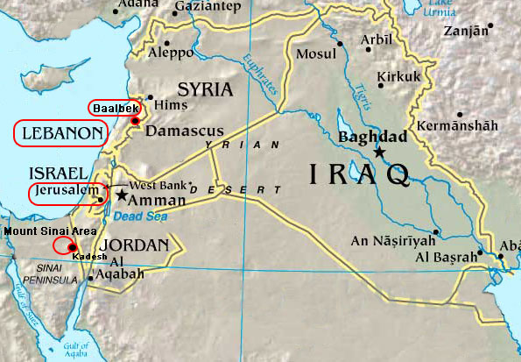
Enki and Ninmah shook their heads and begrudgingly agreed with Marduk. Enlil was outraged and refused to pacify their sympathetic actions:

Excerpt: Enlil goes off on Enki and Ninmah for agreeing with Marduk's actions
One evil deed by another has been followed, fornication from Enki and Marduk the Igigi have adopted,
Our pride and sacred mission to the winds have been abandoned, By our own hands this planet with Earthling multitudes shall be overrun! With much disgust was Enlil speaking. Let the Igigi and their females from Earth depart! On Lahmu conditions unbearable have become, surviving is not possible!
So did Marduk to Enlil and Enki say.
In the Edin they cannot remain! Enlil with anger shouted. With much disgust the gathering he left;
In his heart things against Marduk and his Earthlings was Enlil plotting.
(Is this the origin of the elitist mentality?)

The Igigi and their females were secluded at the spaceport and children were born there, they were called Children of the Rocketships. Marduk and Sarpanit also had children, Asar/Osiris and Satu/Set? were their names. Marduk invited the Igigi to dwell in the 2 cities he had built for his sons. Some of the Igigi and their offspring came to the domain in the dark-hued land while Shamgaz and others remained at the spaceport. (Is this Lower and Upper Egypt being described as 2 cities? It is know that the land in Egypt is know as "black land" because of the richness of the soil, as a result of the Nile River when it floods and recedes, leaving a black silt.) Some of their offspring went to the far eastlands, lands of high mountains (Could this be a description of the Zagros or Himalaya or Caucus Mountains?)

Link to Maps
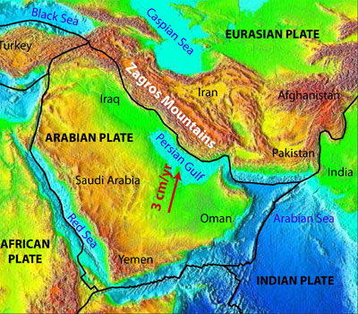 | 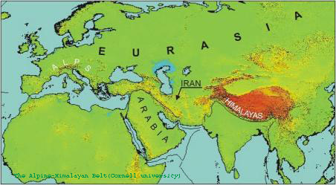

At this time, Lu-Mach was the workmaster in the Edin, and he had married Batanash, the daughter of his father's brother (his father's niece, and his first cousin). Enki admired and was charmed by her beauty. Enki sent word to Marduk to summon Lu-Mach to his domain and teach him how to build a city by labor of Earthlings. When Lu-Mach was summoned he takes his wife to the household of Ninmah, in Shurubak (the Haven City) for her protection from the angry masses of Earthlings. Thereafter Enki was quick to visit his sister Ninmah in Shurubak. Enki sees Batanash bathing on the rooftop of a dwelling, mates with her and impregnates her.(Is this the origin of the story of King David and Uriah and Bathsheba?) These [children] were born to David in Jerusalem: Shimea/Shammua, Shobab, Nathan, and Solomon (the mother of these four was Ammiel's daughter Bathshua)
2 Samuel 11

Excerpt: Lu-Mach is introduced to a son that is not his by his wife Batanash
Word was sent to Lu-Mach/Lamech, son of Matushal/Methuselah, to "return to the Edin because you have a son". He returns to the Edin and Batanash/Betenos shows the son to him.
White as the snow his skin was, the color of wool was his hair,
Like the skies were his eyes, in a brilliance were his eyes shining.
Jubilees 4:28 Book of Noah Ch. CVI (106) Genesis 5:28-29
(Book of Noah in the Book of Enoch is a fragmented version.)
(Is this the description of an albino child with blue eyes, see Melanesians OR Blue- eyed African )

Link to Image | YouTube Video Link to Image
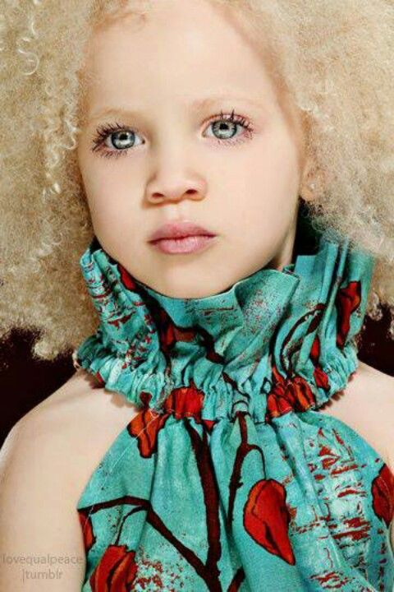 | 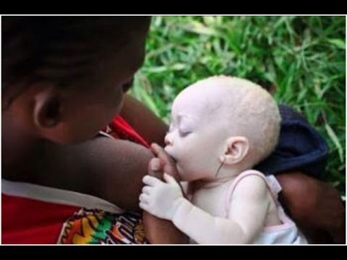
Link to Image
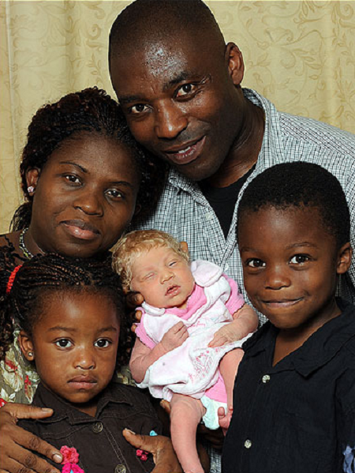

Amazed and frightened was Lu-Mach; to his father Matushal he hurried.
A son unlike an Earthling to Batanash was born, by this birth greatly puzzled I am!
Matushal to Batanash came, the newborn boy he saw, by his likeness amazed he was.
Is one of the Igigi the boy's father? Of Batanash Matushal the truth demanded;
To Lu-Mach your spouse whether this boy his son is, the truth reveal!
None of the Igigi is the boy's father, of this upon my life I swear! So did Batanash him answer
To his son Lu-Mach Matushal then turned, a calming arm on his shoulders he put
A mystery the boy is, but in his oddness an omen to you is revealed,
Unique he is, for a task unique by destiny he was chosen.
What that task is, I know not; in time appropriate, known it shall become!
So was Matushal to his son Lu-Mach saying; to what on Earth was transpiring, he was alluding:
In those days the sufferings on Earth were increasing,
The days colder grew, the skies their rains were holding back,
Fields their crops diminished, in the sheepfolds ewe lambs were few.
Let the son to you born, unusual as he is, an omen be that a respite is coming!
So did Matushal to his son Lu-Mach say. Let Respite be his name!
To Matushal and Lu-Mach Batanash her son's secret did not reveal;
Ziusudra, He of Long Bright Lifedays, she called him; in Shurubak he was raised.
Book of Enoch Ch. 105 Genesis 5:28-29
Ninmah on the child her protection and affection bestowed.
Of much understanding he was endowed, with knowledge he was by her provided.
Enki the child greatly adored, to read the writings of Adapa him he taught,
The priestly rites how to observe and perform the boy as a young man learned.
In the one hundred and tenth Shar was Ziusudra born, (110 x 3600 = 396,000 years)
In Shurubak he grew up and espoused Emzara, and she bore him three sons. Jubilees 4:33 Genesis 5:32
In his days the sufferings on Earth intensified; plagues and starvations the Earth afflicted.

Name Chart #1
Line of An (1st King on Nibiru) and his Spouse An.Tu - 3 sons: An.Ki, An.Ib, & Enuru
An.Ki  Brother to An.Ib & Enuru | An.Ib  Brother to An.Ki & Enuru  Father of An.Shar.Gal with spouse Nin.Ib  Uncle to Enama  Great Uncle to Anu | Enuru  Brother to An.Ki & An.Ib  Father of Enama with spouse Ninuru  Uncle to An.Shar.Gal  Great Uncle to Alam  Great, Great Uncle to Alalu
(NO SONS) | An.Shar.Gal  Grandson to An & An.Tu  Son of An.Ib  Father of Alam with concubine  Nephew to Enuru  1st Cousin to Enama  2nd Cousin to Anu | Enama  Grandson to An & An.Tu  Son of Enuru  Father of Anu with half-sister  Nephew to An.Ib  1st Cousin to An.Shar.Gal  2nd Cousin to Alam  3rd Cousin to Alalu
 | Alam  Great Grandson to An & An.Tu  Grandson of An.Ib  Son of An.Shar.Gal  Father of Alalu  2nd Cousin to Enama  3rd Cousin to Anu | Anu  Great Grandson to An & An.Tu  Grandson to Enuru  Son of Enama  Father of Enlil & Enki with spouse Antu  Great Nephew to An.Ib  2nd Cousin to An.Shar.Gal  3rd Cousin to Alam  4th Cousin to Alalu
 | Alalu  Great, Great Grandson to An & An.Tu  Great Grandson to An.Ib  Grandson to An.Shar.Gal  Son of Alam  4th Cousin to Anu  5th Cousin to Enlil & Enki  (NO SONS) | Enlil - Son of Anu & Antu; Legal Heir  Enki - Son of Anu & Ninlul; Firstborn son with a concubine  Great, Great Grandsons to An & An.Tu  Great Grandsons to Enuru  Grandsons to Enama

Here's where we need to resume the name chart: Name Chart #5 -- More children born on Earth from Matushal/Methuselah down to Ziusudra/Noah
(FBN) = Full-Blooded Nibirian, born on Nibiru (FBNE) = Full-Blooded Nibirian, born on Earth
(HBE) = Half-Blooded, born on Earth (FBM) = Full-Blooded Mankind
After Sati/Seth, 3rd son of Adapa & Titi, color change of names represents a child of that descendant
^{1, 2, .....} = generations down from parents

More children on Earth by Enki, Enlil, Ninmah and their children
E.A/Ea/Nudimmud/Enki (FBN)  Damkina/Ninmah/Ninki his spouse  Son of Anu with Ninlul  Grandson to Enama  Great Grandson to Enuru  2X Great Grandson to An & An.Tu  Half-Brother to Enlil & Ninmah  Son-in-law to Alalu  5th cousin to Alalu  6th cousin to Ninmah  Father of Adamu & Ti-Amat using artificial insemination  Grandfather to the 7 males and 7 females  Father of Adapa & Titi  Grandfather to Ka-In/Cain, Abael/Abel, & Sati/Seth  Great Grandfather to Enshi  2X Great Grandfather to Kunin  3X Great Grandfather to Malalu  4X Great Grandfather to Irid/Jared  5X Great Grandfather to Enki-ME/Enoch  6X Great Grandfather to Matushal | Enlil (FBN)  Ninlil/Sud his spouse  Son of Anu & Antu; Legal Heir  Grandson to Enama  Great Grandson to Enuru  2X Great Grandson to An & An.Tu  Half-Brother to Enki & Ninmah  Uncle to Marduk, 2 unknown daughters of Enki, Nergal, Gibil, Ninagal, Ningishzidda, Dumuzi  5th cousin to Alalu  6th cousin to Ninmah  Uncle to Adamu & Ti-Amat  Uncle to Adapa & Titi  Grandfather to Inanna & Utu  Great Uncle to Ka-In/Cain, Abael/Abel, & Sati/Seth  2X Great Uncle to Enshi  3X Great Uncle to Kunin  4X Great Uncle to Malalu  5X Great Uncle to Irid/Jared  6X Great Uncle to Enki-ME/Enoch  7X Great Uncle to Matushal  8X Great Uncle to Lu-Mach  Uncle to Ziusudra/Noah | Ninmah (FBN)  Biological daughter of Alalu & Namma?/ Nammu?  Royal Stepdaughter to Anu  5th cousin to Anu  6th cousin to Enki & Enlil  Half -Sister to Enki & Enlil  2X Great Step-Granddaughter to An & An.Tu  Great Step-Granddaughter  to Enuru  Step-Granddaughter To Enama  Mother of Marduk  Mother of Ninurta  Alalu's Line  Granddaughter To Alam  Great Granddaughter To An.Shar.Gal  2X Great Granddaughter To An.Ib  3X Great Granddaughter to An & An.Tu  Experiments  Surrogate Mother of Adamu  Aunt to 7 males
Marduk¹ (FBN)  Son of Enki with spouse Damkina/Ninmah/Ninki  Grandson to Anu & Antu  Great Grandson to Enama  2X Great Grandson to Enuru  3X Great Grandson to An & An.Tu  Nephew to Enlil  1st cousin to Ninurta, Nannar, Ishkur  2nd cousin to Inanna & Utu  6th cousin to Alalu  7th cousin to Ninmah  Half - Brother to Adamu  Uncle to Adamu blood 7 males  Half - Brother to Adapa & Titi  Uncle to Ka-In/Cain, Abael/Abel, & Sati/Seth  Great Uncle to Enshi  2X Great Uncle to Kunin  3X Great Uncle to Malalu  4X Great Uncle to Irid/Jared  5X Great Uncle to Enki-ME/Enoch  6X Great Uncle to Matushal | Ninurta¹ (FBN)  Son of Enlil with Ninmah  Grandson to Anu & Antu  Great Grandson to Enama  2X Great Grandson to Enuru  3X Great Grandson to An & An.Tu  Nephew to Enki  Uncle to Inanna & Utu  1st cousin to Marduk, 2 unknown daughters of Enki, Nergal, Gibil, Ninagal, Ningishzidda, Dumuzi  6th cousin to Alalu  7th cousin to Ninmah  1st cousin to Adamu  2nd cousin to Adamu blood 7 males  1st cousin to Adapa & Titi  2nd cousin to Ka-In/Cain, Abael/Abel, & Sati/Seth  3rd cousin to Enshi  4th cousin to Kunin  5th cousin to Malalu  6th cousin to Irid/Jared  7th cousin to Enki-ME/Enoch  8th cousin to Matushal  9th cousin to Lu-Mach  1st cousin to Ziusudra | Adamu (HBE)  (artificial insemination using Enki's blood/DNA)  Surrogate son of Ninmah  Half-Brother to Marduk, 2 unknown daughters of Enki, Nergal, Gibil, Ninagal, Ningishzidda, Dumuzi  1st cousin to Ninurta, Nannar, Ishkur  Half - Brother to Adapa & Titi  Uncle to Ka-In/Cain, Abael/Abel, & Sati/Seth  Great Uncle to Enshi  2X Great Uncle to Kunin  3X Great Uncle to Malalu  4X Great Uncle to Irid/Jared  5X Great Uncle to Enki-ME/Enoch  6X Great Uncle to Matushal
Asar/Osiris¹ (HBE)
Son to Marduk with spouse Sarpanit
Grandson to Enki
Great Grandson to Anu & Antu
2X Great Grandson to Enama
3X Great Grandson to Enuru
4X Great Grandson to An & An.Tu
Nephew to Nergal, Gibil, Ninagal, Ningishzidda, Dumuzi
Great Nephew to Enlil
2nd cousin to Ninurta, Nannar, Ishkur
3rd cousin to Inanna & Utu
7th cousin to Alalu
8th cousin to Ninmah
Nephew to Adamu & Ti-Amat
1st cousin to Adamu blood 7 males
Nephew to Adapa & Titi
1st cousin to Ka-In/Cain, Abael/Abel, Sati/Seth, Azura, & Awan
2nd cousin to Enshi/Enosh/Enos
3rd cousin to Kunin/Cainan
4th cousin to Malalu/Mahalalel
5th cousin to Irid/Jared
6th cousin to Enki-ME/Enoch
7th cousin to Matushal/Methuselah
8th cousin to Lu-Mach/Lamech
Nephew to Ziusudra/Noah
Satu/Set² (HBE)
Son to Marduk with spouse Sarpanit
Grandson to Enki
Great Grandson to Anu & Antu
2X Great Grandson to Enama
3X Great Grandson to Enuru
4X Great Grandson to An & An.Tu
Nephew to Nergal, Gibil, Ninagal, Ningishzidda, Dumuzi
Great Nephew to Enlil
2nd cousin to Ninurta, Nannar, Ishkur
3rd cousin to Inanna & Utu
7th cousin to Alalu
8th cousin to Ninmah
Nephew to Adamu & Ti-Amat
1st cousin to Adamu blood 7 males
Nephew to Adapa & Titi
1st cousin to Ka-In/Cain, Abael/Abel, Sati/Seth, Azura, & Awan
2nd cousin to Enshi/Enosh/Enos
3rd cousin to Kunin/Cainan
4th cousin to Malalu/Mahalalel
5th cousin to Irid/Jared
6th cousin to Enki-ME/Enoch
7th cousin to Matushal/Methuselah
8th cousin to Lu-Mach/Lamech
Nephew to Ziusudra/Noah
2 daughters² with Ninmah, names unknown
(FBNE)
Daughters to Enki with Ninmah
Granddaughters to Anu & Antu
Great Granddaughters to Enama
2X Great Granddaughters to Enuru
3X Great Granddaughters to An & An.Tu
Half-Sisters to Marduk, 2 unknown daughters of Enki, Nergal, Gibil, Ninagal, Ningishzidda, Dumuzi
Nieces to Enlil
1st cousin to Ninurta, Nannar, Ishkur
2nd cousin to Inanna & Utu
7th cousin to Alalu
8th cousin to Ninmah
Half-Sisters to Adamu & Ti-Amat
Half-Sisters to Adapa & Titi
Aunts to Ka-In/Cain, Abael/Abel, & Sati/Seth
Aunts to 60 unnamed children after Abael/Abel's death
Great Aunts to Enshi/Enosh/Enos
2XGreat Aunts to Kunin/Cainan
3X Great Aunts to Malalu/Mahalalel
4X Great Aunts to Irid/Jared
5X Great Aunts to Enki-ME/Enoch
6X Great Aunts to Matushal/Methuselah
7X Great Aunts to Lu-Mach/Lamech
Half-Sister to Ziusudra/Noah
Nergal³ (FBNE)  his spouse Ereshkigal (Enlil's granddaughter)  Son of Enki with concubine  Grandson to Anu & Antu  Great Grandson to Enama  2X Great Grandson to Enuru  3X Great Grandson to An & An.Tu  Half-Brother to Enki's 2 daughters with Ninmah  Uncle to Asar/Osiris & Satu/Set  Nephew to Enlil  1st cousin to Ninurta, Nannar, Ishkur  6th cousin to Alalu  7th cousin to Ninmah  Half - Brother to Adamu  Uncle to Adamu blood 7 males  Half - Brother to Adapa & Titi  Uncle to Ka-In/Cain, Abael/Abel, Sati/Seth, Azura, & Awan  Great Uncle to Enshi  2X Great Uncle to Kunin  3X Great Uncle to Malalu  4X Great Uncle to Irid/Jared  5X Great Uncle to Enki-ME/Enoch  6X Great Uncle to Matushal/Methuselah  7X Great Uncle to Lu-Mach/Lamech | Nannar² (FBNE)  1st Royal Nibirian born on Earth  Ningal was his spouse  Father of Inanna & Utu  Son of Enlil with spouse Ninlil/Sud  Grandson to Anu & Antu  Great Grandson to Enama  2X Great Grandson to Enuru  3X Great Grandson to An & An.Tu  Half-Brother to Ninurta  Nephew to Enki  1st cousin to Marduk, 2 unknown daughters of Enki, Nergal, Gibil, Ninagal, Ningishzidda, Dumuzi  6th cousin to Alalu  7th cousin to Ninmah  1st cousin to Adamu  2nd cousin to Adamu blood 7 males  1st cousin to Adapa & Titi  2nd cousin to Ka-In/Cain, Abael/Abel, & Sati/Seth  3rd cousin to Enshi  4th cousin to Kunin  5th cousin to Malalu  6th cousin to Irid/Jared  7th cousin to Enki-ME/Enoch  8th cousin to Matushal  9th cousin to Lu-Mach  1st cousin to Ziusudra | 7 surrogates (HBE)  blood/DNA from Adamu  Ninimma - male, no name  Shuzianna - male, no name  Ninmada - male, no name  Ninbara - male, no name  Ninmug - male, no name  Musardu - male, no name  Ningunna - male, no name  7 males are Nephews to Marduk, 2 unknown daughters of Enki, Nergal, Gibil, Ninagal, Ningishzidda, Dumuzi  2nd cousin to Ninurta, Nannar, Ishkur  Sons to Adamu  1st cousin to Ka-In/Cain,  Abael/Abel, & Sati/Seth  2nd cousin to Enshi  3rd cousin to Kunin  4th cousin to Malalu  5th cousin to Irid/Jared  6th cousin to Enki-ME/Enoch  7th cousin to Matushal
Gibil⁴ (FBNE)  Son of Enki with concubine  Grandson to Anu & Antu  Great Grandson to Enama  2X Great Grandson to Enuru  3X Great Grandson to An & An.Tu  Half-Brother to Enki's 2 daughters with Ninmah  Uncle to Asar/Osiris & Satu/Set  Nephew to Enlil  1st cousin to Ninurta, Nannar, Ishkur  6th cousin to Alalu  7th cousin to Ninmah  Half - Brother to Adamu  Uncle to Adamu blood 7 males  Half - Brother to Adapa & Titi  Uncle to Ka-In/Cain, Abael/Abel, Sati/Seth, Azura, & Awan  Great Uncle to Enshi  2X Great Uncle to Kunin  3X Great Uncle to Malalu  4X Great Uncle to Irid/Jared  5X Great Uncle to Enki-ME/Enoch  6X Great Uncle to Matushal/Methuselah  7X Great Uncle to Lu-Mach/Lamech | Inanna/Anunitu/Ishtar¹  (FBNE)  Daughter of Nannar with spouse Ningal  Niece to Ninurta & Ishkur  Granddaughter to Enlil & Ninlil/Sud  Great Granddaughter to Anu & Antu  2X Great Granddaughter to Enama  3X Great Granddaughter to Enuru  4X Great Granddaughter to An & An.Tu  2nd cousin to Marduk, 2 unknown daughters of Enki, Nergal, Gibil, Ninagal, Ningishzidda, Dumuzi  7th cousin to Alalu  8th cousin to Ninmah  2nd cousin to Adamu  2nd cousin to Adapa & Titi  3rd cousin to Ka-In/Cain, Abael/Abel & Sati/Seth  4th cousin to Enshi  5th cousin to Kunin  6th cousin to Malalu  7th cousin to Irid/Jared  8th cousin to Enki-ME/Enoch  9th cousin to Matushal  10th cousin to Lu-Mach  2nd Cousin to Ziusudra
Ninagal⁵ (FBNE)  Son of Enki with concubine  Grandson to Anu & Antu  Great Grandson to Enama  2X Great Grandson to Enuru  3X Great Grandson to An & An.Tu  Half-Brother to Enki's 2 daughters with Ninmah  Uncle to Asar/Osiris & Satu/Set  Nephew to Enlil  1st cousin to Ninurta, Nannar, Ishkur  6th cousin to Alalu  7th cousin to Ninmah  Half - Brother to Adamu  Uncle to Adamu blood 7 males  Half - Brother to Adapa & Titi  Uncle to Ka-In/Cain, Abael/Abel, Sati/Seth, Azura, & Awan  Great Uncle to Enshi  2X Great Uncle to Kunin  3X Great Uncle to Malalu  4X Great Uncle to Irid/Jared  5X Great Uncle to Enki-ME/Enoch  6X Great Uncle to Matushal/Methuselah  7X Great Uncle to Lu-Mach/Lamech | Utu² (FBNE)  Son of Nannar with spouse Ningal  Nephew to Ninurta & Ishkur  Grandson to Enlil & Ninlil/Sud  Great Grandson to Anu & Antu  2X Great Grandson to Enama  3X Great Grandson to Enuru  4X Great Grandson to An & An.Tu  2nd cousin to Marduk, 2 unknown daughters of Enki, Nergal, Gibil, Ninagal, Ningishzidda, Dumuzi  7th cousin to Alalu  8th cousin to Ninmah  2nd cousin to Adamu  2nd cousin to Adapa & Titi  3rd cousin to Ka-In/Cain, Abael/Abel & Sati/Seth  4th cousin to Enshi  5th cousin to Kunin  6th cousin to Malalu  7th cousin to Irid/Jared  8th cousin to Enki-ME/Enoch  9th cousin to Matushal  10th cousin to Lu-Mach  2nd Cousin to Ziusudra
Ningishzidda⁶ (FBNE)  Son of Enki with spouse Damkina  Grandson to Anu & Antu  Great Grandson to Enama  2X Great Grandson to Enuru  3X Great Grandson to An & An.Tu  Half-Brother to Enki's 2 daughters with Ninmah  Uncle to Asar/Osiris & Satu/Set  Nephew to Enlil  1st cousin to Ninurta, Nannar, Ishkur  6th cousin to Alalu  7th cousin to Ninmah  Half - Brother to Adamu  Uncle to Adamu blood 7 males  Half - Brother to Adapa & Titi  Uncle to Ka-In/Cain, Abael/Abel, Sati/Seth, Azura, & Awan  Great Uncle to Enshi  2X Great Uncle to Kunin  3X Great Uncle to Malalu  4X Great Uncle to Irid/Jared  5X Great Uncle to Enki-ME/Enoch  6X Great Uncle to Matushal/Methuselah  7X Great Uncle to Lu-Mach/Lamech | Ishkur³ (FBNE)  Son of Enlil with spouse Ninlil/Sud  2nd Royal Nibirian born on Earth  Grandson to Anu & Antu  Great Grandson to Enama  2X Great Grandson to Enuru  3X Great Grandson to An & An.Tu  Brother to Nannar  Half-Brother to Ninurta  Uncle to Inanna & Utu  Nephew to Enki  1st cousin to Marduk, 2 unknown daughters of Enki, Nergal, Gibil, Ninagal, Ningishzidda, Dumuzi  6th cousin to Alalu  7th cousin to Ninmah  1st cousin to Adamu  2nd cousin to Adamu blood 7 males  1st cousin to Adapa & Titi  2nd cousin to Ka-In/Cain, Abael/Abel, & Sati/Seth  3rd cousin to Enshi  4th cousin to Kunin  5th cousin to Malalu  6th cousin to Irid/Jared  7th cousin to Enki-ME/Enoch  8th cousin to Matushal  9th cousin to Lu-Mach  1st cousin to Ziusudra
Dumuzi/ Tammuz⁷ (FBNE)
Son of Enki with spouse Damkina
Grandson to Anu & Antu
Great Grandson to Enama
2X Great Grandson to Enuru
3X Great Grandson to An & An.Tu
Half-Brother to Enki's 2 daughters with Ninmah
Uncle to Asar/Osiris & Satu/Set
Nephew to Enlil
1st cousin to Ninurta, Nannar, Ishkur
6th cousin to Alalu
7th cousin to Ninmah
Half - Brother to Adamu
Uncle to Adamu blood 7 males
Half - Brother to Adapa & Titi
Uncle to Ka-In/Cain, Abael/Abel, Sati/Seth, Azura, & Awan
Great Uncle to Enshi
2X Great Uncle to Kunin
3X Great Uncle to Malalu
4X Great Uncle to Irid/Jared
5X Great Uncle to Enki-ME/Enoch
6X Great Uncle to Matushal/Methuselah
7X Great Uncle to Lu-Mach/Lamech
Adamu⁸ (HBE)
(artificial insemination using Enki's blood/DNA)
Surrogate son to Enki with Ninmah
Grandson to Anu & Antu
Great Grandson to Enama
2X Great Grandson to Enuru
3X Great Grandson to An & An.Tu
Half-Brother to Marduk, 2 unknown daughters of Enki, Nergal, Gibil, Ninagal, Ningishzidda, Dumuzi
1st cousin to Ninurta, Nannar, Ishkur
2nd cousin to Inanna & Utu
3X Great Grandson to An & An.Tu
2X Great Grandson to Enuru
Great Grandson to Enama
Grandson to Anu & Antu
Half-Brother to Adapa & Titi
Uncle to Ka-In/Cain, Abael/Abel, & Sati/Seth
Great Uncle to Enshi
2X Great Uncle to Kunin
3X Great Uncle to Malalu
4X Great Uncle to Irid/Jared
5X Great Uncle to Enki-ME/Enoch
6X Great Uncle to Matushal
Half-Brother to Ziusudra
Ti-Amat⁹ (HBE)
(artificial insemination using Enki's blood/DNA with spouse Damkina/Ninki)
Daughter of Enki with spouse Damkina/Ninki
Granddaughter to Anu & Antu
Great Granddaughter to Enama
2X Great Granddaughter to Enuru
3X Great Granddaughter to An & An.Tu
Niece to Enlil
1st cousin to Ninurta, Nannar, Ishkur
6th cousin to Alalu
7th cousin to Ninmah
Half - Sister to Adamu, Adapa & Titi
Aunt to Ka-In/Cain, Abael/Abel, & Sati/Seth
Aunt to Adamu blood 7 males
Mother for 7 surrogates (HB; Earth) using her own
blood/DNA resulting in 7 females for the 7 males
2nd cousin to Inanna & Utu
Great Aunt to Enshi/Enosh
2X Great Aunt to Kunin/Cainan
3X Great Aunt to Malalu/Mahalalel
4X Great Aunt to Irid/Jared
5X Great Aunt to Enki-ME/Enoch
6X Great Aunt to Matushal/Methuselah
7X Great Aunt to Lu-Mach/Lamech
Half-Sister to Ziusudra/Noah
Adapa¹⁰ (FBM)
Son of Enki with concubine Earthling
Grandson to Anu & Antu
Great Grandson to Enama
2X Great Grandson to Enuru
3X Great Grandson to An & An.Tu
Nephew to Enlil
Half-Brother to Marduk, 2 unknown daughters of Enki, Nergal, Gibil, Ninagal, Ningishzidda, Dumuzi
1st cousin to Ninurta, Nannar, Ishkur
2nd cousin to Inanna & Utu
7th cousin to Alalu
8th cousin to Ninmah
Half-Brother to Adamu & Ti-Amat
Father of 60 unnamed children after Abael/Abel's death
Grandfather to Enshi
Great Grandfather to Kunin
2X Great Grandfather to Malalu
3X Great Grandfather to Irid/Jared
4X Great Grandfather to Enki-ME/Enoch
5X Great Grandfather to Matushal
6X Great Grandfather to Lu-Mach
Half-Brother to Ziusudra
Titi¹¹ (FBM)
Daughter of Enki with concubine Earthling
Granddaughter to Anu & Antu
Great Granddaughter to Enama
2X Great Granddaughter to Enuru
3X Great Granddaughter to An & An.Tu
Half-Sister to Marduk, 2 unknown daughters of Enki, Nergal, Gibil, Ninagal, Ningishzidda, Dumuzi
Niece to Enlil
1st cousin to Ninurta, Nannar, Ishkur
2nd cousin to Inanna & Utu
7th cousin to Alalu
8th cousin to Ninmah
Half-Sister to Adamu & Ti-Amat
Mother to Ka-In/Cain, Abael/Abel, & Sati/Seth
Mother of 60 unnamed children after Abael/Abel's death
Grandmother to Enshi
Great Grandmother to Kunin
2X Great Grandmother to Malalu
3X Great Grandmother to Irid/Jared
4X Great Grandmother to Enki-ME/Enoch
5X Great Grandmother to Matushal
6X Great Grandmother to Lu-Mach
Half-Sister to Ziusudra
Abael/Abel¹ (FBM)
Son of Adapa & Titi
Grandson to Enki
Great Grandson to Anu & Antu
2X Great Grandson to Enama
3X Great Grandson to Enuru
4X Great Grandson to An & An.Tu
Twin Brother to Ka-In
Nephew to Marduk, 2 unknown daughters of Enki, Nergal, Gibil, Ninagal, Ningishzidda, Dumuzi
Nephew to Adamu & Ti-Amat
Great Nephew to Enlil
2nd cousin to Ninurta, Nannar, Ishkur
3rd cousin to Inanna & Utu
8th cousin to Alalu
9th cousin to Ninmah
Uncle to Enshi
Great Uncle to Kunin
2X Great Uncle to Malalu
3X Great Uncle to Irid/Jared
4X Great Uncle to Enki-ME/Enoch
5X Great Uncle to Matushal
6X Great Uncle to Lu-Mach
Nephew to Ziusudra
Ka-In/Cain² (FBM)
his spouse Awan
(sister to Azura, Sati/Seth, Ka-in, & Abael)
Son of Adapa & Titi
Grandson to Enki
Great Grandson to Anu & Antu
2X Great Grandson to Enama
3X Great Grandson to Enuru
4X Great Grandson to An & An.Tu
Twin Brother to Ka-In
Nephew to Marduk, 2 unknown daughters of Enki, Nergal, Gibil, Ninagal, Ningishzidda, Dumuzi
Nephew to Adamu & Ti-Amat
Great Nephew to Enlil
2nd cousin to Ninurta, Nannar, Ishkur
3rd cousin to Inanna & Utu
8th cousin to Alalu
9th cousin to Ninmah
Uncle to Enshi
Great Uncle to Kunin
2X Great Uncle to Malalu
3X Great Uncle to Irid/Jared
4X Great Uncle to Enki-ME/Enoch
5X Great Uncle to Matushal
6X Great Uncle to Lu-Mach
Nephew to Ziusudra
Sati/Seth³ (FBM)
his spouse Azura
(sister to Awan, Sati/Seth, Ka-in, & Abael)
Father of Enshi & Noam
Son of Adapa & Titi
Grandson to Enki
Great Grandson to Anu & Antu
2X Great Grandson to Enama
3X Great Grandson to Enuru
4X Great Grandson to An & An.Tu
Twin Brother to Abael
Nephew to Marduk, 2 unknown daughters of Enki, Nergal, Gibil, Ninagal, Ningishzidda, Dumuzi
Nephew to Adamu & Ti-Amat
Great Nephew to Enlil
3rd cousin to Ninurta, Nannar, Ishkur
4th cousin to Inanna & Utu
8th cousin to Alalu
9th cousin to Ninmah
Grandfather to Kunin/Cainan
Great Grandfather to Malalu/Mahalalel
2X Great Grandfather to Irid/Jared
3X Great Grandfather to Enki-ME/Enoch
4X Great Grandfather to Matushal/Methuselah
Nephew to Ziusudra
Enshi/Enosh¹ (FBM)
his spouse Noam (sister)
Son of Sati/Seth with his spouse Azura
Father to Kunin/Cainan/Kenan
Grandfather to Malalu/Mahalalel
Grandson to Adapa & Titi
Great Grandson to Enki
2X Great Grandson to Anu & Antu
3X Great Grandson to Enama
4X Great Grandson to Enuru
5X Great Grandson to An & An.Tu
Nephew to Ka-in, Abael, Awan, Azura,
Great Nephew to Marduk, 2 unknown daughters of Enki, Nergal, Gibil, Ninagal, Ningishzidda, Dumuzi
2X Great Nephew to Enlil
3rd cousin to Ninurta, Nannar, Ishkur
4th cousin to Inanna & Utu
9th cousin to Alalu
10th cousin to Ninmah
Great Nephew to Adamu & Ti-Amat
Great Nephew to Ziusudra
Kunin/Cainan² (FBM)
his spouse Mualit (half-sister)
Son of Enshi with his spouse Noam
Father to Malalu/Mahalalel
Grandfather to Irid/Jared
Grandson to Sati/Seth & Azura
Great Grandson to Adapa & Titi
2X Great Grandson to Enki
3X Great Grandson to Anu & Antu
4X Great Grandson to Enama
5X Great Grandson to Enuru
6X Great Grandson to An & An.Tu
Great Nephew to Ka-in, Abael, Awan, Azura, Sati/Seth
2X Great Nephew to Marduk, 2 unknown daughters of Enki, Nergal, Gibil, Ninagal, Ningishzidda, Dumuzi
3X Great Nephew to Enlil
4th cousin to Ninurta, Nannar, Ishkur
5th cousin to Inanna & Utu
10th cousin to Alalu
11th cousin to Ninmah
2X Great Nephew to Adamu & Ti-Amat
2X Great Nephew to Ziusudra
Malalu/Mahalalel³ (FBM)
his spouse Dunna (first cousin; niece to Kunin)
Son of Kunin with his spouse Mualit
Father to Irid/Jared
Grandfather to Enki-Me/Enoch
Grandson to Enshi & Noam
Great Grandson to Sati/Seth & Azura
2X Great Grandson to Adapa & Titi
3X Great Grandson to Enki
4X Great Grandson to Anu & Antu
5X Great Grandson to Enama
6X Great Grandson to Enuru
7X Great Grandson to An & An.Tu
2X Great Nephew to Ka-in, Abael, Awan, Azura, Sati/Seth
3X Great Nephew to Marduk, 2 unknown daughters of Enki, Nergal, Gibil, Ninagal, Ningishzidda, Dumuzi
4X Great Nephew to Enlil
5th cousin to Ninurta, Nannar, Ishkur
6th cousin to Inanna & Utu
11th cousin to Alalu
12th cousin to Ninmah
3X Great Nephew to Adamu & Ti-Amat
3X Great Nephew to Ziusudra
Irid/Jared⁴ (FBM)
his spouse Baraka (first cousin; niece to Dunna)
Son of Malalu with his spouse Dunna
Father to Enki-ME/Enoch
Grandfather to Matushal/Methuselah
Grandson to Kunin & Mualit
Great Grandson to Enshi & Noam
2X Great Grandson to Sati/Seth & Azura
3X Great Grandson to Adapa & Titi
4X Great Grandson to Enki
5X Great Grandson to Anu & Antu
6X Great Grandson to Enama
7X Great Grandson to Enuru
8X Great Grandson to An & An.Tu
3X Great Nephew to Ka-in, Abael, Awan, Azura, Sati/Seth
4X Great Nephew to Marduk, 2 unknown daughters of Enki, Nergal, Gibil, Ninagal, Ningishzidda, Dumuzi
5X Great Nephew to Enlil
6th cousin to Ninurta, Nannar, Ishkur
7th cousin to Inanna & Utu
12th cousin to Alalu
13th cousin to Ninmah
4X Great Nephew to Adamu & Ti-Amat
4X Great Nephew to Ziusudra
Enki-ME/Enoch⁵ (FBM)
his spouse Edinni (half-sister)
Son of Irid/Jared with his spouse Baraka
Father to Matushal/Methuselah
Grandfather to Lu-Mach/Lamech
Grandson to Malalu & Dunna
Great Grandson to Kunin & Mualit
2X Great Grandson to Enshi & Noam
3X Great Grandson to Sati/Seth & Azura
4X Great Grandson to Adapa & Titi
5X Great Grandson to Enki
6X Great Grandson to Anu & Antu
7X Great Grandson to Enama
8X Great Grandson to Enuru
9X Great Grandson to An & An.Tu
4X Great Nephew to Ka-in, Abael, Awan, Azura, Sati/Seth
5X Great Nephew to Marduk, 2 unknown daughters of Enki, Nergal, Gibil, Ninagal, Ningishzidda, Dumuzi
6X Great Nephew to Enlil
7th cousin to Ninurta, Nannar, Ishkur
8th cousin to Inanna & Utu
13th cousin to Alalu
14th cousin to Ninmah
5X Great Nephew to Adamu & Ti-Amat
5X Great Nephew to Ziusudra
Matushal/Methuselah⁶ (FBM)
his spouse Ednat
Son of Enki-Me with his spouse Edinni
Father to Lu-Mach/Lamech
Grandson to Irid/Jared & Baraka
Great Grandson to Malalu & Dunna
2X Great Grandson to Kunin & Mualit
3X Great Grandson to Enshi & Noam
4X Great Grandson to Sati/Seth & Azura
5X Great Grandson to Adapa & Titi
6X Great Grandson to Enki
7X Great Grandson to Anu & Antu
8X Great Grandson to Enama
9X Great Grandson to Enuru
10X Great Grandson to An & An.Tu
5X Great Nephew to Ka-in, Abael, Awan, Azura, Sati/Seth
6X Great Nephew to Marduk, 2 unknown daughters of Enki, Nergal, Gibil, Ninagal, Ningishzidda, Dumuzi
7X Great Nephew to Enlil
8th cousin to Ninurta, Nannar, Ishkur
9th cousin to Inanna & Utu
14th cousin to Alalu
15th cousin to Ninmah
6X Great Nephew to Adamu & Ti-Amat
6X Great Nephew to Ziusudra
Lu-Mach/Lamech⁷ (FBM)
his spouse Batanash/Betenos
(first cousin; niece to Matushal/Methuselah)
Son of Matushal/Methuselah with his spouse Ednat
Stepfather to Ziusudra/Noah (son of Enki with Batanash)
Grandson to Enki-ME & Edinni
Great Grandson to Irid/Jared & Baraka
2X Great Grandson to Malalu & Dunna
3X Great Grandson to Kunin & Mualit
4X Great Grandson to Enshi & Noam
5X Great Grandson to Sati/Seth & Azura
6X Great Grandson to Adapa & Titi
7X Great Grandson to Enki
8X Great Grandson to Anu & Antu
9X Great Grandson to Enama
10X Great Grandson to Enuru
11X Great Grandson to An & An.Tu
6X Great Nephew to Ka-in, Abael, Awan, Azura, Sati/Seth
7X Great Nephew to Marduk, 2 unknown daughters of Enki, Nergal, Gibil, Ninagal, Ningishzidda, Dumuzi
8X Great Nephew to Enlil
9th cousin to Ninurta, Nannar, Ishkur
10th cousin to Inanna & Utu
15th cousin to Alalu
16th cousin to Ninmah
7X Great Nephew to Adamu & Ti-Amat
7X Great Nephew to Ziusudra
Ziusudra/Noah⁸ (HBE)
his spouse Emzara
Son of Enki with Batanash
Father to Shem, Ham, & Yafet/Japheth
Step-Son to Lu-Mach/Lamech
Grandson to Anu & Antu
Great Grandson to Enama
2X Great Grandson to Enuru
3X Great Grandson to An & An.Tu
Half-Brother to Enki's 2 daughters with Ninmah
Uncle to Asar/Osiris & Satu/Set
Nephew to Enlil
1st cousin to Ninurta, Nannar, Ishkur
6th cousin to Alalu
7th cousin to Ninmah
Half - Brother to Adamu
Uncle to Adamu blood 7 males
Half - Brother to Adapa & Titi
Uncle to Ka-In/Cain, Abael/Abel, Sati/Seth, Azura, & Awan
Great Uncle to Enshi/Enosh/Enos
2X Great Uncle to Kunin/Cainan/Kenan
3X Great Uncle to Malalu/Mahalalel
4X Great Uncle to Irid/Jared
5X Great Uncle to Enki-ME/Enoch
6X Great Uncle to Matushal/Methuselah (his Grandfather)
7X Great Uncle to Lu-Mach/Lamech (his Stepfather)
Enlil was disturbed by the conjugations of the Igigi and Earthling daughters and distraught at Marduk's marriage to an Earthling. His view was that the Anunnaki mission to Earth had become perverted.

Excerpt: Enlil sleepless because of the activity of the Igigi & Earthlings
To him the howling, shouting Earthling masses an anathema became;
Oppressive the pronouncements of the Earthlings have become,
The conjugations of sleep deprive me! So did Enlil to the other leaders say. Genesis 6:1-6
In the days of Ziusudra plagues and pestilences the Earth afflicted,
Aches, dizziness, chills, fevers the Earthlings overwhelmed.

Ninmah wants to teach the Earthlings how to cure themselves (Enlil forbade her by decree), and Enki wants to teach them pond- and canal-building in order to sustain themselves ("This by decree I forbid! Enlil to Enki said. Let the Earthlings by hunger and pestilence perish!"). Enlil forbade the suggestions of both Ninmah and Enki.
In the lands whereto the Earthlings had spread, waters did not rise from their sources. The earth shut its womb, and vegetation did not sprout.
For one Shar the Earthlings ate the grasses of the fields,
For the second Shar, the third Shar, the vengeance of Enlil they suffered.
Things were becoming unbearable in Shurubak, Ziusudra's city, and Ziusudra, as a spokesman for the Earthlings, goes to Eridu and to the house of Enki pleading for help and salvation, but Enki was bound by Enlil's decrees (official order). (113 x 3600 = 406,800 years)

Excerpt: Events that were effecting the Earth for 4 Shars (14,400 years)
In those days the Anunnaki for their own surviving were concerned;
Their own rations were diminished, by Earth's changes they themselves afflicted became.
On Earth as on Lahmu/Mars the seasons their regularity lost.
For one Shar, for two Shars, from Nibiru the heavenly circuits were studied,
Oddities in the planetary destinies from Nibiru were observed.
On the Sun's face black spots were appearing, from its face flames shot up;
Kishar/Jupiter also was misbehaving, its host its footings lost, dizzying were their circuits.
The Hammered Bracelet was by unseen netforces pulled and pushed,
For reasons unfathomed, the Sun its family was upsetting;
The destinies of the celestials by unsavory fates were overtaken!
On Nibiru the savants alarms raised, in the public squares the people gathered;
The Creator of All, to primordial days the heavens is returning,
Angry is the Creator of All! voices from amongst the people shouted.
On Earth the tribulations were increasing, fear and famine their heads reared.
For three Shars, for four Shars the instruments the Whiteland facing were observed,
By Nergal and Ereshkigal odd rumblings in the Whiteland's snows were recorded:
The snow-ice that the Whiteland covers to sliding has taken! So did they from Abzu's tip report.
In the Land Beyond the Seas, Ninurta in his haven foretelling instruments established,
Quakes and jitters at the Earth's bottom with the instruments he noticed. (Is this the origin of radars and weather forecasting, and is this the origin of the seismograph for measuring movements of the earth or earthquakes?) An odd matter is afoot! So did Enlil to Anu on Nibiru words of alarm send.

For the 5th Shar & 6th Shar the events got stronger and the savants on Nibiru gave forewarnings to Anu, the king. "The next time Nibiru nears the Sun, Earth will be exposed to Nibiru's netforce (gravitational pull) and will not have protection. Lahmu/Mars in its circuits will take its station on the other side of the Sun, therefore will be protected. Kishar/Jupiter and its host, and Lahamu/Venus shall shake and wobble. In the Earth's great Below (South Pole), the snow-ice of the Whiteland (Arctic Circle) is losing its footing. The next time Nibiru shall approach the Earth at its closest point, the snow-ice will come a-sliding of the Whiteland's face. It will cause a calamity: a huge wave, a Deluge, will overwhelm the Earth." Genesis 6:11-12
(119 x 3600 = 428,400 years)

Excerpt: Preparing for the deluge
On Nibiru great was the consternation, uncertain about Nibiru's own fate,
King, savants, and counselors about Earth and Lahmu also greatly worried.
The king and the counselors a decision made: for evacuating Earth and Lahmu to prepare!
In the Abzu the gold mines shut down, therefrom the Anunnaki to the Edin came;
In Bad-Tibira smelting and refining ceased, all gold to Nibiru was lofted.
Empty, for evacuating ready, a fleet of fast celestial chariots to Earth returned;
On Nibiru the heavenly signs were watched, on Earth the tremors recorded were.

While the Anunnaki were preparing for evacuating Earth, they got a surprise visit. Galzu (Great Knower; white-haired), emissary plenipotentiary of King & Council, had been sent to deliver a message to the "leaders" on Earth. (Is this the description of the first gray-haired Anunnaki?) Galzu gives Enlil a sealed message from Anu. Enlil examined the seal of the message. It was unbroken and authentic. Enlil reads the message tablet at Nibru-Ki, and its encoding was trustworthy. The message read: "For King and Council Galzu speaks, his words are my command!". These were the words from Anu.

Galzu requested that Enki & Ninmah be summoned also. When they came, with a smile, he said to Ninmah: "we are of the same school and the same age". She could not remember him, he looked so young and she looked so old, like his mother. The matter was part of his mission, a secret concerning the evacuation. On Nibiru, they had been examining those who returned from Earth since Dimuzi's stay when he went to Nibiru with Adapa. Those who stayed on Earth the longest and returned to Nibiru were harshly afflicted:
1) their bodies were no longer accustomed to Nibiru's cycles
2) their sleep was disturbed
3) their eyesight was failing
4) the netforce of Nibiru weighted their walk
5) their minds were affected ("sons were older than the parents they had left")
6) death came quickly to returnees

Excerpt: Conversation after 3 Leaders get the bad news and their message from the king
Ninmah was the first to speak: That much was to be expected! she was saying.
Enki, the wise one, to her words consented: That much was clear! he said.
Enlil with anger was seized: Before, the Earthlings like us were becoming,
Now we as Earthlings have become to this planet imprisoned!
This whole mission to a nightmare turned, by Enki and his Earthlings from masters, slaves we
were made!
To the outburst Galzu with compassion listened. Indeed much there is to ponder, he said,
On Nibiru much thinking and soul-searching deep questions were raising:
Should Nibiru to its fate been left, whatever by the Creator of All intended, to be let to happen,
Or was the coming to Earth by the Creator of All conceived, and we only unwitting emissaries?
Of that, my comrades, the debate will continue! So was Galzu to them saying.
Now this is the secret command from Nibiru:
The three of you on Earth will remain; only to die to Nibiru you will return!
In celestial chariots, the Earth encircling, the calamity you shall outwait;
To each of the other Anunnaki, a choice to leave or the calamity outwait must be given.
The Igigi who Earthlings espoused must between departure and spouses choose:
No Earthling, Marduk's Sarpanit included, to Nibiru to journey is allowed!
For all who stay and what happens see, in celestial chariots they safety must seek!
As for all the others, to depart for Nibiru forthwith they ready must be!
So did Galzu Nibiru's commands to the leaders in secret reveal.

Excerpt: How the Anunnaki decide to abandon Earth and take an oath to let the earthlings perish in the deluge
In Nibru-ki Enlil a council of Anunnaki and Igigi commanders summoned,
The leaders' sons and their children also were present.
Word of the impending calamity Enlil to them as a secret revealed.
To a bitter end Earth Mission has come! to them he solemnly said.
All who to leave wish in celestial boats that are ready to Nibiru will be evacuated,
But if Earthling spouses they have, without the spouses they must leave.
Igigi who to their spouses and offspring attached are, let them to the highest peaks on Earth
escape!
As for a few of us Anunnaki who will choose to stay, in Boats of Heaven in Earth's skies will we
remain,
The calamity to outwait, the fate of Earth to witness!
As the commander, I shall be the first one to stay! So was Enlil saying.
By their own choice will be the others!
With my father I choose to stay, the calamity to face! So did Ninurta announce.
To the Lands Beyond the Oceans after the Deluge I will return!
Nannar, Enlil's on Earth firstborn, an odd wish announced:
The Deluge to outwait not in Earth's skies but on the Moon; that was his wish.
Enki an eyebrow raised; Enlil, though puzzled, approved.
Ishkur, Enlil's youngest, to remain on Earth with his father his decision made.
Utu and Inanna, Nannar's children who on Earth were born, to stay declared.
Enki and Ninki, to stay and Earth not abandon chose; proudly they so announced.
The Igigi and Sarpanit I shall not desert! Marduk with anger stated.
One by one Enki's other sons their choice to stay announced: Nergal and Gibil, Ninagal and
Ningishzidda and Dumuzi too.
All eyes to Ninmah then turned; with pride her choice to stay she declared:
My lifework is here! The Earthlings, my created, I shall not abandon!
By her words Anunnaki and Igigi to a clamor were stirred; about the Earthlings' fate they
inquired.
Let the Earthlings for the abominations perish; so did Enlil proclaim.
A wonderous Being by us was created, by us saved it must be, Enki to Enlil shouted.
To this Enlil with his own shouted words retorted:
From the very beginning, at every turn, the decisions by you modified were!
To Primitive Workers procreating you gave, to them Knowing you endowed!
The powers of the Creator of All into your hands you have taken,
Thereafter even that by abominations you fouled.
With fornication Adapa you conceived, Understanding to his line you gave!
His offspring to the heavens you have taken, our Wisdom with them you shared!
Every rule you have broken, decisions and command you ignored,
Because of you by a Civilized Earthling brother a brother murdered,
Because of Marduk your son the Igigi like him with Earthlings intermarried.
Who is lordly from Nibiru, to whom the Earth alone belongs, to no one is no longer known!
Enough! Enough! to all that I say. The abominations cannot continue!
Now that a calamity by a destiny unknown has been ordained,
Let what must happen, happen! So did Enlil angrily proclaim;
That all leaders solemnly swear to let events unhindered occur, of all Enlil demanded.
First to take the oath of silence was Ninurta; others of Enlil's side followed.
Nergal of Enki's sons was first to take the oath; others of Enki's sons followed.
To your command I bow! Marduk to Enlil said. But of what worth is the swearing?
If Igigi their spouses will abandon, would not the fear among the Earthlings spread?
Ninmah was in tears; the words of the oath she faintly whispered.
Enlil at his brother Enki gazed. It is the wish of king and council! to him he said.
Why will you bind me with an oath? Enki his brother Enlil asked.
The decision by you was made, on Earth it is a commandment!
The floodwaters I cannot arrest, the Earthling multitudes I cannot save,
To what oath to bind me you therefore desire? So did Enki his brother ask.
To let it all happen as if by fate decreed, let it as Enlil's Decision be known,
On Enlil alone let the responsibility forever rest! So did Enki to all pronounce.
Then Enki from the assembly departed; Marduk with him also left.
With quick words of command Enlil the assembly to order brought
Tasks for what was to be done he with firm decisions assigned,
Between those who will depart and those who will stay the grouping arrange,
Places for assembly to designate, equipment to collect, chariots to assign.
First to depart were those who to Nibiru were returning,
With much embracing and the locking of arms, in joy mixed with sorrow,
the celestial boats they boarded;
One after the other the vehicles from Sippar roared aloft.
At first those left behind journey safely! shouted, then muted were the cries.
After the launchings toward Nibiru completed were,
The turn of Marduk and the Igigi with Earthling spouses came;
Marduk them all on the Landing Place assembled, a choice to them he gave:
With him and Sarpanit and two sons and the daughters to Lahmu go, there the calamity
outwait,
Or to distant mountainlands on Earth disperse, a haven from the Deluge to find.
Enlil then of those who remained took account, by groupings to them chariots he assigned.
Ninurta to the mountainlands beyond the oceans Enlil directed on Earth's rumblings to report;
To Nergal and Ereshkigal, the task the Whiteland to watch Enlil assigned;
To guard against an onrush of Earthlings, to Ishkur the task Enlil gave,
To bar access, barrier and bolt to erect and bolster.
Of all preparations Sippar, the Place of the Celestial Chariots, was the center;
To Sippar Enlil the Tablets of Destinies from Nibru-ki moved, a temporary Bond Heaven-Earth
was there established.
His brother Enki Enlil then addressed, to him he was thus saying:
However if ever the calamity might be survived, let all that had happened be remembered.
Let us tablets of records in Sippar, in the depths of the Earth, safely bury,
Let what from one planet on another done in days to come uncovered be!
Enki his brother's words with approving accepted. ME's and other tablets in golden chests they
stored,
In the depths of the Earth, in Sippar, for posterity they buried.
Thus ready, for the signal to depart the leaders awaited,
The approach of Nibiru in its great circuit with apprehension they watched.
It was at that time of anxious waiting that Enki his sister Ninmah addressed,
To her was Enki thus saying:
In his preoccupation with the Earthlings, of all other living creatures Enlil lost attention!
When the avalanche of waters sweeps over the lands,
Other living creatures, some by us from Nibiru originated, most from Earth itself evolved,
In one sudden swoop to an extinction shall be doomed.
Let us, you and me, their seed of life preserve, their life essences for safekeeping extract!
Ninmah, she who gave life, to the words of Enki favor gave:
I shall do it in Shurubak, you do so with the Abzu's living creatures! So to Enki she said.
While the others sat idly waiting, Enki and Ninmah a challenging task undertook;
Ninrnah in Shurubak by some of her female assistants was helped,
Enki by Ningishzidda in the Abzu, at the olden House of Life, was assisted.
Male and female essences and life-eggs they collected,
Of each kind two by two, two by two they in Shurubak and the Abzu preserved,
For safekeeping while in Earth circuit to be taken, thereafter the living kinds to recombine.
At that time word from Ninurta came: Earth's rumblings ominous are!
At that time word from Nergal and Ereshkigal came: The Whiteland is shaken!
In Sippar all the Anunnaki gathered, the Day of the Deluge they awaited.

10th Tablet
As the Anunnaki are waiting in Sippar for the Day of the Deluge, Enki has a dream-vision. In his dream vision a man appears, "bright and shining like the heavens". Enki recognizes the man because he is "white-haired". It is Galzu. In his right hand is an engraver's stylus and in his left hand is a tablet of lapis lazuli (a blue stone). As Galzu approached Enki's bedside he reminds Enki that his accusations against Enlil were unnecessary, because he was only speaking the truth. He also lets Enki know that the decision, known as Enlil's Decision, was decreed by Destiny and not by Enlil. Galzu instructs Enki to take fate into his own hands, "for the Earthlings will inherit the Earth"; Matthew 5:5 He tells Enki to summon Ziusudra and reveal to him the coming calamity, without breaking the oath, and tell him to build a boat that can withstand the deluge. He then adds, "Let him in it save himself and his kinfolk, And the seed of all that is useful, be it plant or animal, also take; That is the will of the Creator of All!
Then, with the stylus, Galzu drew an image on the tablet and placed at Enki's bedside.
Enki wakes up wondering what the dream-vision meant, and as he stepped off his bed he sees the tablet. He was startled and trembled as he picked up the tablet. As he looks at the tablet he sees the design of odd-shaped boat and at the edge of the tablet the markings of the boat's measurements. (Is this the origin of the term blueprint? Remember the tablet was made of Lapis Lazuli, a blue stone)

Link to Images and Info
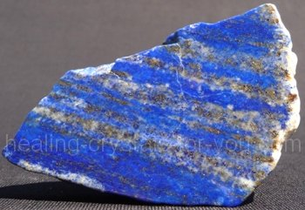 | 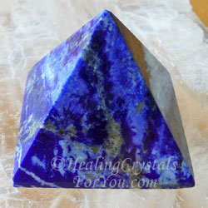

At sunrise, Enki sent for his emissaries and instructed them to find Galzu. They all came back at sundown and tell Enki they can't find him, and that he returned to Nibiru long ago. Enki was baffled as he was trying to comprehend what was happening. Although he was unable to figure out what was happening, the message was clear.
That night he sneaks to Ziusudra's reed hut/house and, not breaking the oath, he talks to the wall.

Excerpt: Enki speaks to the reed hut wall
Wake up! Wake up! to the reed wall Enki was saying, from behind the reed screen he was
speaking.
When Ziusudra by the words was awakened, to him Enki from behind the reed screen said:
Reed hut, reed hut! To my words pay attention, to my instructions heed pay!
On all the habitations, over the cities, a calamitous storm will sweep,
The destruction of Mankind and its offspring it will be.
This is the final ruling, the word of the assembly by Enlil convened,
This is the decision by Anu and Enlil and Ninmah spoken.
Now heed my words, observe the message that to you I am speaking:
Abandon your house, build a boat; spurn possessions, save the life!
The boat that you must build, its design and measurements on a tablet are shown,
By the reed hut's wall the tablet I shall leave.
Make sure that the boat shall be roofed throughout, the sun from the inside must not be seen.
The tackle must be very strong, the pitch strong and tight to ward off the water.
Let the boat be one that can turn and tumble, the watery avalanche to survive!
In seven days build the boat, into it your family and kinfolk gather,
In the boat food and water for drinking heap up, household animals also bring.
Then, on the appointed day, a signal to you shall be given;
A boatguide who knows the waters, by me appointed, to you that day will come;
On that day the boat you must enter, its hatch tightly close you must.
An overwhelming Deluge, coming from the south, lands and life shall devastate;
Your boat from its moorings it shall lift, the boat it shall turn and tumble.
Fear not: To a safe haven the boatguide will navigate you,
By you shall the seed of Civilized Mankind survive! Genesis 6
When Enki's voice fell silent, agog was Ziusudra, on his knees prostrate he fell:
My lord! My lord! he shouted. Your voice I heard, let me see your face!
Not to you, Ziusudra, have I spoken, to the reed wall did I speak! So Enki said.
By Enlil's decision, by an oath upheld am I bound to that all the Anunnaki swore;
If my face you shall see, surely like all Earthlings you will die! Exodus 33:20 John 1:18
Now reed hut, to my words pay heed:
The purpose of the boat, a secret of the Anunnaki with you must remain!
When the townspeople will inquire, to them you will so say:
The lord Enlil with my lord Enki has angry been,
To Enki's abode in the Abzu I am sailing, perchance Enlil will be appeased!
For a while a silence followed. Ziusudra from behind the reed wall came,
A tablet of lapis lazuli, in the moonlight shining, he saw and picked up;
The image of a boat upon it was drawn, notches its measurements gave;
Wisest of Civilized Men was Ziusudra, what he had heard he understood.

The next morning, after Enki had delivered message to Ziusudra, he announces to the townspeople that he can no longer reside there because Enlil is angry with Enki and therefore hostile toward him. So he plans to sail to Enki's domain, the Abzu.

Excerpt: Ziusudra builds the boat
In this city I no longer reside can, nor in the Edin my foot anymore set;
To the Abzu, the lord Enki's domain, I will there a-sailing go.
In a boat that must quickly be built I will away from here depart;
Thereby the lord Enlil's anger will subside, hardships will end,
Upon you the lord Enlil abundance henceforth will shower!
The morning was not yet gone when the people about Ziusudra gathered,
To speedily for him the boat build they each other encouraged.
Timbers of boat-wood the elders were hauling, the little ones bitumen from the marshes
carried.
As woodworkers the planks together hammered, Ziusudra in a cauldron the bitumen melted.
With bitumen the boat he waterproofed inside and out,
As in the drawing upon the tablet the boat on the fifth day was completed.
Eager to see Ziusudra depart, the townspeople to the boat food and water brought,
From their own mouths sustenance they took; to appease Enlil they were in a hurry!
Four-legged animals into the boat were also driven, birds from the field by themselves flew in.
Into the boat Ziusudra his spouse and sons made embark, their wives and children also came.
Any who to the abode of the lord Enki wish to go, let them too aboard come!
So did Ziusudra to the gathered people announce.
Envisioning Enlil's abundance, only some of the craftsmen the call heeded.
On the sixth day Ninagal, Lord of the Great Waters, to the boat came,
A son of Enki he was, to be the boat's navigator he was selected.
A box of cedarwood in his hands he held, by his side in the boat he kept it;
The life essences and life eggs of living creatures it contains, by the lord Enki and Ninmah
collected,
From the wrath of Enlil to be hidden, to life resurrect if Earth be willing!
So did Ninagal to Ziusudra explain; thus were all beasts by their twos in the boat hidden.
Now Ninagal and Ziusudra in the boat the arrival of the seventh day awaited.
(Is this the origin of Noah preparing for the flood?) Genesis 7
In the one hundred and twentieth Shar (120 x 3600 = 432,000) was the Deluge awaited,
In the tenth Shar in the life age of Ziusudra (10 x 3600 = 36,000) was the Deluge forthcoming,
In the station of the Constellation of the Lion/Leo was the avalanche looming.
(Does this mean that Leo is associated with or dedicated to Ziusudra/Noah?)

Excerpt: The Flood
For days before the Day of the Deluge the Earth was rumbling, groan as with pain it did;
For nights before the calamity struck, in the heavens Nibiru as a glowing star was seen;
Then there was darkness in daytime, and at night the Moon as though by a monster was
swallowed.
The Earth began to shake, by a netforce before unknown it was agitated.
In the glow of dawn, a black cloud arose from the horizon,
The morning's light to darkness changed, as though by death's shadow veiled.
Then the sound of a rolling thunder boomed, lightnings the skies lit up.
Depart! Depart! Utu to the Anunnaki gave the signal.
Crouched in the boats of heaven, the Anunnaki heavenward were lofted.
In Shurubak (Shuruppak), eighteen leagues away (1 league = 3 miles; 3 x 18 = 54 miles), the bright eruptions by Ninagal were seen:
Button up! Button up the hatch! Ninagal to Ziusudra shouted.
Together the trapdoor that the hatch concealed they pulled down;
Watertight, enclosed completely, was the boat; inside riot a ray of light penetrated.
On that day, on that unforgettable day, the Deluge with a roar began;
In the Whiteland, at the Earth's bottom, the Earth's foundations were shaking;
Then with a roar to a thousand thunders equal, off its foundations the icesheet slipped,
By Nibiru's unseen netforce it was pulled away, into the south sea crashing.
One sheet of ice into another icesheet was smashing,
The Whiteland's surface like a broken eggshell was crumbling.
All at once a tidal wave arose, the very skies was the wall of waters reaching.
A storm, its ferocity never before seen, at the Earth's bottom began to howl,
Its winds the wall of water were driving, the tidal wave northward was spreading;
Northward was the wall of waters onrushing, the Abzu lands it was reaching.
Therefrom toward the settled lands it traveled, the Edin it overwhelmed.
When the tidal wave, the wall of waters, Shurubak reached,
The boat of Ziusudra the tidal wave from its moorings lifted,
Tossed it about, like a watery abyss the boat it swallowed.
Though completely submerged, the boat held firm, not a drop of water into it did enter.
Outside the storm's wave the people overtook like a killing battle,
No one his fellow man could see, the ground vanished, there was only water.
All that once on the ground stood by the mighty waters away was swept;
Before day's end the watery wall, gathering speed, the mountains overwhelmed.
In their celestial boats the Anunnaki the Earth were circling.
Crowding the compartments, against the outer walls they crouched,
What was happening upon the Earth, down below, to see they strained.
From the celestial boat in which she was, Ninmah like a woman in travail cried out:
My created like drowned dragonflies in a pond the waters fill,
All life by the rolling sea wave away was taken! Thus did Ninmah cry and moan.
Inanna, who was with her, also cried and lamented:
Everything down below, all that lived, has turned into clay!
Thus did Ninmah and Inanna weep; they wept and eased their feelings.
In the other celestial boats the Anunnaki by the sight of unbridled fury were humbled,
A power greater than theirs they with awe those days witnessed.
For the fruits of Earth they hungered, for fermented elixir they thirsted.
The olden days, alas, to clay have turned! So to each other the Anunnaki said.
After the immense tidal wave that over the Earth swept,
The sluices of heaven opened, a downpour from the skies upon the Earth was unleashed.
For seven days the waters from above with the waters of the Great Below were mingled;
Then the wall of water, its limits reaching, its onslaught ceased,
But the rains from the skies for forty more days and nights continued.
From their perches the Anunnaki looked down: Where there were dry lands, now was a sea of
water,
And where mountains once to the heavens their peaks raised,
Their tops now like islands were in the waters;
And all that on the dry lands was living in the avalanche of waters perished.
Then, as in the Beginning, the waters to their basins were gathered,
Waving back and forth, day by day the water level came lower.
Then, forty days after the Deluge over the Earth swept, the rains also stopped.
After the forty days Ziusudra the boat's hatch opened, his whereabouts to survey.
A bright day it was, a gentle breeze was blowing;
All alone, with no other sign of life, the boat upon a vast sea was lolling.
Mankind, all living things, off the Earth's face are wiped out,
No one except us few survived, but there is no dry land to set a foot upon!
So did Ziusudra to his kinfolk say as he sat down and lamented.
At that time Ninagal, by Enki appointed, the boat toward the twin peaks of Arrata directed,
A sail for her he shaped, toward the Mount of Salvation he the boat guided.
Impatient Ziusudra was; birds that were on board he released
To check for dry land, for surviving vegetation to verify he sent them.
He sent forth a swallow, he sent forth a raven; both to the boat returned.
He sent forth a dove; with a twig from a tree to the boat it returned!
Now Ziusudra knew that the dry land from under the waters had emerged.
A few more days, and the boat by rocks was arrested:
The Deluge is over, at the Mount of Salvation we are! So did Ninagal to Ziusudra say.
Genesis 8:1-19

Link to Map | Link to Map
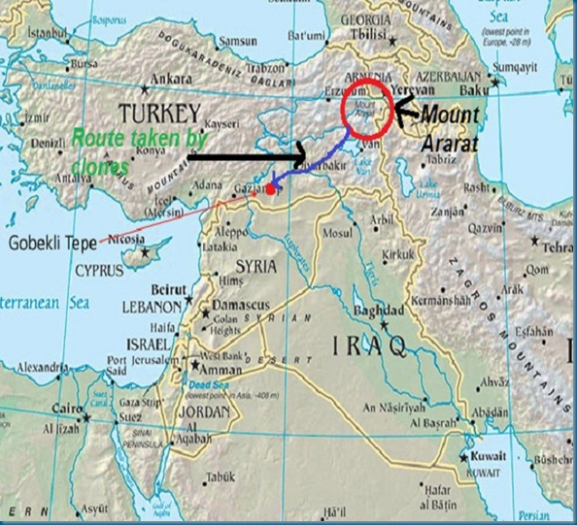 | 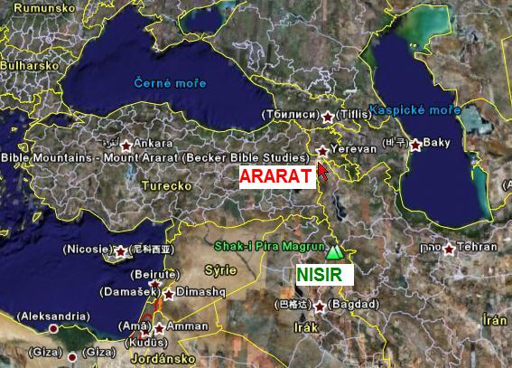
Link to Map | Link to Map
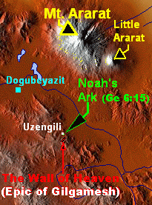 | 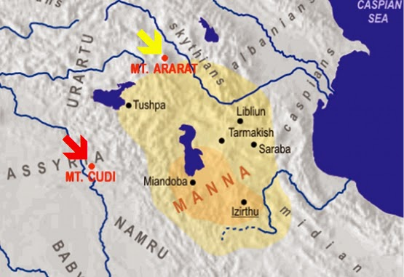

Opening the watertight hatch, from the boat Ziusudra emerged;
The sky was clear, the Sun was shining, a gentle wind was blowing.
Hurriedly upon his spouse and children he to come out called.
The lord Enki let us praise, to him thanks give! to them Ziusudra said.
With his sons stones he gathered, with them an altar he built,
Then a fire on the altar he lit, with aromatic incense he made a fire.
A ewe-lamb, one without blemish, for a sacrifice he selected,
And upon the altar to Enki the ewe-Iamb as a sacrifice he offered.
Genesis 8:20

As Ziusudra and kinfolk are offering up a lamb to Enki as a sacrifice, Enlil is communicating with Enki from his celestial boat saying: "Let us in Whirlwinds (are these helicopters?) from the celestial boats upon the peak of Arrata descend, The situation to review, what to be done to determine!"

Excerpt: Survivors are discovered
While the others in their celestial boats the Earth to circuit continued,
Enlil and Enki in Whirlwinds upon the peak of Arrata descended.
Smiling the two brothers met, with joy their arms they locked.
Then Enlil by the whiffs of fire and roasting meat was puzzled.
What is that? to his brother he shouted. Has anyone the Deluge survived?
Let us go and see! meekly to him Enki responded.
In their Whirlwinds to the other peak of Arrata they flew over,
The boat of Ziusudra they saw, by the altar that he had built they landed.
When Enlil the survivors saw, Ninagal among them, his fury no bounds had.
Every Earthling had to perish! he with fury shouted; at Enki with anger he lunged,
To kill his brother with his bare hands he was ready.
He is no mere mortal, my son he is! Enki, to Ziusudra pointing, cried out.
For a moment Enlil was hesitating. You broke your oath! at Enki he shouted.
To a reed wall I spoke, not to Ziususdra! Enki said, then to Enlil the dream-vision related.
By then, by Ninagal alerted, Ninurta and Ninmah in their Whirlwinds also touched down;
When the account of events they heard, Ninurta and Ninmah by the account were not angered.
The survival of Mankind the will of the Creator of All must be! So did Ninurta to his father say.
Ninmah her necklace of crystals, a gift of Anu, touched and swore:
On my oath, the annihilation of Mankind shall never be repeated!
Relenting, Enlil by the hands Ziusudra and Emzara his spouse took and blessed them thus:
Be fruitful and multiply, and the Earth replenish! Genesis 9:1
Thus were the Olden Times ended.

Now the waters are receding and everything in the valleys is under mud. All the cities in the Edin and the Abzu were completely vanished. The mountains were unscathed.

Excerpt: Restoration
But in the Cedar Mountains the great stone platform in the sunlight glistened,
The Landing Place, in the Olden Times established, was still standing!
One after another the Whirlwinds upon the platform landed;
The platform was intact; at the launch corner the huge stone blocks held firm. (Could this be the evidence we see today at Baalbek, in Lebanon, where huge blocks of stone exist that are estimated to be 2,000 tons each?)
Clearing debris and tree branches away, the first to land to the chariots signaled;
One after the other the celestial chariots came, upon the platform they touched down.
Then to Marduk on Lahmu and Nannar on the Moon words were sent,
And they too to Earth returned, upon the Landing Place they came down.
Now the Anunnaki and Igigi who were thus gathered by Enlil to assembly were called.
The Deluge we have survived, but the Earth is devastated! So did Enlil to them say.
All ways to recover we must assess, be it on Earth, be it elsewhere!
Lahmu by the passage of Nibiru was devastated! So did Marduk relate:
Its atmosphere was sucked out, its waters thereafter evaporated, a place of dust storms it is!
The Moon by itself life cannot sustain, only with Eagle masks is staying enabled!
So did Nannar to the others account give, and then words of enamor he added:
Once there, that it was Tiamat's host's leader one must recall,
Of Earth a companion it is, with it Earth's destiny is connected!
Lovingly Enlil on his son's shoulders his arm put. With survival now we are concerned!
So did Enlil to Nannar mildly retort; now, sustenance is our first concern!
Let us the sealed Creation Chamber examine; perchance Nibiru's seeds we shall still find!
So did Enlil to Enki say, of the grains once created him reminding.
At the side of the platform, clearing some mud, the shaft from times remote they found,
The stone that blocked it they lifted off, the sanctuary they entered.
The diorite chests with seals were fastened, the seals with a copper key they made open.
Inside the chests, in crystal vessels, the seeds of Nibiru's grain were there!
(Is this the origin of today's seed banks in underground bunker's that we've heard about?)
Once outside, to Ninurta Enlil the seeds gave, to him he was thus saying:
Go, the mountainside terrace, let the grains of Nibiru once again bread provide!
In the Cedar Mountains, on other mountains too, Ninurta waterfalls dammed,
Terraces constructed, the eldest son of Ziusudra to raise crops he taught.
To Ishkur, his youngest, Enlil another task assigned:
Where the waters have receded, go and remaining fruit-bearing trees find!
To him as fruit cultivator Ziusudra's youngest son was assigned:
The first fruit they found, the vine that by Ninmah was brought it was;
Of its juice, as the Anunnaki's elixir renowned, Ziusudra took a sip.
By one sip, then another and another, Ziusudra was overpowered, like a drunkard he fell
asleep!
(Was Ninmah also a winemaker/beer brewer/bootlegger? Is this the origin of Noah getting drunk and passing out?)
Genesis 9:20-21
Then a gift to Anunnaki and Earthlings Enki presented:
The chest that Ninagal had carried he unveiled, its surprising contents to all he announced:
The life essences and life eggs, in the wombs of the four-legged animals from
Ziusudra's boat can be combined, (Is this the origin of the 2 by 2 talked about in the Bible?)
Sheep for wool and meat will multiply, cattle for milk and hides will all have,
Then with other living creatures the Earth we shall replenish!
To Dumuzi the shepherding tasks Enki gave, in the task was Ziusudra's middle son assisting.

Excerpt: Enlil focuses on Egypt
With Ninagal, at the confluence of mighty waters the mountains he dammed,
Fierce waterfalls to a lake he channeled to let the waters as a lake accumulate. (Is this describing what we know today as Lake Nasser, in Egypt?)
Then the lands between the Abzu and the Great Sea with Marduk he surveyed:
Where habitations once were, the river's valley how to drain he considered.
At midstream where the river's waters cascaded, an island from the waters he raised.
In its bowels twin caverns he carved out, above them from stones sluices he fashioned.
From there two channels in the rocks he cut, for the waters two narrows he fashioned,
Thus the flowing waters from the highlands coming he could slow or let go faster;
With dams and sluices and the two narrows the waters he regulated.
From the Cavern Island, the island of Abu, the river's serpentine valley from under
the waters he raised: (The Cavern Island, the island of Abu (is this Abu Simbel?) below Lake Nasser and north of the Sudanese border.)

Link to Map | Link to Image
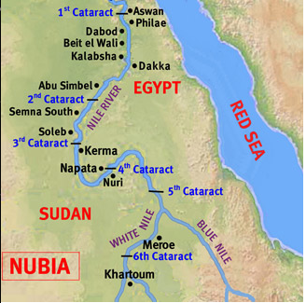 | 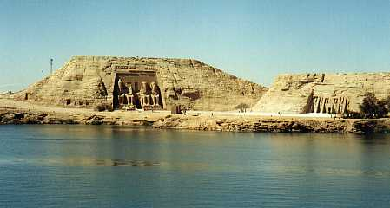
Link to Image | Link to Image
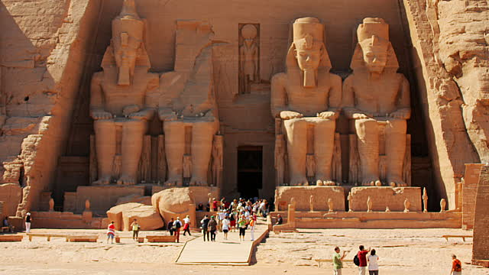 | 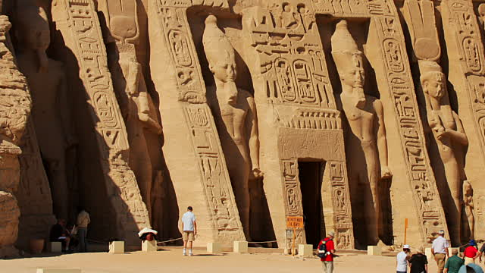

In the Land of the Two Narrows for Dumuzi and the shepherds a habitation did Enki fashion.
With satisfaction did Enlil all this to Nibiru words send; with words of concern Nibiru responded:
The close passage that Earth and Lahmu affected on Nibiru too much damage caused;
The shield of gold dust was torn, the atmosphere was dwindling again,
Now new supplies of gold quickly were needed!
Fervently to the Abzu Enki went, with Gibil his son to survey and search he journeyed.
All the gold mines were gone, by the avalanche of water they were buried.
In the Edin, Bad-Tibira too no longer existed, in Sippar a place for the chariots was no more!
The hundreds of Anunnaki who in the mines and Bad-Tibira toiled, from the Earth were gone,
The multitude of Earthlings, as Primitive Workers serving, by the Deluge were to clay turned;
No gold can from Earth anymore be provided! So did Enlil and Enki to Nibiru announce.
On Earth and on Nibiru there was desperation.

Terminology exploration:
Abzu/Abtu = Persian Gulf & Arabian Sea
Great Sea =Mediterranean Sea
mighty waters = Nile River, its source is the western White Nile and eastern Blue Nile. The confluence (where they merge) is at Khartoum. (Rosetta/Rasheed River, & Damietta [a corruption of Tamiati which is correct name] River are part of the Nile Delta where it dumps into the Mediterranean Sea). The source of the White Nile is Lake Albert, between Democratic Republic of Congo and Uganda, flowing down to Khartoum, in Sudan. The source of the Blue Nile is Lake Tana, in Ethiopia, flowing down to Khartoum, in Sudan. The Nile flows South to North from Khartoum, through Lake Nubia (Sudan), through Lake Nasser (Egypt), where the Aswan Dam is on the north side. From Khartoum to Aswan, there are 6 major cataracts (large waterfalls and/or rapids). Also, at one time that same area was known as Upper and Lower Nubia, from the 3rd Cataract down to the 1st Cataract near Aswan, and split by what we know as the Egypt/Sudan border.

Link to Map
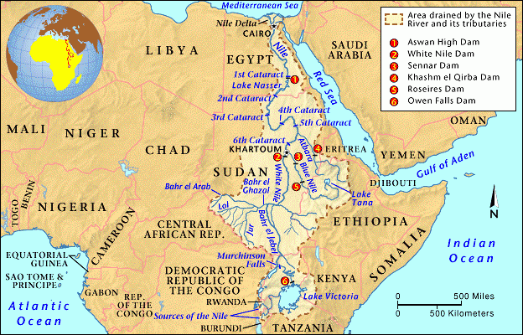

At that time Ninurta was completing his tasks in the Lebanon Mountains. He then goes back to the mountainland beyond the oceans (Is this Australia or Americas?) where the avalanche of water had cut into the mountainsides exposing large and small nuggets of gold. He communicates his finding to Enlil and Enki and they both hurried to see the discovery.

Excerpt: How will the gold be gathered?
Gold, pure gold, refining and smelting not requiring, all about was lying! A miracle it is! So was Enki to Enlil saying. What by Nibiru was wrought, by Nibiru was amended!
The unseen hand of the Creator of All it is life on Nibiru to enable! So did Enlil say. Now who could collect the nuggets, how to Nibiru they will be sent? the leaders each other asked.
Of the first question, Ninurta had the answer:
In the high mountainland on this side of Earth, some Earthlings have survived!
Descendants of Ka-in they are, with the handling of metals they are knowing;
Four brothers and four sisters are their leaders, on rafts they themselves saved,
Now their mountaintop in the midst of a great lake is an island. (Is this Mt. Everest in the Himalayas on the Tibetan Plateau bordering India and Tibet, China? Mt. Everest is the highest peak on Earth. Special Note: At one time India was an island [when Earth was Pangea] OR Is this the Americas?)
As the protector of their forefathers they me recall, the Great Protector they call me!

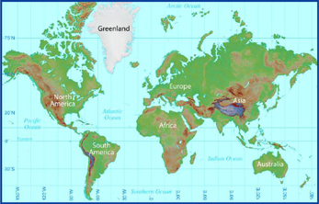 |  | 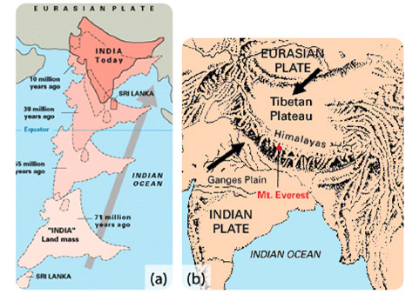
 | 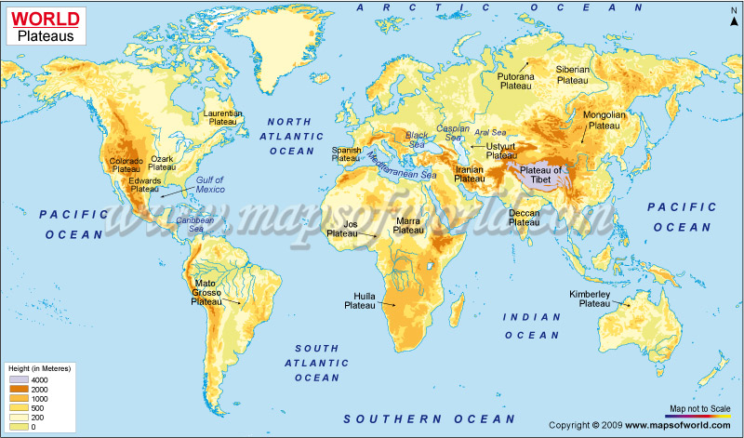

The Annunaki leaders were glad to hear that there were Earthling survivors, including Enlil who wanted them all to perish. "It is the will of the Creator of All! to each other they said. Now let us a new Place for Celestial Chariots establish, therefrom the gold to Nibiru send!"
Now the leaders search for a specific place to establish a new spaceport facility. What they were looking for was a new plain where the soil had dried and hardened. They find it near the Landing Place, in a desolate peninsula. It was flat and surrounded by white mountains. (Is this area that we know of today as the Sinai Peninsula?)
In the peninsula the Anunnaki reflected the Way of Anu and Way of Enlil on Earth. Enlil suggests to Enki that the new Place of the Chariots be located on that boundary and the heart of the plain reflect the heavens. Enki agrees and Enlil measures the distances from the skies and marks on a tablet a grand design for all to see. He also suggest that the Landing Place in the Cedar Mountains be part of the new facilities.

Excerpt: The new facility
The distance between the Landing Place (Baalbek?) and the Chariot Place (Tilmun?) he measured, In the midst thereof a place for a new Mission Control Center (Jerusalem?) he designated:
There a suitable mount he selected, the Mount of Way Showing (Is this Mount Zion at Jerusalem) he named it.
A platform of stones, akin but smaller than the Landing Place, to be built there he ordered;
In its midst a great rock was carved inside and out, to house a new Bond Heaven-Earth it was
made. (Could this be Mount Zion where the Temple Mount is located in the old Jerusalem city?)
Link #1 to Baalbek Info Link #2 to Baalbek Info
 | 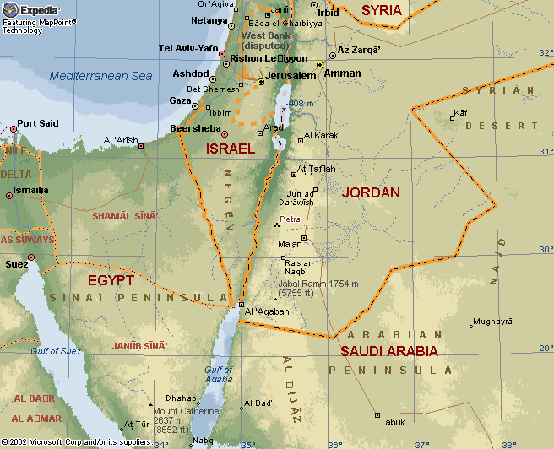
Link to Map |  | Link to Picture & Additional Info!
 |  | 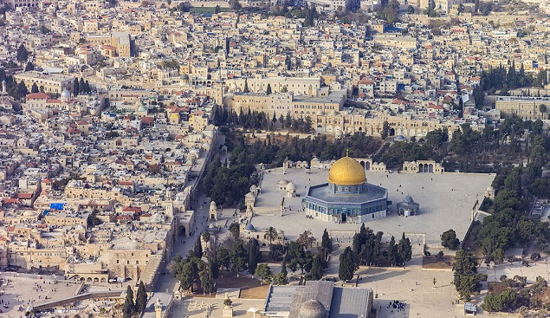
Link to Image and Info |  | Link to Map and Info
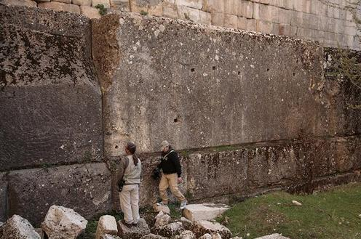 |  | 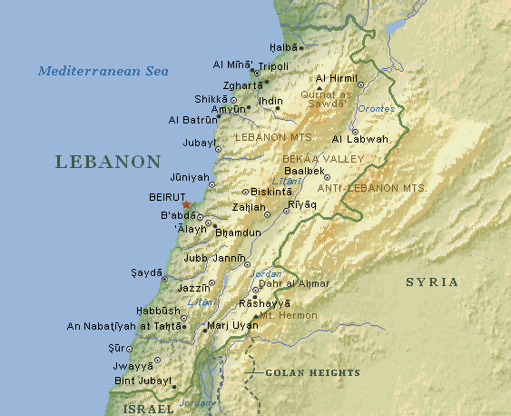

Temple Mount Israel

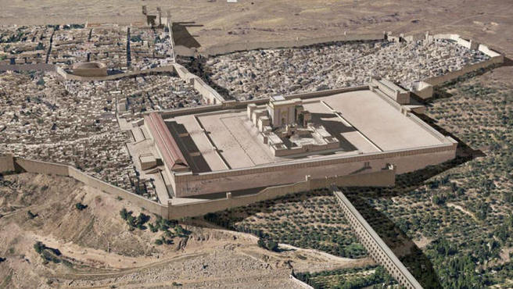
The platform in Jerusalem was built by the Annunaki, After the Deluge — the Great Flood —as their mission control center. It was established in this particular place because it was equidistant from the spaceport, Tilmun that was in the Sinai Peninsula and from a landing platform Baalbek that existed from pre-deluvial times (and still exists) in Lebanon. And they developed it on a line that connected the mountains of Ararat with the great pyramids in Egypt. That is why mission control was established precisely at that spot. below are the huge stones in the Rabbi Tunnel, which are part of the construction at the base of the platform.

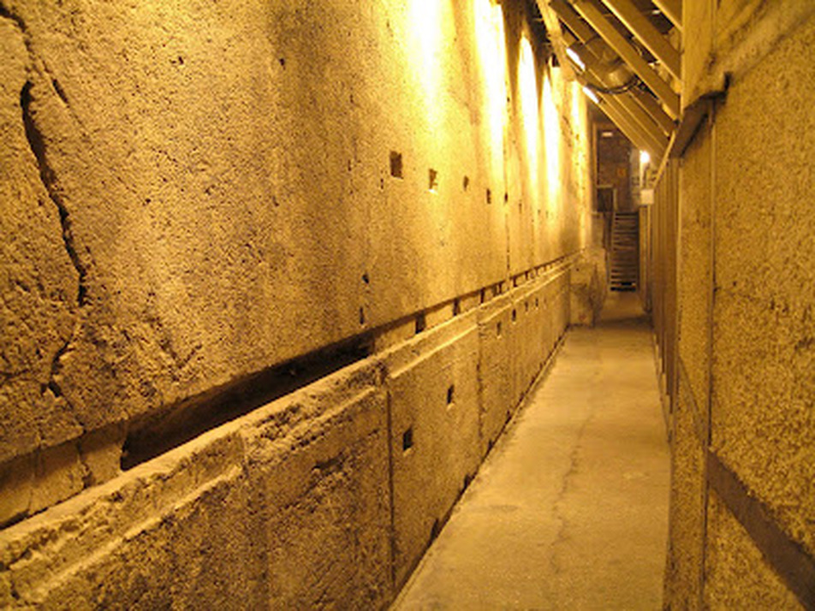

A new Navel of the Earth, the role of Nibru-ki before the Deluge to replace.
The Landing Path on the twin peaks of Arrata in the north were anchored;
To demarcate the Landing Corridor Enlil two other sets of twin peaks required,
To delimit the Landing Corridor's boundary, ascent and descent to secure.
In the southern part of the desolate peninsula, a place of mountains,
Twin adjoining peaks Enlil selected, on them the southern delimit he anchored.
Where the second set of twin peaks was required, mountains there were none,
Only a flatland above the water-clogged valley from the ground protruded.
(Is this the area where we today know as Cairo/Giza?)
Artificial peaks thereon we can raise! So did Ningishzidda to the leaders say.
On a tablet the image of smooth-sided, skyward rising peaks for them he drew.
(Ningishzidda designs the pyramids at Giza)
If it can be done, let it so be! Enlil with approval said. Let them also as beacons serve!
On the flatland, above the river's valley, Ningishzidda a scale model built,
The rising angles and four smooth sides with it he perfected.
Next to it a larger peak he placed, its sides to Earth's four corners he set;
By the Anunnaki, with their tools of power, were its stones cut and erected.
(Is this a reference to power tools?)
Beside it, in a precise location, the peak that was its twin he placed;
With galleries and chambers for pulsating crystals he designed it.
When this artful peak to the heavens rose, to place upon it the capstone the leaders were
invited. Of electrum (a natural or artificial alloy of gold with at least 20 percent silver, used for jewelry, especially in ancient times), an admixture by Gibil fashioned, was the Apex Stone made.
The sunlight to the horizon it reflected, by night like a pillar of fire it was,
The power of all the crystals to the heavens in a beam it focused.

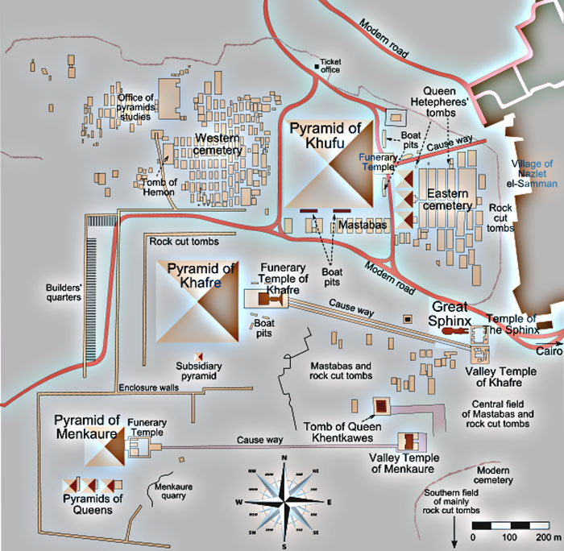 | 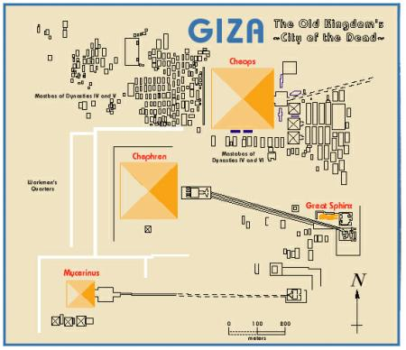

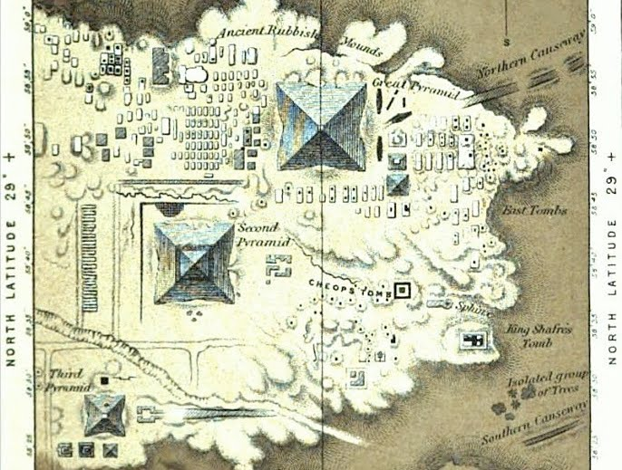

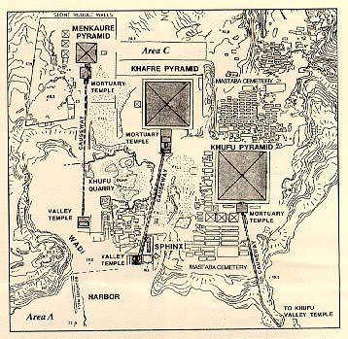



FIGURE 6.
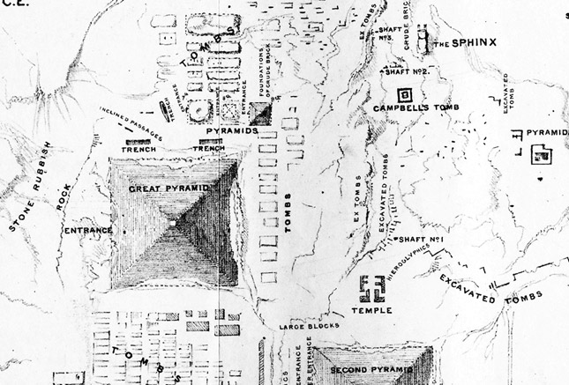

FIGURE 6. Detail from the folding map of the Giza Plateau drawn up by John S. Perring, appearing opposite page 1 of Volume I of Howard Vyse, Operations Carried on at the Pyramids of Gizeh in 1837, London 1840, 3 vols. The Osiris Shaft is labelled ‘Shaft No. 1’ on this map, near the centre of the plan shown here. The Sphinx is shown at the top, both temples in front of it being unknown at that time and still covered in sand. The Chephren Causeway, which runs over the top of the Osiris Shaft, was also covered in sand and was unknown at this time except for the point where it crosses the Osiris Shaft. The ruins marked ‘temple’ just above the ‘Second Pyramid’ (the Pyramid of Chephren) is the Funerary Temple of Chephren. This map of 1837 is not only the earliest plan showing the location of the Osiris Shaft, it is the only one.



FIGURE 6. Supplementary.
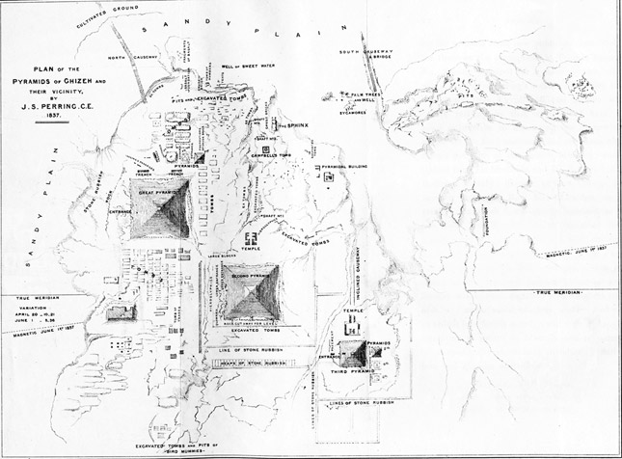
FIGURE 6. Supplementary
This is the folding map of the Giza Plateau drawn up by John S. Perring, appearing opposite page 1 of Volume I of Howard Vyse, Operations Carried on at the Pyramids of Gizeh in 1837, London 1840, 3 vols. combined with a vesica piscis by the Coptic Church of Egypt.

Giza
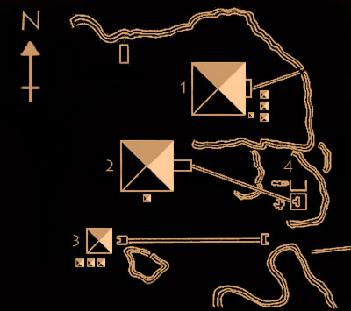

- The Great Pyramid and Complex (Khufu)
- Khafre's Pyramid Complex
- Menkaure's Pyramid
- Great Sphinx and Sphinx temples
Click to view a map of Giza including the pyramids, temples, sphinx and mastabas.

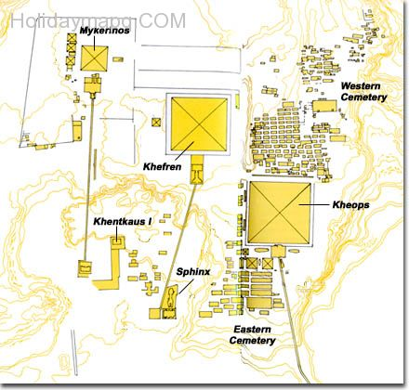

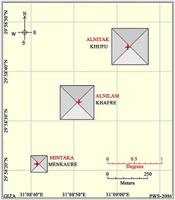 | 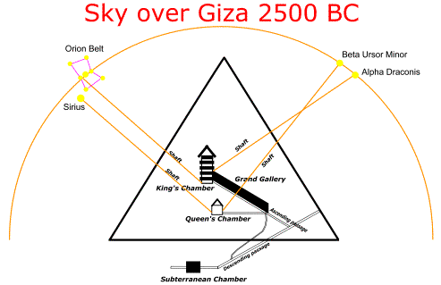

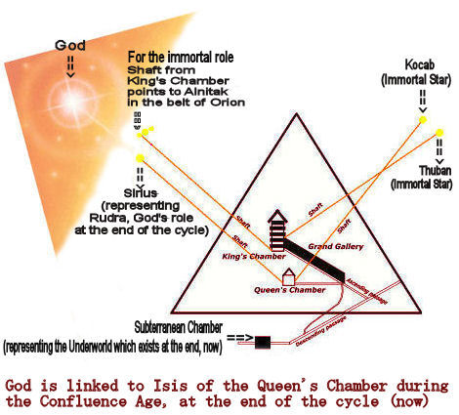

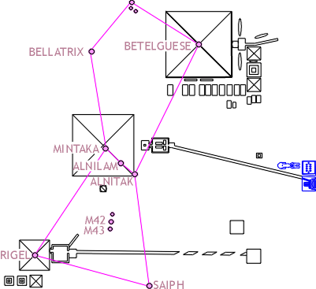

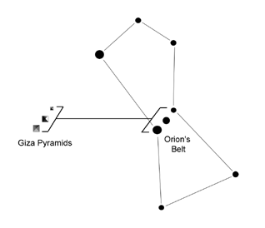 | 

